Mr. Jose Graziano da Silva, Director General, FAO visited IPM program in Nepal
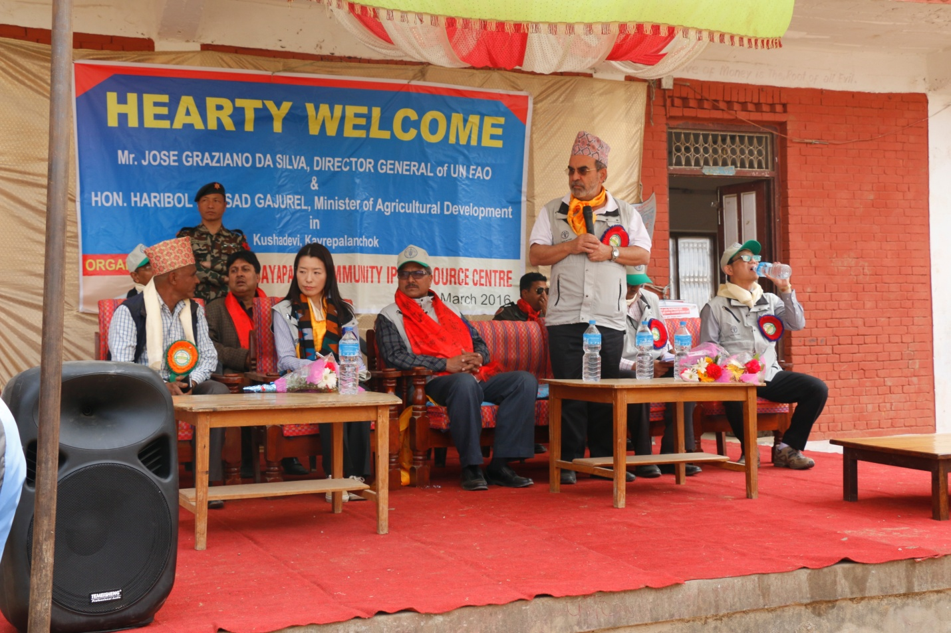
Director General at the United Nations Food and Agriculture Organisation, Mr. Jose Graziano da Silva, opening speech.
Director General at the United Nations Food and Agriculture Organisation, Mr. Jose Graziano da Silva visited the peasants at Kushadevi, Kavre district in Nepal on 12 March 2016 and observed the IPM program conducted by Plant Protection Directorate and technical supported by FAO.
During the visit he observed IPM Community Resource Centre where farmers are producing biopesticides in their laboratory and IPM trained farmers elaborates all the process of production of biopesticides in the resource centre. Mr Jose also expressed his interest in knowing the process of FFS during production of potato seed.
Mr. Jose Graziano da Silva was accompanied by Hon Agricultural Development Minister Mr Hari Bol Prasad Gajurel who expressed satisfaction and happiness to see the local peasants availing IPM facility and reaping double crop production due to it.
He said the new technologies were doing rounds among the peasants due to the increasing level of awareness among them and that he was confident the campaign to alleviate famine in the country would gain a success with the use of the IPM approach among the farmers.
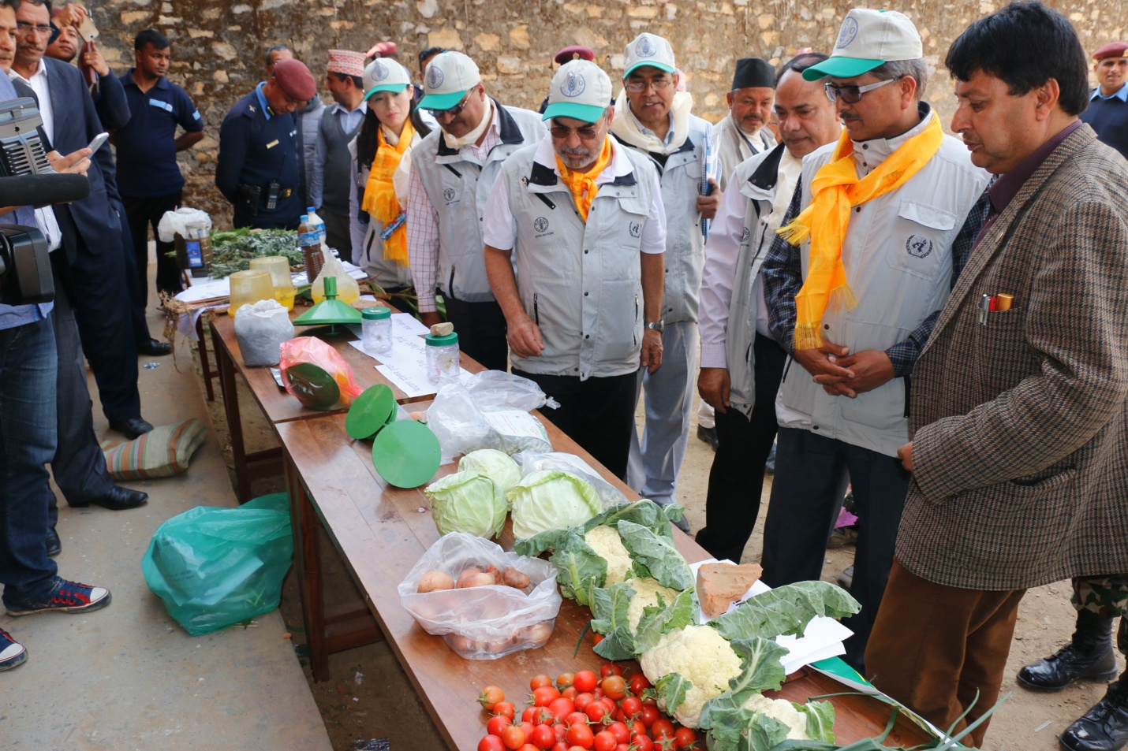
Observation of IPM product
Director-General Jose Graziano da Silva and Hon Minister also participated in the formal farmers gathering program and show their happiness about the very proud work of farmers in the IPM program in Nepal. In discussion with Director-General, farmers of Kusadevi shared that they were applying hazardous pesticides before launching the IPM program yet now they are using biopesticides and producing double and healthy crops in the village and minimizing the use of chemical pesticides in the village.
In response Director-General Jose Graziano da Silva highlighted that the FAO’s presence in the country was meant to provide technical support to the agriculture sector in Nepal and FAO will continue providing its technical support in the IPM program in Nepal.
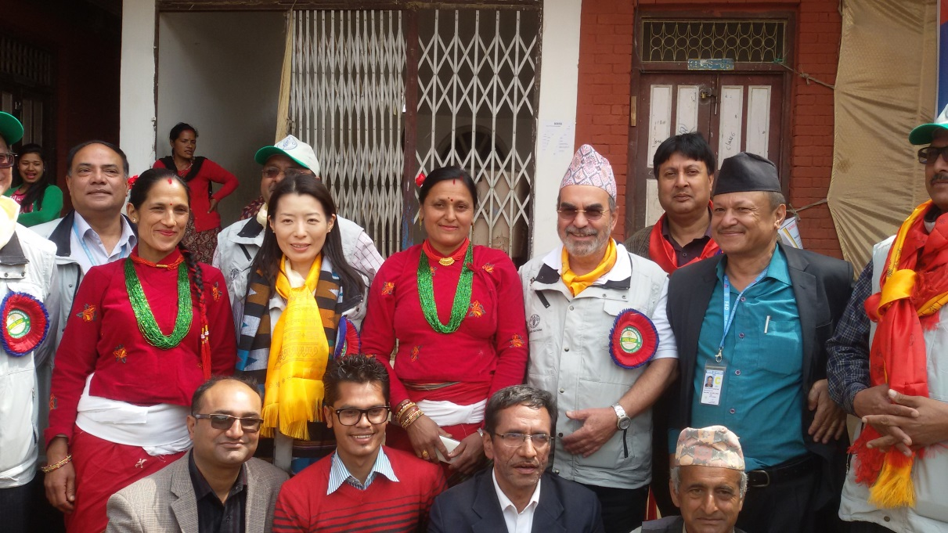
Warm welcome

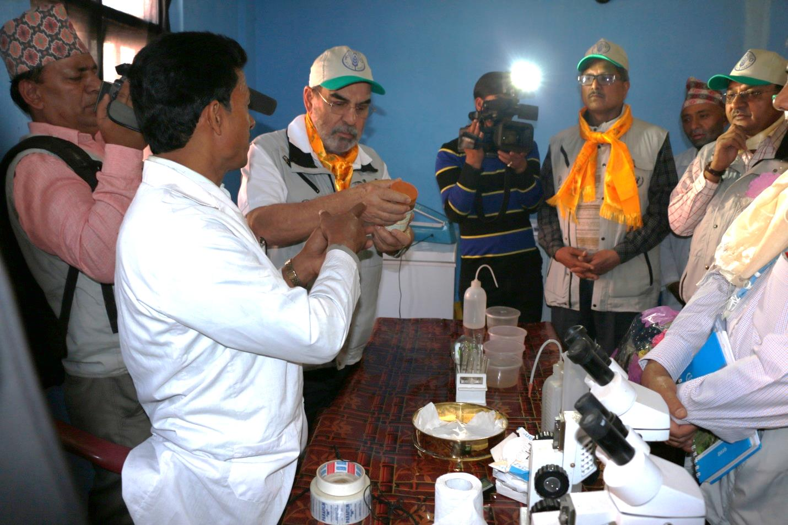
Biopesticide laboratory visit

FAO technical assistance to Nepal in IPM and pesticide management in recent years
A pilot programme on IPM-FFS in rice in Nepal was initiated in May 1997 based on season long Farmer Field School (FFS) approach through FAO Technical Cooperation Programme (TCP). Upon phase out of the FAO Community IPM Program in 2003, bilateral funding from government of Norway became available for a 4-year project from 2004 to 2007. The goal of the project was to contribute to sustainable broad-based poverty alleviation and food security in Nepal while contributing to environmental protection. FAO provided technical support in this phase and the activities expanded in terms of area and crops (rice, vegetables, coffee, tea and citrus).

FAO provided continual technical assistance to Nepal through UTF/NEP/059/NEP (Consolidation, Up-Scaling and Institutionalization of IPM) as the country would like to continue the initiatives of IPM programme with the funding from the Government of Norway in support of the consolidation, up-scaling and institutionalization of the National IPM Programme from Oct. 2008- Jan. 2014. This support is based on the holistic and sustainable production and protection management that can help achieve food security and alleviate poverty. It was implemented in 12 districts of 5 development regions representing 3 agro-ecological zones of the country.

As a result, a large number of farmers have been benefited from participation in IPM-FFS trainings, a significant improvements of knowledge and capacity in agro-ecological practice as well as market access have been achieved. Three community IPM Resource Centers were established to enhance "Community−based conservation" approach for better access to knowledge, inputs and services by creating the conditions for sustaining both natural resources and local practices to sustainability.Farmer’s empowerment had impact on the adoption and up-scaling of IPM technologies in districts contributing to food and nutritional security as well as environment protection.

In order to help the country to promote to a sustainable pesticide management system for improving the environment, health of growers and the surrounding community, FAO provided support with a new TCP/NEP/3502 “Strengthening Pesticide Management in Agriculture to Reduce Risks to Health and Environment”, which will be implemented from 2015-2016.

