Great Success – 29th Session of APPPC

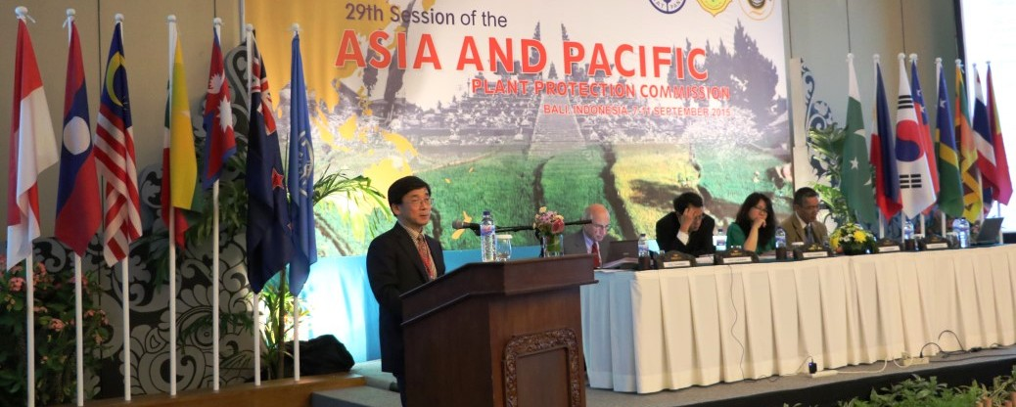
The Twenty-ninth session of the Asia and Pacific Plant protection Commission (APPPC) was held on Bali Island, Indonesia, from 7 to 11 September 2015.
The meeting brought together over 70 participants from 21 Member Countries and observers from Japan and CABI. The unique and effective picture of the current state of Asia and Pacific Plant Protection Agreement draws a broad range of international expertise in plant protection.
The commission appreciated the work of the APPPC Secretariat, provide by FAO, for facilitating implementation the workplan.
Along with the discussion each standing Committee’s chair provided progress reports. Hence, great progress was achieved in areas of plant quarantine, electronic phytosanitary certification, pest surveillance, plant protection, pesticide management, pest management and promotion of sustainable crop production intensification.
One of the most fascinating aspects of the Standing Committee on pant quarantine work is more than 10 highly efficient meetings in addition to other activities that were organized since last Session and funded by dononrs and APPPC funds available from the operational funding mechanism.
During the discussion of the work plan for next biennium the Standing committee on plant quarantine put emphasis on the implementation of surveillance programme, ePhyto development in the region and regional standard of phytosanitary measures (RSPM). Number of countries expressed willingness to share the information and expertise on hot water treatments (HWT) of mango and other commodities and agreed to develop a specification for the future regional standard on HWT of mango.
To extend the work on ePhyto development the development of technical capacity in participation in the three years “ePhyto IPPC Hub” project have been approved. Nevertheless, it was noted that already some of APPPC countries have better progress in this area of work compare to other regions and IPPC in general.
With regard to surveillance programme countries approved six years strategic plan on surveillance and first two workshops will be implemented in upcoming biennium. It was agreed that results and recommendations from each workshop will r be implemented at national level.
Countries also expressed interest in continuing capacity building activities in rubber growing countries to prevent introduction of South Amerian Leaf Blight (SALB).
Number of members countries highlighted the importance of the implementation of ISPM31: Methodologies for sampling of consignments. For this reason, at least one workshop was proposed to be held in next biennium.
In terms of information exchange, the working group will continue its work. The participants agreed that countries will share information on capacity building activities, roster of experts and success stories on eradication and incursion programmmes.
APPPC Standing Committee on IPM discussion highlighted that during the period of 2013-2015, countries in Asia and Pacific have undertaken efforts at intensifying food production to meet food needs of increasing populations. It was noted that most of the countries in the region have included IPM into their national policies for more sustainable crop production intensification. It was also referred that in the APPPC member countries during the past two years, lessons have been learned on scaling up IPM to reach more small-holder farmers. These efforts have been taken for improving the key role of extension agents for more effective IPM promotion and capacity building of smallholder farmers in particular.
The Standing committee on IPM workplan for upcoming biennium includes two main activities such as Workshop on Supporting Capacity Building on Integrated Control of Fruit Flies of Economic Importance and Farmer Empowerment for Sustainable Crop Production Intensification.
APPPC Standing Committee on Pesticide Management Progress report highlighted number of activities, organized during last biennium. Countries appreciated the progress made within last two years, yet agreed to pay more attention to this area of work.
Discussion on the work programme for upcoming biennium identified a registration of bio-pesticides in the countries as an outstanding issue. Thus, countries highlighted the need for capacity building, testing protocol, data requirement for registration as well as trained personnel.

Finally, the 29 Session of APPPC approved a budget for next biennium and venue for 30th meeting of the commission which will take place in New Zealand with additional financial support provided by the Government of New Zealand.

