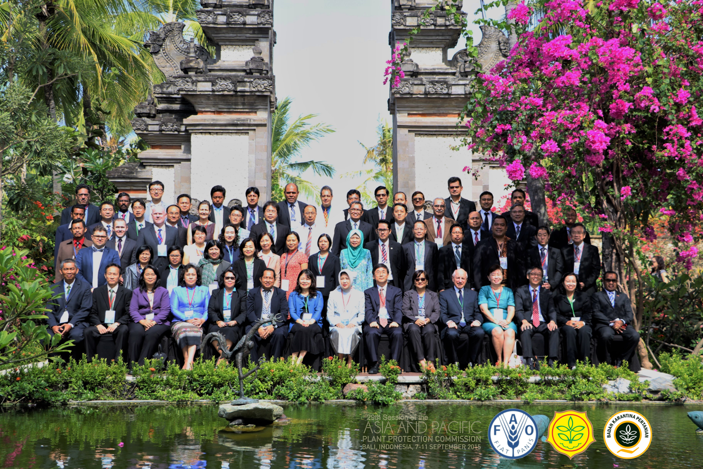
The Twenty-ninth session of the Asia and Pacific Plant protection Commission (APPPC) has been opened in Bali Island, Indonesia, from 7 to 11 September 2015.
The meeting brought together over 60 participants from 21 Member Countries, Japan, Observers from CABI and FAO.
The main principal objectives for the Commission are review the progress, made since last Session in 2013, discuss on work plan for next biennium and approve on the budget for upcoming biennium (2016-2017). In-depth discussion will take place on work programme of each standing committee.
The APPPC Secretariat will present report with the remarkable progress on the implementation of the work plan adopted by the previous Session. Thus, convincing volume of work has been done in areas of plant quarantine, electronic phytosanitary certification, pest surveillance, plant protection, pesticide management, pest management and promotion of sustainable crop production intensification in support food security approaches as well as Implementation of International standards on Phytosanitary Measures (ISPMs) etc.
Member countries will report update changes and developments and progress since last Session. Emphasis rests on the significance of the organizational changes, revision of plant protection regulations, capacity building activities and collaboration with counterparts and International organisations. Issues and progress on management of pest and pesticides will also be reported.
The commission will carefully examine and synthesize the various main areas of plant protection in the region to be collaborated and coordinated to produce comprehensive work-plan for next biennium.
The importance of APPPC was highlighted by Director-General, Indonesian Agricultural Quarantine Agency in reducing hunger, improving livelihoods of people and overall food security. These will be achieved through meeting the challenge of protecting regional and global plant resources, agricultural resources, forests, natural habitats, biodiversity from transboundary movement of harmful plant pests.
Please access APPPC website to find update information during the week.

