Development of Long- term Action Plan of National Plant Protection Organization

Draft

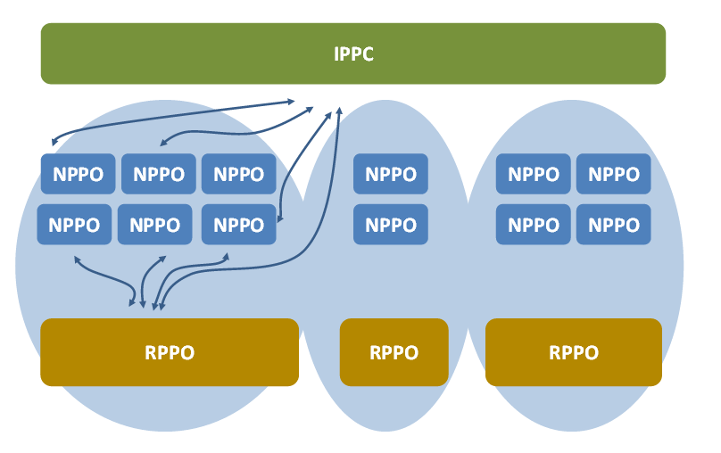

Ministry of Agricultural Development
Department of Agriculture
Plant Protection Directorate
HariharBhawan, Lalitpur, Nepal
July, 2015

Table of Contents
Foreword i
Acknowledgements ii
Abbreviations and Acronyms iii
Team Composition v
List of Figures vi
Executive Summary vii
1 Background Information 1
2 Rationale and Justification 3
3 Objectives of the Study 4
4 Technical Approach and Methodology 5
4.1 Technical Approach 5
4.1.1 Review of Literature 5
4.1.2 Holistic Research Approach 5
4.2 Methodological Tools for Collecting Information 6
4.2.1 Inception Meeting with relevant stakeholders 6
4.2.2 Meetings with the relevant institution/organizations and individuals 6
4.2. 3 Coordination and Linkages 6
5 Responsibility for Related Areas of Work and Services by NPPO 8
5.1 Objectives of NPPO 8
5.2 NPPO Areas of Work and Services 9
5.3 Role of the NPPO for the implementation of WTO-SPS Rules 10
5.4 Functions of NPPO 11
5.4.1 Legal authority for the NPPO 11
5.4.2 Management responsibility 11
5.4.3 Administrative responsibilities 12
5.4.4 Regulatory development and revision 12
5.4.5 HRD and resources of the NPPO 13
5.4.6 Operational responsibilities 13
5.5 Provisions for the organization arrangement of NPPO (IPPC text 1997, article IV) 15
5.6 Selecting/identifying experts for nomination to draft standards 16
5.7 Reporting obligations for NPPO 16
6 Procedure and Practices for Delivery of NPPO Services 18
6.1 Practices and procedures for the issuance of Phytosanitary Certificate for Export and Re-export 19
6.2 Practices and procedures for the Import Inspection and Certification (Issuance of Entry Permit and Release Order) of Plants, Plant Products and other regulated articles into Nepal 22
6.3 Declaration of pest freedom in an area 30
6.4 Eradication of pest and pest free area declaration 31
6.5 Inspection and Testing Methods 32
6.6 Pest Surveillance, Database Preparation and Pest Risk Analysis 33
6.7 Practices of Quarantine treatment 35
7 Organizational and Institutional Frameworks 36
7.1 Institutional Structure framework 36
7.2 Major thrust of NPPO 40
7.3 Administrative and Organizational Structure of NPPO 42
7.4 Technical Panel and Expert Working Groups 45
7.5 Organizational/institutional set-up and working pattern of some major countries and neighboring countries 47
7.6 Members in the NPPO (Proposed) 48
7.7 Existing Members in the NPPO 49
7.8 Meeting of the NPPO 49
8 Policy and Legal Aspects 50
8.1 Review of the existing policy and legal authority 50
8.1.1National Context 50
8.1.2 International Context 51
8.1.3 Policy and legal aspects of NPPO not cover by the Plant Protection legislation 52
8.2 Phytosanitary standards and Policies consideration 55
8.3 Other Considerations 57
9 Internal and External System for Establishing Contact and Coordination 59
9.1 Coordination and collaboration between NPPO and non-NPPO bodies 59
9.2 Inter-Organizational Linkages ……………………………………………………………………………………………………..60
9.3 Coordination Mechanisms…………………………………………………………………………………………………………...61
9.4 Participation in developing topics for ISPMs……………. 62
9.5 Relevant tasks demanding national and international contact……………………………………………………..63
10 Short-term and Long-term Action Plans for Achieving Targets of NPPO 67
11 Weak and Strong Points on NPPO 69
11.1 Weak Points 69
11.2 Strong Points 70
12 Main Constraints and Issues 70
12.1 Constraints 71
12.2 Issues 71
13 Recommendations 71
14 References 72
15Lists of Annexes 74
Annex 1: NAPPO Organizational Chart 74
Annex 2: United States 75
Annex 3: Country Plant Protection Profiles- Australia 76
Annex 4: Description of the NPPO of Germany 77
Annex 5: Structure of the Hungarian NPPO 78
Annex 6: Organizational Chart of Indian Plant Quarantine Structure 79
Annex 7: Description of the NPPO of Germany 79
Annex 8: Plant Protection Organization Chart of China 80
Annex 9: NPPO Action and Contact 81
16 Lists of Appendixes 85
Appendix 1: Nepal Gazette designating PPD as the NPPO of Nepal 85
Appendix 2: Power to designate National Plant Protection Organization 85

Foreword
IPPC Article IV requires each country to establish a NPPO primarily for the prevention of introduction, establishment and spread of dangerous alien pests within the country and effectively managing the domestic pest control programmes including development of pest management strategies and approaches to manage pests of quarantine importance for export promotion of healthy plants and plant products. NPPOs, designated under the IPPC, have historically dealt mostly with agricultural crops. In Nepalese case in recent years, however, forest pests have become a more prominent concern and increased communication between forest sector personnel and the NPPOs is needed. All sectors in forestry need to understand what the IPPC is, and how NPPOs work so that the forest sector can play its part in implementing ISPMs and help preserve forest plant health. To this context, a study mainly focusing to design and develop short-term and long-term plan of actions of NPPO to provide Sanitary and Phytosanitary (SPS) services was made. The scope of this study includes identifying the area of work and services, developing organizational structure and administrative management for the PQ service, policy and legal bases and procedure and practices for delivery of services for NPPO. The main objective of the study is to develop plan of actions of NPPO to comply with WTO/ SPS obligations and improve access to international markets of agricultural products. The main objective of the study is to develop plan of actions of NPPO to comply with WTO/ SPS obligations and improve access to international markets of agricultural products in line with Plant Protection Act, 2007 and Plant Protection Regulations, 2010 of Nepal.
The contents of the report are divided into six chapters. The first chapter deals with the Identification of the area of work and services of NPPO. The second chapter describes the formulation of necessary policy and legal bases for undertaking the duties by NPPO. The third chapter presents the development of administrative and organization structure of NPPO and present organizational/institutional set-up and working pattern of some major countries and neighboring countries NPPO. The fourth chapter furnishes the procedure and practices for delivery of services. The fifth chapter furnishes the internal and external system for establishing contact and coordination and lastly it describes the short-term and long-term plan of actions for achieving overall targets of NPPO.
This guide will help develop this understanding and assist policy-makers, planners, managers, plant quarantine officers and plant protection officers to improve communication between agencies at a national level and apply these standards in the plant health sector. Development of Long- term Action Plan of NPPO is the first attempt in Nepal.

Dilli Ram Sharma
Program Director, PPD
Head NPPO, Nepal

Abbreviations and Acronyms

AEC: Agro enterprise Centre
ALPP: Area of Low Pest Prevalence
AFU: Agriculture and Forestry University
APPPC: Asia and Pacific Plant Protection Commission
CBD: Convention on Biological Diversity
CITES: Convention on International Trade in Endangered
Species of Wild Fauna and Flora
CPM: Commission on Phytosanitary Measures
DoA: Department of Agriculture
DFTQC: Department of Food Technology and Quality Control
DADOs: District Agricultural Development Offices
DPR: Department of Plant Resources
DOF: Department of Forest
DFO: District Forest Office
GAP: Good Agriculture Practice
GMOs: Genetically Modified Organisms
HRD: Human Resource Development
IPM: Integrated Pest Management
IPPC: International Plant Protection Convention
IPP: International Phytosanitary Portal
ISPMs: International Standard for Phytosanitary Measures
LMOs: Living Modified Organisms
MoAC: Ministry of Agriculture Development
NPPO: National Plant Protection Organization
NPQP: National Plant Quarantine Programmee
NTFP: Non-Timber Forest Products
NARC: National Agriculture Research Council
NNA: National Notification Authority
NRO: National Reporting Obligation
PPD: Plant Protection Directorate
PQCP: Plant quarantine check post
PQSCP: Plant quarantine sub-check post
PRA: Pest Risk Analysis
PFA: Pest Free Area
PC: Phytosanitary Certificate
PRMS: Pesticide Registration and Management Section
PCE: Phytosanitary Capacity Evaluation
RPPOs: Regional plant protection organizations
RPQO: Regional Plant Quarantine Office
SPS: Sanitary and Phytosanitary
SQCC: Seed Quality Control Center
SPSEP: Sanitary and Phytosanitary Enquiry Point
TP: Technical Panel
WTO: World Trade Organization
WTO: World Trade Organization

List of Figures

Figure 1: Practices and procedures for the issuance of Phytosanitary Certificate for Export and Re-export (pursuant to Rule 8 sub-rule 1 of Plant Protection Regulation 2010)
Figure 2: Procedures of Plants and Plant Products Quarantine
Figure 3: Practices and procedures for the issuance of Entry Permit of Plants, Plant Products and other regulated articles into Nepal (pursuant to Rule 5 of Plant Protection Regulation, 2010)
Figure 4: Practices and procedures for the renewal of Entry Permit of Plants, Plant Products and other regulated articles into Nepal (pursuant to Rule 6 of Plant Protection Regulation, 2010)

Figure 5: Practices and procedures for the issuance of release order for Plants, Plant Products and other regulated articles into Nepal (pursuant to Rule 7 of Plant Protection Regulation, 2010)

Figure 6: Declaration of pest freedom in an area

Figure 7: Eradication of pest and pest free area declaration

Figure 8: Inspection and Testing Methods

Figure 9: Procedure and practices for Pest Surveillance, Database Preparation and Pest Risk Analysis
Figure 10: Quarantine treatment

Figure 11: Institutional Structure framework of NPPO

Figure 12: Administrative and Organizational Structure of NPPO

Figure 13: Organizational Arrangements of Plant Protection
Figure 14: Working with national and regional plant protection organizations (NPPOs and RPPOs)

Executive Summary

The study seeks to better understand the plan of action for NPPO to reduce or remove the export barriers. The main objective of the study is to develop plan of actions of NPPO to comply with WTO/ SPS obligations and improve access to international markets of agricultural products. This study mainly focuses on development of short-term and long-term plan of actions for achieving targets of NPPO. The scope of this study also includes identifying the area of work and services, developing organizational structure and administrative management for the PQ service, policy and legal bases and procedure and practices for delivery of services for NPPO as well as suggesting measures to increase the export of Nepalese products.

The main objective of the NPPO is safeguarding and promoting plant health from an international perspective. As such the organization is responsible of implementation of IPPC requirements for plant health, export phytosanitary certification requirements and planning of plant health checks, including supervision and audits. Compliance with notification obligations remains a challenge for WTO Members This has led National Plant Protection Organizations worldwide to develop global structures for international harmonization of phytosanitary measures and their technical justification.
National Plant Quarantine Program under the Plant Protection Directorate (PPD), DoA/ MoAC with the promulgation of Plant Protection Act 2007 and Plant Protection Regulation 2010 is actively engaged in phytosanitary measures to protect the plant diversity and health of plants. The Directorate of Plant Protection (PPD) is the official NPPO of Nepal in terms of membership of the IPPC. The qualitative information indicates that there are institutional barriers arising mostly due to lack of clarity of responsibilities and coordination between government agencies.
The methodology was participatory and covered major stakeholders and groups involved in the plant quarantine activities and related activities. Several meetings with the relevant institution/organizations and individuals have also been organized to identify key issues and the priorities.
As the provisions made in Plant Protection Act, 2007 (Article 2 (6)), Nepal has officially authorized the Plant Protection Directorate to have the overall responsibility of NPPO as referred by IPPC. The NPPO has statutory responsibility for preventing the introduction, transmission, and spread of pests in the Nepal. Under its delegated authority, NPPO works to fulfill this responsibility through a variety of activities. Plant Protection Regulations provide specific rules and details for how to put the law into practice. To put those legislative provisions into execution, there are a number of areas of works relating plant health as specified by Plant Protection Act and Regulations and IPPC.
The NPPO is designed as the Government agency responsible for the formulation of the plant protection policies and involve in the implementation of the Plant Quarantine activities and delivery of services through multi-pronged approach by various stakeholders. Inspection and quarantine procedures for delivery of services normally include six steps: 1. application for inspection, 2. acceptance of application, 3. calculation and collection of fees, 4. inspection and quarantine, 5. decontamination treatment, and 6. issuance of certificate and release of goods.
Institutions exhibit a formal nature (rules, regulations, laws, rights, etc.). Organizations, on the other hand, refer to a group or association, formal or informal, in which there are defined and accepted roles, positions and responsibilities structured in some relationship to each other in order to achieve a specific objective(s). The responsibility for phytosanitary controls and the application of phytosanitary measures against the introduction and spread of invasive alien species are shared by a number of institutions. The streamlining of NPPO administration has become imperative to cope with the increasing demand of international trade & also to protect plant biodiversity from the exotic pests associated with imported commodities.

Legal authority of NPPO-N is prevailing as specified in article 6 of the Plant Protection Act 2007 and Plant Protection Regulation 2010 which states that Government of Nepal with the Power specified by Legislature-Parliament in “The Plant Protection Act 2007“The Government of Nepal may, by notification in the Nepal Gazette, designate any central level office related with plant protection as the National Plant Protection Organization. At present PPD has been designated to work as NPPO and also as focal Institutions for IPPC.

NPPO should ensure the effective and consistent application of phytosanitary legislation and regulations and compliance with international obligations. This may require operational coordination with other government services or government agencies involved with imports, e.g. Customs and other relevant concerned organizations. Administration of the import regulatory system should be coordinated at national level but may be organized on a functional, regional or other structural basis and may need internal departmental or ministry level decision to carry out the functions of the NPPO. A multi-stakeholder approach in managing invasive alien species is considered the most effective way. The NPPO therefore collaborates with all relevant stakeholders who include environmentalist, researchers, regulators, policymakers, private sector and civil society in managing invasive alien species.
Better coordination and collaboration in the phytosanitary research area would help reverse the erosion of the scientific base and underpin the development and implementation of Plant Health policy to meet the challenges caused by increased bio-security threats and declining resources in the phytosanitary field.
Being the official point of IPPC and as the focal point of NPPO, the PPD should prepare the short-term and long-term strategically plans of the service, as well as setting of priorities in respect of issues under the competency on the national level; secure the implementation of the said plans and priorities. The plan of actions will serve as a guide for decision-makers as they commence the long-term recovery process.

1 Background Information
Nepal being a member of the WTO is duty-bound to observe and/ to comply with the bindings, rules and conditions of Agreement on SPS Measures in its trades a contracting party of IPPC which states that each contracting party shall make provision, to the best of its ability, for an official national plant protection organization with the main responsibilities set out in Article (1) under general provisions relating to the organizational arrangements for national plant protection. The Text of the International Plant Protection Convention (IPPC) requires that Contracting Parties designate a National Plant Protection Organization (NPPO) as the official authority for phytosanitary measures. This is an official service established by a government to discharge the functions specified by the IPPC (FAO 2010).
National Plant Quarantine Program under the Plant Protection Directorate (PPD), DoA/ MoAC with the promulgation of Plant Protection Act 2007 and Plant Protection Regulation 2010 is actively engaged in phytosanitary measures to protect the plant diversity and health of plants.
Plant protection Act, 2007 has clearly indicated the provision for the establishment of NPPO. Accordingly, the Government of Nepal may, by a Notification in the Nepal Gazette, designate any central level office related with plant protection as the National Plant Protection Organization (Section 6 of Plant Protection Act, 2064 (2007).Organization" means the national plant protection organization prescribed by the Government of Nepal pursuant to Section 6 of Plant Protection Act, 2064 (2007).
lj?jf ;+/If0f P]g @)^$ n] u/]sf] lj?jf :j:ytf ;+jlGwJoj:yf
- g]kfn ;/sf/n] g]kfn /fhkqdf ;'rgfk|sfzg u/L lj?jf ;+/If0f ;+u ;+alGwt s]lGb|o:t/sf] s'g} sfof{nonfO{ /fli6«o lj?jf ;+/If0f ;+u7gsf] ?kdftf]Sg ;Sg]5 – bkmf ^-!_ – o; cg';f/ g]kfn ;/sf/n] ldlt @)&).!!.% sf] /fhkqdf ;'rgfk|sfzg u/]/ afnL ;+/If0f lgb]{zgfnonfO{ g]kfns]f /fli6«o lj?jf ;+/If0f ;+u7g tf]lsPsf] 5 .
The Directorate of Plant Protection (PPD) is the official NPPO of Nepal in terms of membership of the IPPC. As a member to the IPPC, the NPPO of Nepal aims to prevent the spread and introduction of pests of plants and plant products, and to promote appropriate measures for their control maintaining coordination with relevant stakeholders which includes environmentalist, researchers, regulators, policymakers, private sector and civil society in managing invasive alien species.
NPPOs are the government agencies within the IPPC member countries that implement the phytosanitary standards by developing and enforcing national regulations. They undertake pest risk analyses for the establishment of phytosanitary measures; manage pest surveillance; report to other countries on pest status; coordinate the control of pests; and establish and monitor pest free areas. They also take responsibility for ensuring phytosanitary security of consignments from certification until export; conduct verification inspections and, if necessary, require treatment of consignments or where appropriate, destruction or refusal of entry. Because pests do not recognize international borders, NPPOs frequently have to work with neighboring countries to prevent pest entry, establishment and spread. This collaboration may be done through Regional plant protection organizations (RPPOs) also.

Like in most developing countries, Nepal has experienced some problems in carrying out NPPO function smoothly. The Complexity in procedures and mechanisms, and legal and technical interpretation of WTO rules and agreements – particularly the SPS Agreement, inadequacy of technical human resources and required laboratory facility are commonly faced issues by the stakeholders. While a contracting party implements phytosanitary procedures and regulations, it should try to use measures that reduce risk to an acceptable level with the least negative impacts on trade.
The work of NPPOs relies on scientific expertise, but the services providing this expertise increasingly lack staff, funds and training. On the one hand, the whole scientific basis of the phytosanitary field is quickly eroding. Taxonomy, classical plant pathology and other scientific fields which are vital for sustaining sound public policy are threatened with extinction, because they are no longer in the forefront of science priorities. On the other hand, the need for phytosanitary expertise, training and research is substantially and continuously increasing. A foundation activity of NPPOs is the conduct of pest surveillance. The products of pest surveillance provide the basis for pest listing, identification of pest status, pest categorization and the conduct of pest risk analyses. The number and complexity of plant pest problems increases every year. Unless urgent action is taken, indispensable expertise and scientific disciplines will irreversibly disappear, and NPPOs will be unable to do their duty.

2 Rationale and Justification
No doubt trade policy or trade agreements between the countries are aimed to facilitate international trade; however, not all countries benefit equally from the trade agreements. To gain maximum benefit from the trade agreements, domestic environment of the countries should be favorable to increase their share in the international market. Therefore, removal or minimization of these obstacles would contribute toward a higher export propensity. Barriers to exporting are all those procedural, structural, policy and structural ones that hinder the firm's ability to initiate, develop, or sustain international operations. Although these constraints play an important role to reduce the export trading, export traders alone are not able to remove or minimize them. They need the Government or other institutional support to reduce the cost of export imposed by the barriers of export.
From SPS perspective, current trade policy does not provide clear guidance for long run strategies and does not create conducive environment for the promotion of trade and business in order to make it competitive at international level. Lack of SPS conducive policy is the major policy barrier. Due to lack of comprehensive strategic plans, Nepal could not get comparative advantages from the export of raw materials or semi -processed products; on the other hand, it has created ecological and environmental problems in the home country and high value addition products have not received attention for export.
Inadequacy of skilled manpower and physical facilities at quarantine check post / offices are often reported. The quarantine officials also reported the lack of institutional mechanism to deal with quarantine issues for Nepalese products with the neighboring quarantine officials. The qualitative information indicates that there are institutional barriers arising mostly due to lack of clarity of responsibilities and coordination between government agencies. The need for the establishment of accredited labs based on agreement between the importing and exporting countries was pointed out to solve institutional barrier created by quarantine problem. There is no clarity of authority between forest, agriculture and Trade Departments regarding the permission related to export of medicinal herb and some other products.

In the context of government commitment in international level and WTO, it is necessary to identify the scope/area of work and services to be provided by NPPO, develop procedure and practices for delivery of services , develop institutional structure of NPPO for the PQ service, develop policy and legal bases for NPPO, develop administrative and organization structure of NPPO, develop internal and external system for establishing contact and coordination, develop short-term and long-term plan of actions for achieving targets of NPPO, present organizational/institutional set-up and working pattern of some major countries and neighboring countries.

The roles and functions of NPPO are associated with broad areas of plant protection. New revised text of International Plant Protection Convention 1997 has framed the function of NPPO in a standard format. However, most of the countries have their own frameworks of the working areas. Based on relevant laws/regulations/directives/working procedures, availability of resources, capacities and prioritized agenda, working modalities have been developed. Since IPPC is international standard setting body in the field of plant protection, a national guideline for NPPO action plan is essential in meeting the national requirements and fulfilling international obligations.

3 Objectives of the Study
The study seeks to better understand the plan of action for NPPO to reduce or remove the export barriers. The main objective of the study is to develop plan of actions for achieving targets of NPPO to comply with WTO/ SPS obligations and improve access to international markets of agricultural products.
The study was designed with the following specific objectives:

- To identify the scope/area of work and services to be provided by NPPO
- To develop procedure and practices for delivery of services
- To develop institutional structure framework of NPPO
- To formulate necessary policy and legal bases for undertaking the duties by NPPO
- To develop administrative and organization structure of NPPO
- To develop internal and external system for establishing contact and coordination
- To develop short-term and long-term plan of actions for achieving targets of NPPO
- To present organizational/institutional set-up and working pattern of some major countries and neighboring countries

4 Technical Approach and Methodology
The methodology adopted for this study was participatory and covered major stakeholders and groups involved in the plant quarantine activities and related activities. To achieve the objectives of the project both the primary and secondary; quantitative as well as qualitative information were utilized. Primary quantitative information was collected through personal interview with relevant stakeholders. Qualitative information was also collected through discussions. Secondary information was collected from government policy documents, reports, publications, and other relevant published and unpublished past researches. For this assessment, participatory research approach was the tool used to assess both the qualitative and quantitative information as required for this study.

4.1 Technical Approach
To meet the objectives of the study and to carry-out the activities specified in the TOR of the study following approaches have been used:

4.1.1 Review of Literature
Immediately after the contract agreement, the consultant team collected relevant reports, manuals, guidelines, Act, Rules, Regulations and other materials from the client as well as from other concerned organization. Published literature from different governmental and non-governmental organizations was reviewed to develop mid-term and long-term plan of actions for achieving targets of NPPO. Similarly, review of information was also analyzed from annual reports, study reports, published articles, papers and records of governmental and semi-governmental.

4.1.2 Holistic Research Approach
Holistic survey research approaches have been undertaken. Involvements of related stakeholders have been consulted during the collection of primary data. Discussion with concerned line agencies such as PPD, NPQP, Agri-business Promotion and Marketing Development Directorate was made to generate required information for the accomplishment of study objectives.

4.2 Methodological Tools for Collecting Information
Apart from the collection and use of secondary information, the following werethe major tools for collecting information.

4.2.1 Inception Meeting with relevant stakeholders
Before the commencement of the assignment, the consultant team were familiarized themselves with the work, got overview of project, and assessed the role and responsibilities of different actors, contractual compliance matters. In order give overview of the project, one day inception meeting/workshop was organized for relevant stakeholders in consultation with the PPD and NPQP. The objectives of the meeting were to: (i) Clarify and understand the project goals and objectives; (ii) review and approve the work plan; (iii) review and approve matters related the technical work packages, viz. technical approach and methodology.
The program generally covered presentations in the following areas:
- Background Information
- Project's Activities
- Technical Approach and Methodology
- Work Plan (WP)

4.2.2 Meetings with the relevant institution/organizations and individuals
Several meetings with the relevant institution/organizations and individuals have also been organized to identify key issues and the priorities. Some key stakeholders have been contacted. The stakeholders have been contacted and briefed about the project. The team members requested to the relevant institution/organizations and individuals to provide your views/ ideas/suggestions/ experiences related to plan of action of NPPO and export/import barriers (Policy/ institutional/structural/procedural/procedures and practices issues as barriers) and possible measures to remove them, and comparative advantages for Nepal.

4.2. 3 Coordination and Linkages
Efficient communication and productive cooperation with the concerned client/PPD/NPQP as well as other stakeholders was maintained. Full use of available and applicable reports, standards, guidelines, laws and regulations, etc. was made. PPD, NPQP as well as other concerned officials and authorities have been fully and regularly briefed of progress of the activities and problems connected thereto.

5 Responsibility for Related Areas of Work and Services by NPPO

The NPPO has statutory responsibility for preventing the introduction, transmission, and spread of pests in the Nepal. Under its delegated authority, NPPO works to fulfill this responsibility through a variety of activities. The NPPO is the official service responsible for the operation and/or oversight (organization and management) of the import/export regulatory system. Other government services, such as the Customs service, may have a role (with defined separation of responsibilities and functions) in the control of imported commodities and liaison should be maintained. Government of Nepal has the sovereign right to regulate imports to achieve their appropriate level of protection, taking into account their international obligations. Rights, obligations and responsibilities associated with international agreements as well as the principles and standards resulting from international agreements, in particular the IPPC (1997) and the World Trade Organization Agreement on the Application of Sanitary and Phytosanitary Measures (WTO-SPS Agreement), affect the structure and implementation of import/export regulatory systems.
IPPC and APPPC assume member countries to have national plant protection organizations. Under the IPPC definition, the official NPPO is the government service that discharges the functions specified by IPPC. It also defines the official NPPO as the national authority for the “control and issuance of phytosanitary certificates.

5.1 Objectives of NPPO
The main objective of the NPPO is safeguarding and promoting plant health from both national and an international perspective. As such the organization is responsible of implementation of IPPC requirements for plant health, export phytosanitary certification requirements and planning of plant health checks, including supervision and audits of 16 PQCs. Specifically it will support in the following specific areas.
- To protect plant health in agriculture, forestry and the uncultivated environment
- To develop an international strategy against the introduction and spread of pests (including invasive alien plants) that damage cultivated and wild plants, in agricultural and natural ecosystems and protecting biodiversity.
- To prevent introduction, establishment and spread of dangerous alien pests within the country.
- To promote and regulate the availability of healthy and productive plant material and the quality of agricultural products in Nepal.
- To involve in domestic pest control programmes
- To develop treatment technologies to eradicate pests of quarantine importance.
- To promote export of healthy plants and plant products.
- To encourage harmonization of phytosanitary regulations and all other areas of official plant protection action.
- To promote the use of modern, safe, and effective pest control methods.
- To provide a documentation and information service on plant protection.

5.2 NPPO Areas of Work and Services
Plant Protection Regulations provide specific rules and details for how to put the law into practice. To put those laws into effect, there are a number of areas of works relating plant health specified by Plant Protection Act and Regulations and IPPC. The Areas of Work and Services of NPPO are presented below:

SN | Areas of Work and Services
1 | Bear the legal authority for its quarantine related actions
2 | Implement common and effective measures on national and international level to prevent the importation and distribution of pests of plants and plant product
3 | Establish legal, technical and administrative measures necessary to achieve the goals of the IPPC
4 | Phytosanitary standards setting
5 | Pest surveillance - to generate information about the presence or absence of pests
6 | Inspection, sampling, and testing of plant and plant products
7 | Pest management and IPM
8 | Standards implementation
9 | Report to international organizations –IPPC, RPPO, FAO
10 | Response over the questionnaires and other subjects received from international and regional organizations
11 | National phytosanitary planning (Strategic and operational plan)
12 | Enacting Standard Operating Procedure (SOP)
13 | Monitoring and application of phytosanitary measures
14 | Verify compliance with phytosanitary requirements for agri and forest products
15 | HRD/ Capacity development
16 | Implement safeguards against potential problems such as conflicts of interest and fraudulent use of certificates

lj?jf ;+/If0f P]g @)^$ n] u/]sf] lj?jf :j:ytf ;+jlGwJoj:yf
;+u7gsf] sfdst{Jo / clwsf/ b]xfoadf]lhdx'g]5 M
- k}]7f/L jflgsf;Lul/g] lj?jfjflj?jfhGopkhsf] :j:ytf ;+alGw dfkb08 tof/ ug]{
- lj?jf, la?jfhGopkh, afof]nf]lhsn s06«f]n Ph]06, nfebfossL/f / cGo a:t'sf] kl/If0f, hfFr, lgl/If0f / pkrf/ ;+alGwlgb]{lzsftof/ u/L nfu' ug]{
- zq'hLjd'Qm If]q Pjdsdzq'hLj ;+qmldt If]qsf] klxrfg u/L To:tf If]qsf] 3f]if0ff tyflgu/fgLug]{
- la?jftyfla?jfhGopkh, nfebfosls/f, afof]nf]lhsn s06«f]n Ph]06 jfcGo j:t' ;+alGwsfdsf] /fli6«o ;dGjostf{sf] ?kdfsfdug]{
- k}7f/L jflgsf;Lul/g] la?jfjflj?jfhGopkhsf] :j:ytf ;+jlGw :jLs[t dfkb08 nfu' ug]{ u/fpg]
- cGo /fi6«x?sf] lj?jf :j:ytf ;+jlGwlgsfo;+u ;dGjo u/L Ps csf{sf] k|j]z cg'dltkqtyf :j:ytf k|df0fkqnfO{ dfGotflbg] ;+aGwdf ;dembf/L ug]{

5.3 Role of the NPPO for the implementation of WTO-SPS Rules
The NPPO oversees the implementation of the WTO/SPS rules. Among the roles of the NPPO are:
- Act as contact point for the country in relation to WTO-SPS and IPPC matters in Nepal
- Review of the Plant Quarantine legislation, procedures and guidelines in accordance with the WTO-SPS Agreement and IPPC as well as to meet ISPMs requirements.
- Harmonize and enforce Plant Quarantine procedures and guidelines
- Initiate and establish bilateral activities for market access and resolves plant quarantine issues with trading partners.
- Send notifications to WTO on plant quarantine matters related to new rules or regulations and to trading partners on non compliance
- Facilitate trade
Besides, from the overall discussion it is concluded that to protect the plant health and trade facilitation NPPO has to perform these roles:
- Regulatory – Acts, Rules, Directives, working procedures, agreements
- Coordinating – Within and among stakeholders
- Facilitating – To the stakeholders and trade partners
- Executing – Implementation of the standards, measures, monitoring, motivation
- Information exchange – Among and within stakeholders

5.4 Functions of NPPO
As the provisions made in Plant Protection Act, 2007 (Article 2 (6)), Nepal has officially authorized the Plant Protection Directorate to have the overall responsibility of NPPO as referred by IPPC. Plant Protection Act (Article 5 (18)) mentions on notifying information in the prevalence and spread of pests that may cause immediate or potential danger. The Notification Authority lies in Ministry of Agriculture Development that notifies pest of immediate or potential danger to WTO member countries. For the exchange of information, an official contact point has been designated at Department of Food Technology and Quality Control.

5.4.1 Legal authority for the NPPO
The NPPO has the sole authority by legislative or administrative means to conduct, develop and maintain a phytosanitary certification system related to exports and re-exports, and should bear the legal responsibility for its actions in using this authority, in accordance with Article IV.2 (a) of the IPPC. The NPPO has the legal authority (powers) to prevent the export of consignments that do not meet phytosanitary import requirements.

5.4.2 Management responsibility
The NPPO have a management system that ensures that all requirements, including certification specifications, legislative requirements and administrative requirements are satisfied.

5.4.3 Administrative responsibilities
Administrative activities required supporting a Pest Free Area or Area of low pest prevalence, pest free place of production or pest free production site involve documentation of the system and the maintenance of adequate records concerning the measures taken. Review and audit procedures undertaken by the NPPO are essential to support assurance of pest freedom and for system appraisal. Bilateral agreements or arrangements may also be needed.
The administration of the import regulatory system by the NPPO should ensure the effective and consistent application of phytosanitary legislation and regulations and compliance with international obligations. This may require operational coordination with other government services or government agencies involved with imports, e.g. Customs. Administration of the import regulatory system should be coordinated at national level but may be organized on a functional, regional or other structural basis.
The NPPO should have a management system that ensures that all legislative and administrative requirements related to phytosanitary certification are satisfied and be able to:
- identify institutionswithin the NPPO responsible for the phytosanitary certification system
- identify the duties and communication channels of all personnel involved in phytosanitary certification
- employ or authorize personnel who have appropriate qualifications and skills
- ensure that adequate and sustained training is provided
- ensure that adequate personnel and resources are available.

5.4.4 Regulatory development and revision

The issuing of phytosanitary regulations is a government (contracting party) responsibility (Article IV.3(c) of the IPPC). Consistent with this responsibility, governments may make the development and/or revision of phytosanitary regulations the responsibility of their NPPO. This action may be under the initiative of the NPPO in consultation or cooperation with other authorities as appropriate. Appropriate policies and regulations should be developed, maintained and reviewed as necessary and in compliance with applicable international agreements, through the normal legal and consultative processes of the country.

5.4.5 HRD and resources of the NPPO

NPPO should have adequate resources to carry out its functions (Article IV.1 of the IPPC)

5.4.5.1 Training and development of staff
The NPPO should have personnel with a level of expertise appropriate for the duties and responsibilities of the positions being occupied. NPPOs should have or have access to personnel with training and experience in:
  - performing inspections of plants, plant products and other regulated articles for purposes related to the issuance of phytosanitary certificates
  - identification of plants and plant products
  - detection and identification of pests
  - performing or supervising phytosanitary treatments required for the certification in question
  - survey, monitoring and control activities related to phytosanitary certification
  - constructing appropriate certification systems and formulating instructions from importing country phytosanitary requirements
  - auditing of accredited personnel and certification systems, where appropriate.
5.4.5.2 Equipment and facilities

The NPPO should ensure that adequate equipment and facilities are available for:
- inspection, sampling, testing, surveillance and consignment verification procedures
- communication and access to information (by electronic means as far as possible).

5.4.6 Operational responsibilities

The NPPO should have the legal authority and capability to undertake the following operational responsibilities:

- providing a national plant protection organization contact point in terms of the IPPC in Nepal
- issuing phytosanitary certificates or re-export phytosanitary certificates for consignments of plants, plant products and other regulated articles intended for export
- issuing phytosanitary import permits for consignments intended for import
- conducting pest risk analyses
- based on risk assessment, develop a list of— (i) quarantine pests; (ii) regulated non-quarantine pests; and (iii) pests of national concern
- regulating the movement of plants, plant products, other regulated articles and biological control agents into, within from Nepal
- developing and publishing phytosanitary measures;
- proposing, reviewing, and enforcing phytosanitary measures;
- inspection of consignments of plants, plant products and other regulated articles-the inspection of consignments of plants and plant products moving in international traffic and, where appropriate, the inspection of other regulated articles, particularly with the object of preventing the introduction and/or spread of pests
- the disinfestations or disinfection of consignments of plants, plant products and other regulated articles moving in international traffic, to meet phytosanitary requirements
- the protection of endangered areas and the designation, maintenance and surveillance
of pest free areas and areas of low pest prevalence
- notifying trading partners regarding non-compliance with phytosanitary import requirements;
- notifying other countries about the Nepal’s phytosanitary measures, regulations, requirements and legislation;
- conducting surveillance for regulated pests in Nepal-the surveillance of growing plants, including both areas under cultivation (inter alia fields, plantations, nurseries, gardens, greenhouses and laboratories) and wild flora, and of plants and plant products in storage or in transportation, particularly with the object of reporting the occurrence, outbreak and spread of pests, and of controlling those pests, including the reporting referred to under Article VIII paragraph 1(a)
- conducting phytosanitary audits to ensure that pest management is in compliance with official phytosanitary measures and standards
- rendering plant health services that include phytosanitary diagnostic services and quarantine services
- establishing procedures for accreditation of any quarantine station, official analyst, official laboratory or any other person or institution from the public or private sector involved in the implementation phytosanitary functions
- distribute plant health information within the territory of the contracting party regarding regulated pests, the means of their prevention and control and any other phytosanitary matters that are of public interest
- fostering collaboration with public entities which play a role in plant related matters
- representing the bilateral, regional and other international phytosanitary forums
- negotiating and maintaining export work programmes, bilateral protocols for importing and exporting plants and plant products and other regulated articles; as well as any other related phytosanitary measures; and
- do all such acts as appear to it to be requisite, advantageous or convenient for or in connection with the carrying out of the NPPO's functions or to be incidental to their proper discharge and may carry on any such activities in that behalf either alone or in association with any other person or body whether public or private
- any other functions as may be required by the provisions of Plant Protection Act and relevant international agreement

5.5 Provisions for the organization arrangement of NPPO (IPPC text 1997, article IV)
- Issuance of certificate
- Surveillance
- Inspection
- Disinfestations/disinfection
- Protection of endangered area
- Conduct PRA
- Assurance of phytosanitary security
- Distribution of information
- Research and investigation
- Reporting

5.6 Selecting/identifying experts for nomination to draft standards
NPPO should make functional arrangements for timely selection and submission of their experts whenever the IPPC Secretariat issues a call for experts on proposed standards. This requires that NPPO should
- establish a roster of experts
- maintain a network of such experts
- nominate the relevant experts to serve in the working groups of the IPPC.
All nominations should include:
- curriculum vitae (CV) of the nominees)
- contact details
- summary of expertise and
- a signed statement of commitment to undertake the work of drafting the proposed standard.

5.7 Reporting obligations for NPPO

The aims of the obligations are to ensure that same rules apply to all contracting parties and that there is consistency, timeliness, accuracy and completeness of information on phytosanitary measures applied by countries. By becoming a contracting party to the IPPC, a country commits to obligations relating to necessity for international cooperation in controlling pests of plants and plant products and preventing their international spread especially into endangered areas; technical justification, transparency non- discrimination in the application of phytosanitary measures and unnecessary restrictions in international trade; coordination of measures; framework for development and application of harmonized phytosanitary measures as the internationally approved principles of plant in accordance with the WTO-SPS Agreement. These obligations relate to work of NPPOs, IPPC Secretariat and RPPOs. Obligations for NPPO are as follows:
1. Pest reports (Articles IV 2(b) & VIII 1(a));
2. Description of the NPPOs (Article IV 4);
3. Phytosanitary restrictions, requirements and prohibitions (Article VII 2(b));
4. Points of entry with specific restrictions (Article VII 2(d));
5. List of regulated pest (Article VII 2(i));
6. Emergency actions (Article VII 6);
7. Official contact points (Article VIII 2)

6 Procedure and Practices for Delivery of NPPO Services

Article IV of the International Plant Protection Convention requires that contracting parties, to the best of their ability, establish a NPPO which implements many of the services and functions specific to obligations under the IPPC. The NPPO is responsible for delivering the following services:
- Phytosanitary certification : Issuance of Phytosanitary Certificates (PSC), and Plant Import Permit (PIP)
- Conducting surveillance and inspection of pests and pathogens,
- Implementing control measures to prevent the spread of pests and pathogens (e.g. treatments, disinfection, or disinfestations),
- Protecting habitat and endangered areas,
- Conducting pest risk assessment and analysis,
- Ensuring the phytosanitary security of consignments to be exported and imported,
- Designation and maintenance of pest free areas and areas of low pest presences
On delivering these services NPPO shall require to implement the activities like Phytosanitary certification (i.e. export and import), Pest surveillance, Pest database preparation, PRA, inspection, treatment, prevention of endangered area, declaration of PFA and ALPP, awareness creation, improvement in phytosanitary regulation/legislation, safe and effective use of pesticide, Good Agricultural Practices (GAP), notification, training and capacity enhancement etc.
For the implementation of service delivering activities; NPPO should have the preparation and preparedness on the following subject matters:
- Analysis, Preparation and approval of necessary legislation (laws, acts, regulations, guidelines, standards, procedures) and administrative requirements.
- Adoption of ISPMs and preparation of National Standards (NSPMs).
- Harmonizing the inspection, testing and treatment methods as of international standard or at least to that of contracting parties.
- Preparation of pest database.
- Identify Reference Central Lab and accreditation of it accordingly.
- Identification of notification authority for the notification of regulation/legislation/non-compliance.
- Provision of authorities for inspection, testing, certification, diagnosis, referral, post entry quarantine, treatment etc.
Some of these provisions are already been established in NPPO Nepal and there are still some preparations to be made ready for the fully delivery of its services. For the practice of service delivery procedure, it may require specific standards, regulations, guidelines and procedures. In this case, NPPO needs to prepare those required procedures. Otherwise, those may be the general procedures for all NPPOs i.e. from ISPMs, NSPMs, Acts, and Regulations etc.
Here are given the general practices followed/to be followed by NPPO of Nepal for the delivery of its services. For some of the procedures, NPPO should make further elaboration with the consultation of experts.

6.1 Practices and procedures for the issuance of Phytosanitary Certificate for Export and Re-export
The phytosanitary certificate is an official declaration stating that plants and plant material exporting are free from pests and diseases, so as to prevent introduction and spread of any pests in the importing countries.
It is the one of the most important services provided by NPPO is issuance of Phytosanitary Certificate (PSC) for export and re-export of plants and plant products. It is important because it ensures the compliance of import requirements of importing contracting parties and hence facilitating the trade.
Here is given the general procedure and practices for the issuance of PSC (Figure 1 and 2).
Documents Required:
(a) The certificate of origin of the goods to be exported,
(b) The clearance slip issued by the Department of Forests, in the case of forest products,
(c) A recommendation letter of the Department of Archaeology in the case of goods of archaeological importance,
(d) Invoice of the goods to be exported,
(e) Import permit issued by the importing country in the case of goods to be re-exported,
(f) A duplicate copy of the phyto-sanitary certificate submitted while making import into Nepal in the case of goods to be re-exported,
(g) Official identity card of the exporter or a copy of the registration of organization and letter of assignment if someone is assigned for that act if export is made by such organization.
Fee Required: NRs 100
Figure1: Practices and procedures for the issuance of Phytosanitary Certificate for Export and Re-export (pursuant to Rule 8 sub-rule 1 of Plant Protection Regulation 2010)

Examination and Verification of documents
If Laboratory testing is required

Re -submission
Incomplete documents
If Laboratory testing is not required
Consignment is compliant to requirements

Treatment possible

Rejection of consignment

Treatment

Treatment impossible
Consignment is non-compliant to requirements

Notification to Applicant

Complete documents
Application Received
Registration of application
Sampling
Inspection
Laboratory testing
Inspection report
Record keeping
Issuance of Phytosanitary certificate

Figure 2: Procedures of Plants and Plant Products Quarantine
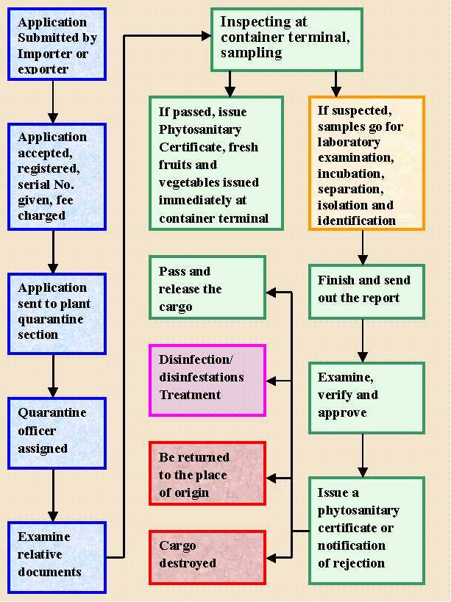

6.2 Practices and procedures for the Import Inspection and Certification (Issuance of Entry Permit and Release Order) of Plants, Plant Products and other regulated articles into Nepal
(General Import Inspection Procedures and Techniques for Plant Health)
There are a number of procedures and techniques that are common to all plant health inspections and these have been divided into several steps. When conducting an inspection, an inspector should follow the general steps for plant health inspection, along with the procedures and techniques that pertain to the specific commodity being inspected.
Step 1: Review of consignment's import documentation
The types of information that are necessary to complete a plant health import inspection include:
- location of the consignment,
- description of product including any required scientific or common names of the plant or plant product to be inspected,
- size of the consignment,
- type of consignment (i.e. commercial or non-commercial),
- status of consignment (i.e. imported for use in Nepal or in-transit),
- origin of the plant or plant product (i.e. where it was grown or harvested),
- end use
If the documentation cannot be brought back into compliance, the consignment must be ordered removed from Nepal or destroyed.
Step 2: Confirm that inspection is required
Determining whether or not an inspection is required for a particular consignment will depend on a number of factors, such as:
- the type and origin of the commodity being imported,
- existing monitoring programs, border lookouts and blitzes in effect,
- Operations work plans, and,
- biological and environmental considerations.
If no inspection is required, this should be noted and the activity ends.
If an inspection is required, a Notice to Importer is issued by the inspector, where necessary, to inform the owner of a consignment, or his agent, that the commodity to be imported:
Step 3: Preparing for an inspection
Before going out to inspect a consignment, the inspector must review inspection requirements for the commodity including potential pest issues. The equipment and documents required to complete the inspection should be collected.
Step 4: Reviewing inspection and import requirements
An inspector should review both the inspection procedures for the commodity as well as the import conditions/requirements listed on the Permit to Import. For example, a permit may specify a place to which the material must be shipped for inspection prior to further distribution. Material must not be moved to any place other than that specified and must remain intact and unopened until given consent by the inspector. In situations where material has been moved to a location not specified on the Permit to Import, the inspector may take a number of actions against the importer ranging from a verbal warning to regulatory action.
Documents and equipment needed for an on-site inspection may vary depending on the commodity to be inspected, the life stage of the pest(s) of concern, the type of samples that need to be drawn, etc.
Step 5: Selecting an inspection area
In order to conduct an effective inspection, it is important to have the proper work conditions. Inspections must occur in an area where the inspector is not at risk from vehicles, forklifts, and stacked cargo. Whenever possible, the inspection should occur where there is protection from rain, wind and other adverse conditions. An adequate area with a work surface of appropriate dimensions and height is required. Adequate lighting is required to see small pests that might be present on the commodity.
Step 6: Consignment identity, integrity and condition
The verification of the identity, integrity and condition of a consignment involves doing a visual check of the imported material to ensure that it is accurately described by its documents and is in adequate condition for inspection. The material in the consignment must match the accompanying documentation. Particular care must be taken to note any discrepancies. Sometimes an exporter will add more plants or plant products at the last minute or will substitute some plants or plant products that aren't included on the Permit to Import or Phytosanitary Certificate. Inspectors must be aware that this can occur, investigate the cause and take appropriate regulatory action.
Step 7: Selecting inspection units
It is not possible for an inspector to inspect every plant or plant product that enters Nepal, therefore, inspection units must be selected from consignments or lots within consignments in order to determine their compliance with phytosanitary import requirements. The method of selecting inspection units will depend on the nature of the commodity to be inspected.
Step 8: Inspect the consignment
Depending on the nature of the inspection activity, each inspection unit should be examined until all the units have been inspected or until a pest or pests of concern have been detected. Inspection should continue even after pests of concern are found where there is need to confirm the identity of the pest or to collect additional information on the pests. In this case, the number of pests detected or the percent infestation should be recorded.
If an inspector suspects that a consignment contains a quarantine or regulated non-quarantine pest, the first step is to take control of the consignment and initiate action to prevent the spread of the organism or dispersal affected material.
It may also be necessary to examine additional units. Examples include further inspections for a particular pest when signs or symptoms are observed, checks as to the degree of infestation by a regulated non-quarantine pest, or examination of additional units to determine whether or not a required treatment (e.g. fumigation) has been effective.
The inspection procedure should allow for the detection of specific regulated pest(s) on or in the commodity and for detection of other organisms that may be of potential concern. For example, using a hand lens of at least 10X magnification facilitates the detection of small organisms and signs of their activity. All senses should be used while conducting the inspection.
The signs and symptoms of plant pests that may be observed during an import inspection depend on the commodity being inspected and the specific pest(s) present. The inspector should be familiar with the signs and symptoms of specific regulated pests before conducting an inspection. In addition, inspectors should look for general signs and symptoms of diseases and infestation.
Step 9: Collect and prepare samples for testing or identification
In many cases, pests or signs of pests that have been detected may require identification by a specialist before a determination can be made on the phytosanitary status of the consignment.
It is important that samples are correctly taken and identified and that their integrity is maintained. It may be necessary to place the consignment under regulatory control and ensure that it remains intact until the laboratory results are obtained and it has been determined whether or not the consignment requires further regulatory action.
Step 10: Determine inspection outcome and take appropriate action
There are a number of possible outcomes that can arise as the result of an inspection, depending on whether or not the consignment is in compliance with the Plant Protection Act and Regulations and the nature of the potential or actual non-compliance. It is important that all relevant documentation is collected and that the inspection results and any required follow-up actions are recorded in a clear, complete, concise and accurate manner as this information can be used to support a compliance decision as well as a Notice of Non-Compliance.
If an inspector suspects that a consignment contains a quarantine pest or a regulated non-quarantine pest, the first step is to take control of the consignment and initiate action to prevent spread of the organism or the dispersal affected material.
If a consignment is inspected and found to be in compliance with phytosanitary import requirements, the inspector notifies the importer and records this information. No further action is required by the inspector.
If the non-compliance is confirmed, care must be taken to prevent the spread of the pest and contamination of compliant materials. The consignment must be ordered removed or destroyed. It may be necessary to treat the consignment before removal in order to eradicate the pest. If the consignment is found to be in compliance, the importer must be informed and the results should be recorded. No further action is required.
Step 11: Complete appropriate inspection and regulatory documents
Complete and accurate notes are a crucial component of the inspection process. Therefore, it is essential to be very precise about matters such as:
- Dates | - Times of day | 3 Addresses
4 Names | 5 Weather conditions, if applicable | 6 Lot numbers or other identifying marks
7 Phytosanitary certificate numbers | 8 Nature of the commodities inspected (including scientific names where applicable) | 9 Type of packing material
10 Quantities, including number of units inspected | 11 Origin of consignment | 12 Pests found and samples taken
13 Treatments called for following inspection and procedures to ensure that treatments have been completed effectively | 14 Arrangements for re-inspection, when necessary | 15 Any other details considered necessary or pertinent

Figure 3: Practices and procedures for the issuance of Entry Permit of Plants, Plant Products and other regulated articles into Nepal (pursuant to Rule 5 of Plant Protection Regulation, 2010)
Re -submission
Rejection to issue Entry Permit
Notification to Applicant

Compliant to Requirements
Record keeping

Issuance of Entry Permit

Non-compliant to Requirements
Examination and verification of Documents
Registration of Application
Application Received

Non-compliant to Requirements

Documents Required:
(a) A copy of the citizenship certificate or passport of the importer,
(b) A copy of the certificate of registration of body and renewal thereof if import is intended to be made in the name of such organization,
(c) A copy of the pro forma invoice of the organisms to be imported,
(d) Recommendation of the Seeds Quality Control Center if an import of seeds is made,
(e) If an import is made for the purpose of research, a request letter of the researcher person or organization and recommendation made by the Nepal Agricultural Research Council.
Fee Required: NRs 200
Figure 4: Practices and procedures for the renewal of Entry Permit of Plants, Plant Products and other regulated articles into Nepal (pursuant to Rule 6 of Plant Protection Regulation, 2010)
Documents Required: Application with previous documents/Permit
Rejection to renew Entry Permit
Notification to Applicant

Compliant to Requirements
Record keeping

Renewal of Entry Permit

Non-compliant to Requirements
Examination and verification of Documents
Registration of Application
Application for Renewal
Fee Required: NRs 400
Figure 5: Practices and procedures for the issuance of release order for Plants, Plant Products and other regulated articles into Nepal (pursuant to Rule 7 of Plant Protection Regulation, 2010)

Treatment impossible
If Laboratory testing is not required
If Laboratory testing is required

Re -submission
Incomplete documents
Consignment without regulated and live pests

Treatment possible

Rejection of consignment

Treatment

Consignment with regulated and live pests

Notification to Applicant

Complete documents
Submission of filled declaration form
Sampling of consignment
Examination and Verification of documents

Inspection
Laboratory testing
Inspection and Laboratory report
Issuance of Release Order
Record Keeping

Documents Required:
(a) The import entry permit obtained from Nepal
(b) The documents as required to issue entry permit are also required
(c) The phyto-sanitary certificate issued by the country exporting the goods
Fee Required: Not Required

6.3 Declaration of pest freedom in an area
Declaration of pest free area is one of the obligations made during the accession to WTO/IPPC that to be fulfilled, but till Nepal is unable to do so. Also might be the necessary obligation for export of plants and plant products. The general procedure for declaration of PFA is included in Figure 6. For any specific procedures, NPPO should decide through its meeting.
Figure 6: Declaration of pest freedom in an area
Pest Detected
Suggested for corrective actions
Notification to Applicant

Pest Not Detected
Record keeping

Declaration of freedom

Survey and surveillance and field monitoring
Meeting of NPPO
Application received to declare pest freedom
Formation of technical team
Report to NPPO meeting
Notification to Contracting parties

6.4 Eradication of pest and pest free area declaration
When any regulated pest is detected in any area and is required to be eradicated to declare freedom of the pest NPPO may follow the following procedure. For this, NPPO may develop the specific technical guideline for specific regulated pest. Other administrative matters should be decided through the NPPO meeting as per the local requirement.
Figure 7: Eradication of pest and pest free area declaration
Pest Not Detected
Record keeping

Declaration of freedom

Monitoring Survey
Meeting of NPPO
Application received to Eradicate quarantine pest
Formation of technical team
Reportto NPPO
Notification

Identification and implementation of management options

6.5 Inspection and Testing Methods

Another service delivery of NPPO is inspection and testing of the consignment or the any plant and plant product for the presence of regulated pest. It will also be carried out to provide the phytosanitary certificate for export of plant and plant products.
NPPO should develop the procedure manual for each of the methods as required. The general procedure may be included as flow chart given below.

Figure 8: Inspection and Testing Methods

6.6 Pest Surveillance, Database Preparation and Pest Risk Analysis
The provision of official information regarding pest status is an obligation under the IPPC. The reliable pest records or information and the determination of pest status are vital components in phytosanitary trade. We have to prepare pest database through pest surveillance and conduct pest risk analysis (PRA) to comply with import regulations, meet requests for information from other countries for the purpose of PRA on pests in their territory; and all other countries for PRA purposes, national, regional or international pest management planning, establishing national pest lists, establishing and maintaining pest free area, GIS mapping of pest distribution of the country, and ensuring early detection of introduced pests. Pest Database is an electronic documentation of pest status information on pest survey activity & pest status, data collation, pest records on the basis of many sources as surveys, findings of general surveillance, scientific publications, journals etc. The information on the status of a pest in areas, countries and regions may be used to establish the global distribution of a pest.
To provide these services, NPPO may follow the procedure and practices as described below in the figure 9.

Figure 9: Procedure and practices for Pest Surveillance, Database Preparation and Pest Risk Analysis

6.7 Practices of Quarantine treatment
NPPO may follow the one of the following methods as quarantine treatment according to the pest, volume, time availability. If treatment is not possible, rejection of consignment or distruction of the consingment or plant and plant products is carried out. (Figure 10)
Figure 10: Quarantine treatment.

.

7 Organizational and Institutional Frameworks
The most widely used definition is the one propounded by North (1993), who pithily described institutions as “rules of the game” and organizations as “the players”. Institutions exhibit a formal nature (rules, regulations, laws, rights, etc.). Organizations, on the other hand, refer to a group or association, formal or informal, in which there are defined and accepted roles, positions and responsibilities structured in some relationship to each other in order to achieve a specific objective(s). Infrastructure refers to the basic conditions (facilities and technology) that allow an organization’s work to proceed.

7.1 Institutional Structure framework
Institutions involve a range of areas such as normative structures, culture, legal frameworks, policies and trends. Institutions are recognized as important elements underlying all social, organizational and even individual processes of change.
One of the important obligations of the CP to IPPC is to establish and administer a National Plant Protection Organization (IPPC Article IV). Nepal has designated the PPD as the NPPO. In view of the scope and area Plant quarantine the present issues in relation to the establishment of NPPO faced are the organizational structure and its administrative placement so that it can function smoothly without any administrative and hierarchical hassle for plants and plant products dealt in agriculture and forestry. However, NPPO being connected to the global system of agro-forest trade, a multi-stakeholder approach in managing invasive alien species is considered the most effective way. It has been accepted that NPPO therefore should collaborate with all relevant stakeholders that include environmentalist, researchers, regulators, policymakers, universities, private sector and civil society in managing invasive alien species. Without appropriate institutional set up with its clear roles and responsibilities and law enforcement it is impossible to achieve NPPO’s mission in plant protection sector. Further the import/export phytosanitary requirements of all WTO member countries need to comply not only with IPPC and SPS Agreement provisions but also with the Convention on Biological Diversity (CBD), adopted in 1992. Most of the measures of the CBD focus on the conservation of ecosystems; however, two aspects concerning the conservation of biological diversity are relevant for bio-safety - the management of risks associated with LMOs resulting from technology and the management of risks associated with alien species. The Institutional Structure framework of NPPO is shown in Figure 11.
The current institutional structure of phytosanitary controls in Nepal is fragmented. An NPPO has been formally established in Nepal as required by Article IV of the IPPC. The responsibility for phytosanitary controls and the application of phytosanitary measures against the introduction and spread of harmful organisms are shared by a number of institutions. These are:
Stakeholders of NPPO-N
1.MoAD | 7. DoF | 13. Entry Points: RPQOs, PQCPs, PQSCPs
2. SPS Committe | 8. DPR | 14. PRMS
3. DoF and DPR | 9. VDC, DDC, Municipalities/Sub-municipalities | 15. NARC /Research organizations & Institutions
4. MoSTE | 10. AEC | 16. Commodity Associations and Federations
5. DoA | 11. PPD | 17. Various I/NGOs
6. DoC | 12. NPQP | 18. Different Universities
19. ANSAB | 20. TEPC

    - Ministry of Agriculture and Development for the formulation and approval of quarantine policy, national phytosanitary standards and enforcement of plant quarantine regulations. Furthermore developing coordination mechanism and linkage among relevant ministry, trading partners and regional / international organizations to access country’s phytosanitary information for export promotion
    - Ministry of Commerce & Supplies for bilateral & multilateral agreement in promoting safe agriculture trade with trading partners
- Ministry of Science Technology & Environment for the conservation of biological diversity aroused by the risks associated with LMOs, GMOs resulting from biotechnology& pesticide degradation in the environment.
    - The Department of Forests and Soil Conservation for coordinating regional, district and local bodies for regulating the internal quarantine and for maintaining the PFA. The main mandate of DoF is to manage the country’s forest resources for the conservation of the natural environment and to supply the forest products to the people. The department focuses on protection, management and utilization of forests and conservation of natural resources, planning, implementation and coordination of forestry development activities.
    - Department of Plant Resources for developing import requirements and conservation of Non-Timber Forest Products (NTFP) and CITES. The Department conducts and provides services in the field of research and development of plant resources in Nepal.
    - Department of Customs for effectively implementation of the phytosanitary regulations in border points
- Ministry of Commerce and Supplies, Trade and Export Promotion Centre
The centre merged three organizations; Trade Promotion Centre, Export Promotion Board and Carpet & Wool Development Board with the objective of promoting foreign trade in general and export trade in particular of the country. The centre works to advise the Government of Nepal in formulating for the development and expansion of trade and export and contribute to the strengthening the national economy by developing and expanding trade and export of the country. Among other functions the centre implements appropriate programs to attract investment at the national and international level for export- oriented and import management project and acts as information pool by collecting, disseminating and publishing useful trade-related information.
- Local Self Government Act 2055 and Regulations 2056 has given independent status to local bodies like Village Development Committees (VDC), Municipalities/Sub-municipal corporations/ Municipal Corporations and District Development Committees (DDCs). Local bodies have their own program, budget and resources. They have mandate of formulating and implementing agricultural programs at local level and managing human resources.
    - Agri-Enterprise Centre to expand and strengthen market oriented private sector driven enterprises eliminating trade barriers facing the flow of agricultural products to foreign markets.
    - NARC for developing national pest/host list, pest diagnosis, conducting PRA, verification of PFA maintenance, research in pest eradication of exotic/quarantine pests
- Plant Protection Directorate to prevent the introduction of exotic pests in the country and to prevent the further spread of existing plant pests in infested areas to pest-free areas.
- National Plant Quarantine Programme to facilitate safe global trade in agriculture by implementing trade related phytosanitary obligations& assisting producers, exporters and importers and by providing technically comprehensive and credible phytosanitary certification.
- Entry points as RPQO, PQCP, PQSCP to implement appropriate phytosanitary measures on imported/exportable consignments (clearance, rejection, re-export, destruction, treatment).
- Seed Quality Control Committee to coordinate all stakeholders of the seed industry and to advise the MoAD on policies and issues related to the seed sector.
- Pesticide Registration and Management Section enforces the pesticide regulation & circulars safe pesticide application in the commodities
- SPS Committee in protecting animal, plant and human health; promoting safe foods for the domestic and export markets; and facilitating trade between the Nepal and its trading partners.
- Different universities which have mandate of teaching are providing the higher education together with mandatory research work. These universities have plant protection studies, researches and laboratory facilities.
- Commodity Associations and Federations for the development of private institutions in trade sectors. Organized private sectors like Federation for Nepalese Chamber of Commerce and Industry (FNCCI), Farmers Associations, unorganized private sectors and farmers are involved in agriculture production and trade. Amateur institutions and professional societies like Agricultural Associations;
- Plant Protection Society Nepal is working in their respective fields.
- Various I/NGOs are working and gaining the experience in the field of Plant Protection and Agriculture. In sum up all these organizations, institutions, agencies have direct and indirect bearings in the tasks of NPPO.
- The Asia Network for Sustainable Agriculture and Bio-resources (ANSAB)
Community empowerment and economic incentives is placed at the heart of its approach, believing that as people benefit from natural resources they become more motivated to protect them. ANSAB implements a variety of innovative solutions by working for the creation of enterprises based on the sustainable use of natural resources, especially Non Timber Products (NTFPs) and the establishment of payment-schemes for ecosystem services, especially Reducing Emissions from Deforestation and Forest Degradation, Forest Conservation, Sustainable Management of Forests and Carbon Stock Enhancement (REDD+). The work is carried out in the context of global climate change, which continues to threaten the environmental and economic progresses achieved so far- in Nepal as in the rest of the world.
Therefore, they should be recognized as stakeholders of NPPO-N.

7.2 Major thrust of NPPO
There is a trend to develop and use risk-based principles of risk assessment, management and communication involving a multi-layered, pro-active approach, rather than having sole reliance on border inspection. Strong organizational structure and supportive institution is needed to achieve the overall objectives.
In practice the work is central to facilitate trade in line with WTO SPS Agreement. Principle of transparency is duly considered in WTO SPS Agreement. National legislations, Organizational set up, working modalities are developed in maintaining plant health. In Nepal major work in phytosanitation is guided by Plant Protection Act 2007 and Regulation 2009. Plant Protection Directorate is NPPO and National focal point to IPPC. NPQP is certificate issuing agency, SPS Enquiry Point, National Notification authority are in front line to execute the function as envisaged by IPPC new revised text 1997

Figure 11: Institutional Structure framework of NPPO

CBD
MoAD
(Notification Authority)

IPPC/ RPPO/ APPPC

WTO /SPS

SPS co-ordination Committee
NPPO

Plant Quarantine Committee

DFTQC (SPS focal point)
Research Institutes

Commodity Associations

Universities

DADOs
DOA (SPS implementation Committee)

Traders/Farmers Farmers

5 RPPLs

PRMS

NPQP

PPD

5 RPQO

7PQCP/ 3PQSCP

Ministry of Forest & Soil Conservation

Ministry of Commerce &Supplies

NARC

SQCC

AEC

Dept of Customs

Department of Plant Resources

Ministry of science technology & environment
Department of Forestry

7.3 Administrative and Organizational Structure of NPPO
As organizations specialize their functions and the infrastructure required to maintain and carry out those functions, they require greater interdependence with the various work groups. In other words, specialization increases complexity. The way an organization transforms its resources into results through work processes is what people call “systems.” Organizational capacity is the ability of an organization to use its resources to perform. If the Organization itself is the unit of analysis, all of the resources, systems and processes that organizations develop to support them in their work can be assessed. Organizations are not only composed of individuals, but also interdependent groups with different immediate goals (derived from specialization), different ways of working, different formal training, and even different personality types. Every organization should attempt to meet its goals with an acceptable outlay of resources while ensuring sustainability over the long term. “Good performance” means the work is done effectively and efficiently and remains relevant to the stakeholders. It involves the division of labor, including roles, responsibility and authority, as well as the coordination of labor into units and inter- and intra-unit groupings.
Formalized entities involve a cluster of people who are brought together for a common purpose in the organization. Organizations both conform to and influence institutions. They include a wide spectrum of human activity and can be categorized as private or public, for-profit or non-profit, governmental or non-governmental, and so forth. Organizations have a structure (i.e. functions). Organizations do not exist in a vacuum. Each organization is set in a particular environment that provides multiple contexts that affect the organization and its performance.
The streamlining of NPPO administration has become imperative to cope with the increasing demand of international trade & also to protect plant biodiversity from the exotic pests associated with imported commodities. Plant quarantine operations in Nepal are carried out by the PPD and NPQP, which functions under the aegis of the Ministry of Agriculture Development. For minimizing those phytosanitary issues, Plant Quarantine Regulations are operative in Nepal through the Plant Protection Act, 2007 & Plant Protection Regulation, 2010.
Fifteen Plant Quarantine entry points (5 RPQOs, 8 PQCPs and 2 PQSCP) have been established for phytosanitary border controls. The collaboration between the different stakeholders and their official Plant Protection Services is shown in the organization chart below. Enquiries regarding technical/scientific phytosanitary matters in general, pest reports from Nepal and interceptions of specific consignments should be addressed to the NPPO.
The administrative structure of plant quarantine is shown in the organizational chart (Figure 12).

Figure 12: Administrative and Organizational Structure of NPPO

IPPC / RPPOs, APPPC
Ministry of Agriculture Dev DevDevelopment

Plant Quarantine Committee
Serves as a channel of communication between NPPO& related institutions & commercial farmers/traders on phytosanitary measures

NPPO
Acts as Secretariat to the PQ Committee;
Enforces the phytosanitary regulations of the country.
Participates in bilateral, multilateral and international quarantine agreement negotiations;
Administrative and decision mechanisms
Accredits importers and quarantine treatment private service providers;
Maintains International Phytosanitary Portal;
Undertakes phytosanitary capacity evaluation
Supervises and coordinates the agro-forest trade
Undertakes consultations on PQ matters;
Responsible for compliance to obligations under the IPPC &APPPC/SPS pest categorization, pest reporting, etc

Co-ordination with relevant authorities
- Research Institutes
- Universities
- DADOs
- NGOs
- Traders Association/ Federation
- Farmers

Unit
- NPPO
- IPM
- PRA
- PFA
- Survey
- Monitoring
- Emergency Action
- Technical panel

PPD
Plans, formulates &reviews programs
Administrative supervision over PQ staff
Monitors PQ activities
Undertakes surveillance of proposed pest free areas
Establishes PFA & ALPP

PRMS
-Enforces pesticide regulations, procedures & guidelines
-Registers & checks the indiscriminate use &application of pesticide in agricultural crops.
-Monitors the level of pesticide residues in local, exportable and
Imported agricultural crops;
-Provides analytical services for residues in commodities.

5RPPL
Determine and evaluate practices on the use of pesticides
Undertakes grow-in and post entry monitoring
Pest identification, survey & control
NPQP
-Implements PQ regulations to prevent the introduction of foreign pests and further spread of such quarantine pests that are already present in the country;
-Facilitates safe trade of plants and plant products;
-Issues import permits, domestic permits and phytosanitary certifycate
-Perform PQ training, data gathering and data processing.

2 PQSCP
Undertakes phytosanitary inspection

8 PQCP -Undertakes phytosanitar y inspection
-Issues PC,&
Commodity
Clearance

5RPQO
-Undertakes phytosanitary inspection
-Issues PC, -commodity
Clearance and domestic
Quarantine permits

Figure 13: Organizational Arrangements of Plant Protection

7.4 Technical Panel and Expert Working Groups
The implementation of SPS measures is challenging in any context, and requires country to have a certain level of capacity. Gaps in capacity can cause ineffective and inefficient implementation. Measures to protect plants are based on scientific principles with sufficient evidence. The managerial and operational roles of NPPO are always of multidisciplinary nature. NPPO should be constituted with Technical Panels and Expert Working Groups to meet the SPS measures. NPPO should strengthen their focus on implementation modalities for SPS measures. Relevant member of the technical panel coordinates with all the stakeholders to form "specific task working group".
Technical Panel
In order to verify the functions of different working groups, an efficient technical panel should be constituted within the NPPO Secretariat. NPPO will call all or some members of technical panel for required duration to support, collaborate or verify the works done by the working groups. Technical panel will meet as and when necessary. NPPO, as per the need of the hour should assign technical panel specific tasks to be performed. The related institutions should be given a freedom to select the expert to be sent to the NPPO, but the experts should be registered in the expert's roster of NPPO. Upon receiving the formal letter regarding demand of expert from NPPO, related institution should nominate the expert to the technical panel. While working as the member of the technical panel, each member should be provided with some recognition card or ID card. The card holder should have right to access any of the relevant data from any of the relevant institution. The report is communicated by NPPO secretariat with the help of NPPO unit to related contracting party or stakeholder via email/ formal letter.
The suggested TP will be as under:
1. Technical Panel on Phytosanitary Measures
2. Technical Panel on quarantine pests for forest
3. Technical Panel on Phytosanitary Treatment
4. Technical Panel on PRA Development
5. Technical Panel on PFA
6. Technical Panel on Phytosanitary Inspection
7. Technical Panel on Biological Control Agents
8. Technical Panel on Diagnostic and Quality Assurances
9. Technical Panel on Pest List Development
Expert Working Groups
This directive assumes the specific working groups as the backbone of NPPO. Based on requirement and nature of the activity to be performed, members of technical panel shall form different working groups. The member of working group is not necessarily being the member of technical panel. Each EWG will be constituted by the NPPO under the chairmanship of one of the relevant members of the technical panel. The size and the members of the working group will be decided by the panel according to the nature of task. The members will be selected from relevant institutions. The NPPO will make formal MOU with relevant institutions for technical collaboration. The meeting of EWG will be held as and when necessary. The working groups may be of different nature, for example:
- Open ended working group for big task like mass awareness campaign,
- Strategic planning group,
- Survey group,
- Risk analyst's group,
- SPS database management group,
- Negotiation group,
- Extension group,
- Awareness group,
- SOP group,
- PFA group,
- Reference specimen maintenance group,
- Pest diagnostic group,
- Forest pest survey group,
- NTFP pest survey group,
- Pest reporting group,
- Dispute dealing group,
- Advertising group etc.

7.5 Organizational/institutional set-up and working pattern of some major countries and neighboring countries
All countries have their own organizational and institutional structures and frameworks as per the need of country. No two organizations are alike. Each has a distinct history, vision and mission, culture, and incentive and reward system. Organizations vary in a number of ways.
Working Modalities
IPPC is the focal standard setting body in plant health management. It has expert working group, technical panel and standard committee in setting phytosanitay standards. APPPC work in plant protection is not limited only in plant quarantine but also in pesticide management, IPM and other discipline of plant protection. In Australia the Australian Government Department of Agriculture, Fisheries and Forestry (DAFF) serves as NPPO. It has two divisions – Plant Division and border compliance division. Plant division deals with plant biosecurity, plant helath policy, Plant Quarantine operation and plant export operation. In Newzealand Ministry of Primary Industry is designated as NPPO. It works under the Bio-security Act 1993. NPPO deals with import and export, surveillance and control programme for pests of National importance. In USA United States Department of Agriculture (USDA) – Animal and Plant Health Inspection Service (APHIS) serves as NPPO. APHIS is involved in protecting and promoting US agricultural health, regulating genetically engineered organisms, administering the Animal welfare Act and carrying out wildlife damage management activities. Local government is involved in surveillance and control of pest of local importance. Other public and private organizations do the pest surveillance and control programmes for pests of interest to their organizations. In India NPPO works for plant quarantine, IPM, Locust control, Central Pesticide Board & Registration Committee. It covers both import quarantine, domestic quarantine. In China - three administrative organizations are responsible for the NPPO work, i.e. Ministry of Agriculture (MOA), General Administration of Quality Supervision, Inspection and Quarantine (AQSIQ) and State Forestry Administration (SFA).

The Organizations of the plant protection service in different countries are given in Annex 1-8 as examples of the structure.

7.6 Members in the NPPO (Proposed)
The NPPO shall consist of the following members, namely:
    - Program Director of Plant Protection Directorate of DoA Chairperson
    - Representative, International trade Promotion Section,
Agri-business Promotion and Statistics Div, MoAD Member
    - Representative, SPS Enquiry Point, DFTQC Member
    - DDG, Planning, DoA Member
    - Representative, Department of Plant Resources Member
    - Representative, AEC, Federation of Nepal Chamber of Commerce
and Industries Member
    - Chief, Entomology Division, Nepal Agriculture Research Council (NARC) Member
    - Chief, Plant Pathology Division, NARC. Member
    - Representative, Directorate of Agri-business Promotion and Market
Development of DoA Member
    - Pesticide Registrar, Pesticide Registration
and Management Division Member
11. President, Nepal Agricultural Federation, to be nominated
by the Government Member
12. Chief, Trade and Export Promotion Centre Member
- President, Forum for Protection of Consumers/ National
Consumers Forum, to be nominated by the Government Member
- One Pesticide Expert to be nominated by the Government Member
- Chief, National Plant Quarantine Programme of DoA Member Secretary

The experts of various institutions/organizations may also be invited for consultations in NPPO. The NPPO may nominate more members listed in the NPPO Roaster in the meeting as per the requirement. The persons nominated shall, unless their seats become vacant earlier by resignation, death or otherwise, hold office for three years from the date of their nomination but shall be eligible for re-nomination.

7.7 Existing Members in the NPPO
1. Program Director, Plant Protection Directorate of DoA Chairperson
2. Representative, WTO Section, MoAD Member
3. DDG, Planning, DoA Member
4. Representative, Department of Plant Resources Member
5. Directorate of Vegetable Development of DoA Member
6. Directorate of Agri-business Promotion and Market
Development of DoA Member
- Entomology Division, NARC Member
- Plant Pathology Division, NARC Member
- SPS Enquiry Point, DFTQC Member
- Pesticide Registration and Management Division Member
- Agri-Enterprise Centre Member
- One person to represent the Agriculture and Forestry University,
to be nominated by the Government Member
- Two experts in related field Member
- Chief, National Plant Quarantine Programme Member Secretary

7.8 Meeting of the NPPO

The meetings of the Committee shall be held at such place, time and date as may be specified by the Chairperson. The NPPO members will meet as and when required but at least once in each quarter of the financial year. The decisions of the Committee shall be authenticated by the member secretary.

8 Policy and Legal Aspects

The capacity of efficient NPPO is measured in terms its knowledge, functions and the ability related to plant protection measures to facilitate traders, producers, civil society, consumers, other government bodies, and the general public to protect plant resources and enhance trade and finally contribute to improve crop yields, enhance food security, trade and economic developments. All the functions NPPO perform broadly falls under technical, legal and administrative management (www.phytosanitary.info).An efficient NPPO always maintains cordial relationships with its stakeholder maintaining its decision-making role and operational responsibility at policy and operational levels to achieve its objective.
NPPO while discharging its authority and responsibilities with legal basis should consider the Article IV of the IPPC. Depending upon the situation, NPPO has also to observe other measures (including prohibitions) concerning imported commodities and other regulated articles, and take necessary actions when incidents of non-compliance or incidents requiring emergency action are detected. In this context, member countries of the WTO SPS Agreement have agreed to harmonize sanitary and phytosanitary measures as wide a basis as possible. IPPC approved 36 ISPMs, to assist NPPOs for implementing fundamental activity as part of the responsibilities as mentioned in ISPM 1,5, 6, 8, 11, 18,19,21,24,25,26,31,33,35.

8.1 Review of the existing policy and legal authority

8.1.1National Context
National Agriculture policy recognizes the opportunities for economic development through commercialization of agriculture. Efficient and appropriate Quarantine services are essential for enhancing trade considering international requirements on Phytosanitary measures, (National / International). Thus NPPO’s capability needs to be strengthened in order to maintain the high quality of agricultural products during the movement in international market.
Legal authority of NPPO-N is prevailing as specified in article 6 of the Plant Protection Act, 2007 and Plant Protection Regulation, 2010 which states that Government of Nepal with the Power specified by Legislature-Parliament in “The Plant Protection Act 2007“The Government of Nepal may, by notification in the Nepal Gazette, designate any central level office related with plant protection as the National Plant Protection Organization. At present PPD has been designated to work as NPPO and also as focal Institutions for IPPC.
Areas covered under the Plant Protection Regulation are as follows.
- Prescribe standards required to be observed in carrying test, treatment of plants or plant products, establishing post entry quarantine facilities, area of low pest prevalence and establishing laboratories or treatment rooms to be established by the private sector,
- Make recommendation to the Government of Nepal for the validation/accreditation of laboratories which are established by the private sector to carry out test, treatment or research of plants or plant products and meet the standards as referred to in clause (b)
- Encourage research and studies to mitigate risks likely to occur on plant or plant products from the entry of living modified organisms, genetically modified organisms or transgenic substance,
- Encourage also the private sector to carry out activities relating to post entry facilities, test centers, laboratories and treatment procedures,
- Get approval and enforce the good agriculture practices in order to encourage quality products for the promotion of exports.

8.1.2 International Context
- The Plant Protection Act and Rules compatible with CBD. The CBD imposes obligations on member states with regard to invasive alien species. Article 8(h) of the CBD requires each contracting party to “prevent the introduction of, control or eradicate those alien species which threaten ecosystems, habitats or species.” Since most invasive species can be categorized as plant pests, the CBD reinforces governments’ responsibility to address these threats.
- The New Revised Text applies to the protection of both cultivated and natural flora and includes seeds and germ plasma. Nepal Plant Protection Act 2007 lack to clarify the potential impacts of plant pests on the environment and addresses the import and use of LMOs that may directly or indirectly effect plants or other organisms. The New Revised Text emphasizes cooperation and the exchange of information on plant protection, and formalizes the IPPC Secretariat. The text also identifies new phytosanitary concepts, such as pest risk analysis, the designation of pest free areas and the phytosanitary security of export consignments after certification. Plant Protection Regulation 2010 has not clearly specified responsibility of the NPPO after certification.
- Phytosanitary legislation belongs to the realm of agriculture and its implementing institutions naturally should have an agricultural background. While trade issues are inevitably a concern of other Institutions also, it should be sufficient for a technical institution such as the NPPO to ensure that its phytosanitary requirements and phytosanitary measures are technically applied by all. Compliance with purely international trade-related criteria, such as minimal impact and non-discrimination, should be monitored by the national institutions that are responsible for international trade with appropriate level of specific expertise.
- NPPO should decentralize some responsibilities and the devolution of powers to relevant stakeholders and ensure all stakeholders participation in decision making process regarding their regulatory needs and staffing and other resource. However it is to be remembered that the IPPC requires one single government authority to be assigned certain core responsibilities for phytosanitary controls. But it should be possible for a government to allow local authorities to exercise some of those responsibilities and need to be legally authorized to NPPO. NPPO should keep oversight functions vis-à-vis the decentralized authorities.

8.1.3 Policy and legal aspects of NPPO not cover by the Plant Protection legislation
- MoAD retain the power to review administrative decisions, the power to declare a phytosanitary emergency, to designate official laboratories or to add or remove a quarantine check post, but the recommendation for the decisions are made by the head of the NPPO. To this context, such consultation process needs to be formalized and incorporated in the Plant Protection Regulation, enumerating a requirement of consultation before making decision by the MoAD.
- Respective functions of NPPO head and stakeholders such as National Plant Quarantine program, District Plant protection Offices, Pesticide Registration and management Office, NARC, Academic Institutions, private service providers on SPS related matter and the legal basis for linkages among the stakeholders and NPPO should be clearly spelled out to avoid overlapping or gaps in the implementation of the Act.
- In view of the increasing volume of the trade existing Legislative Acts and regulation needs to be reviewed periodically depending upon the trade volume and as well as the changes made in the Phytosanitary requirements at international level. NPPO need to carry out PCE prior developing the national phytosanitary strategy and priorities as part of the regular responsibility of the NPPO.
- NPPO Structure and organizational standing needs to be clarified. It should have provision for support staffs in the NPPO secretariat along with experts’ panels with respective roles and responsibilities and accountability on Phytosanitary related issues. Phytosanitary related functions carried out from Ministry of Forest and soil conservation, Ministry of Finance, Research institutions and private organization at national level need to be linked with NPPO and it should be specified in Plant Protection Law.
- There is lack of accredited laboratories or other testing facilities at private level. Government mechanism to review and supervise the use of the mark and its application, inspection or monitoring and auditing procedures is weak. Thus NPPO should have authority for accrediting Pest diagnostic laboratory run by NGO, CSO or private body for providing pest diagnostics services only after having formal arrangements with laboratories or similar institutions in the country.
- NPPO do not have the authority for establishing the mandates, duties and responsibilities of all stakeholders' for pest surveillance and prioritize NPPO budget including the contribution of industry (private sector) to surveillance, maintain pest diagnostic laboratory at different development regions.
- When there is an emergency, NPPO should have an authority to involve all the concern stakeholders to address the emergency. Present Plant protection legislature do not speak on this matter
- NPPO is responsible to provide information on pest status from importing countries. Thus NPPO should have legal authority to have access to databases of plant pest records from other national and local government agencies, research institutions, universities, scientific societies (including amateur specialists), producers, consultants, museums, the general public, scientific and trade journals, unpublished data and contemporary observations.
- NPPO’ structural status should be as a high level advisories body to perform supervisorial and monitoring role to provide service for the country in the protection of plants and plant products. The NPPO should support the National Plant Quarantine bodies develop institutional framework both legal and administrative, necessary for effective plant protection and trade facilitation. Basically NPPO need to put especial focus to implement their international obligations with a view to facilitating international trade in plants and plant products. Plant Protection Act, 2007 does not clearly specify this aspect. NPPO should have authority to deal and settle the matter with the counterpart of the respective trading country.
- The NPPO should have a management system that ensures that all legislative and administrative requirements related to phytosanitary certification especially to:
- Develop legal mechanism to safeguards against potential problems such as conflicts of interest and fraudulent issuance and use of Phytosanitary certificates
- Have flexibility in NPPO scope to accommodate new concepts and procedures developed within the IPPC framework and national policies relevant to agriculture and natural resource development over time in areas such as: administration; audit and compliance checking; action on non-compliance; emergency action; authorization of personnel; and settlement of disputes. In addition, The NPPO while authorizing other appropriate government services, or non-governmental organizations, or persons to act on its behalf and under its control for defined functions provision for legal protection need to be defined in national legislation.
- Furthermore, following areas also need to be included into NPPO’s regular responsibilities through the Plant Protection Regulation, 2010:
- plants and plant products used for planting, consumption, processing, or any other purpose
- storage facilities
- packaging materials including dunnage
- conveyances and transport facilities
- potentially contaminated equipment
- In the existing Plant Protection Act, 2007 there is no provision of the delegation of public powers except to government officials. However in view of increasing trend in trade volume and specific commodities and the nature of work provision for outsourcing the private parties for laboratory services amendments in the current legislation need to be made.

8.2 Phytosanitary standards and Policies consideration
The relationship between research and extension institutions, trader’s groups and other relevant standard-setting organization may vary. In Nepalese case, it is suggested, NPPO be established as a high level advisories plant protection body and it should be made as a legal binding body to all plant protection related national institutions in relation to SPS matter. However its administrative command depending upon situation may not in them is binding to all stakeholders. But the institutions under NPPO in the country are encouraged to base their Phytosanitary related actions /measures related Plant protection and pest management as per the guidelines set by the NPPO.(for ref. only relationship between The North American Free Trade Agreement and the North American Plant Protection Organization (NAPPO), where the standards established by the latter have direct legal effect. At the other end of the spectrum, standards established by the European Plant Protection Organization (EPPO) are not binding on European Union members, although they are persuasive and are most often taken on board. In most cases, international treaties have no direct application at national level unless they are made effective through enabling national legislation).
- One important policy with implications for Phytosanitary regulation is the overall agricultural policy; followed by the environment, land use and trade policy. Thus, in Nepalese case NPPO need to be kept in loop while reviewing the Agribusiness Promotion Policy 2063, Agro bio diversity policy 2063, and National Seed Policy 2056 in relation to SPS activities. Some of the other specific areas where NPPO’s involvement is necessary include; Nepal – India trade treaty, Foreign Direct Investment on agriculture and agro-industries, Legal frame work off or plant variety protection, and Agreement on agriculture Market access and National commodities policies .
- In general, existing Act and regulation is comprehensive and for some years to come the provision made in the legislation is sufficient to carryout regular trade activity but concern is for its implementation and enforcement of the existing legislation. In some areas there is overlapping or confusion creating situation between NPPO authority and National Quarantine program and also in import and export inspection systems among the entities of the Ministry of agriculture, Custom and Home affairs authorities responsible for commerce or trade. Internationally the inspection of agricultural products falls within the ambit of the phytosanitary law enforced by Ministry of Agriculture Development. Conflicting scenario of responsibility implementing agencies for enhancing trade and commerce may cause their authority to undertake certain actions are open to legal challenge. To avoid this, it is crucial that boundaries be clearly identified in the phytosanitary law and that mandates, powers and responsibilities between the various regulatory authorities be delineated as clearly as possible. This may require amendment of legal instruments other than phytosanitary legislation in order to eliminate any overlap and to ensure the primacy of the NPPO in the phytosanitary area.
- Often food, agriculture, forests and forest products are confusing for the plant quarantine officials. They consider forest products as a separate area, distinct from agriculture and needs separate treatment, which in reality is not true. Thus it is recommended that as per the phytosanitary legislation the control of pests in food items, forest plants and seeds of forest species and the surveillance of pests in forest lands all these should be under the mandate of Plant Protection Act. NPPO. Close collaboration with and perhaps delegation to the forest experts will maximize effectiveness, although the NPPO retains ultimate responsibility for Phytosanitary control. Though the Nepalese Phtytosanitary law is comprehensive but, there are difficulties in its implementation because of lack of resources and the government’s ability to monitor the import and export of agricultural products, taking into account the fact that inspection services are often understaffed and lacking in basic infrastructure, including buildings, equipment and vehicles. In addition, laboratories do exist, but do not have the appropriate means to perform necessary analyses.
- Plant Protection Act also should permit the NPPO to be responsible agency to use not only its own employees but also employees of other authorities (public – or private, so long as there is no conflict of interest) in the enforcement of the law. The MoAD is the ministry assigned as overall enforcement authority under the law, but may have to rely on customs officers at border points for various matter.
- During an outbreak in the country, the law should permit the NPPO to issue a temporary ban on imports. However, such a prohibition should not be unduly prolonged or continue past the point where it is scientifically justified through pest risk analysis

8.3 Other Considerations
- Pesticide Act, 1991 regulates pesticides for registration, quality checking, labeling, storage, marketing and use and disposal of manufactured and imported pesticides. Pesticides are one of a number of pest control measures which the NPPO may have to impose in order to prevent the outbreak or limit the spread of a certain pest. An argument arises from time to time that phytosanitary issues and pesticides issues are intricately related and so NPPO need to be in loop with Pesticide related decision as pesticide contribute during the pest outbreaks and so pesticide equally contribute to the subside the emergency. Another area of overlap between pesticide management and plant health control is the pest management component of pest risk analysis. Thus a permanent mechanism of consultation between NPPO and pesticide registration and management office is required – for example through representation in each other’s institutions may be enough to guarantee efficiency and information exchange.
- Introduction and their use of LMOs are emerging issues. Plant Protection Act, 2010 has slightly specified regarding LMOs. The regulation of LMOs that are plants or plant products is part of the regular mandate of the NPPO, which has the power to approve or deny approval for the import of plants or seeds which are the products of biotechnology. But, because the assessment of LMOs focuses on non-target impacts and the propensity for traits to move to other related crops, the authorities responsible for environmental matters will have an interest in the regulation of LMOs as well. For permanent consultation on this issue NPPO should be authorized to form advisory body.
- NPPO should review carefully that the phytosanitary law should be harmonized with any other legislation in place newly emerging one that regulates some or all of the risk assessment for LMOs(e.g. a bio-safety law) and should eliminate overlaps in decision-making (e.g. between the NPPO and the authorities responsible for bio-safety).

- The Phytosanitary Capacity of any country is not static but it is changing. NPPO should be watchful that the international legal framework always supports to create enabling national framework for the implementation of international obligations dealing with SPS issues. The increasing volume of international trade in agricultural products compels to strengthen their controls and at the same time make them more transparent and reliable. In all of these tasks, NPPO has a role to play and it should be legally powered.

9 Internal and External System for Establishing Contact and Coordination

9.1 Coordination and collaboration between NPPO and non-NPPO bodies
Globalization of trade is recognized as a major factor contributing to the introduction and spread of species outside their indigenous distribution area. Import of living plants and plant products from other countries is a key entry pathway for exotic pest species. To prevent introduction and spread of alien pests that pose a risk to plant health, the government has implemented specific regulatory provisions.The Agreement on the Application of Sanitary and Phytosanitary Measures (SPS Agreement) of the WTO sets out the basic rules for food safety and protecting animal and plant health in the context of international trade. It permits WTO Members to protect their human, animal and plant life and health but seeks to minimize any negative effects of SPS measures on trade. The SPS Agreement recognizes that technical capacity to implement the SPS Agreement will vary and commits Members to facilitate the provision of technical assistance to developing countries, either through the relevant national and international organizations coordination or bilaterally.
Under the IPPC (i.e. Article VIII), each country is obliged to designate a contact point for the exchange of information connected with the implementation of the IPPC. In particular, countries are required to cooperate in the exchange of information on plant pests, such as the reporting of the occurrence, outbreak and spread of a pest that may be of immediate or potential danger. Pest reports and other relevant information should be submitted directly to these contact points, as these are the countries representatives established to communicate such information.
For NPPO a wide variety of representative stakeholders (from both public and private sectors) are identified. It is recommended that staff from the NPPO and, as far as possible, several non-NPPO representatives (from appropriate research institutes, agricultural universities, agro-industries or import/export associations, etc.) are involved in the application of the tool. An important additional objective is to enhance coordination among international organizations of different stakeholders. Communication between public and private stakeholders is essential to ensure a rapid response in the event of an emerging threat. This is also a good way of optimizing resources in view of the challenges facing plant protection. Such coordination and collaboration between NPPO and non-NPPO bodies would: (a) optimize the use of limited national funds; (b) better support policy makers through better access to data, strategically targeted research and better consultation; (c) encourage the development of phytosanitary research, including the establishment of national programmes in country where they currently do not exist; (d) better support the much larger phytosanitary science effort that develops and implements policy (e.g. diagnostics; inspection activities); (e) increase linkages between various disciplines; (f) increase potential research collaboration; (g) help maintain the high health status of plant-based exports.
Preparation of survey surveillance and pest database involves various government agencies and institutions- basically DPR, NARC and NPQP. Therefore, in order to facilitate and coordinate among government agencies and concerned stakeholders, NPPO should take a lead to initiate and carry out the activities.The NPPO is to facilitate the affect traders, producers, civil society, consumers, other government bodies, and the general public.
Better coordination and collaboration in the phytosanitary research area would help reverse the erosion of the scientific base and underpin the development and implementation of Plant Health policy to meet the challenges caused by increased bio-security threats and declining resources in the phytosanitary field.
The managerial and operational roles of NPPO are always of multidisciplinary nature. NPPO need to be strengthened in order to design and develop policy, norms setting, fund raising, endorsing the reports of Technical Panel and coordinating with related ministries and international organizations.
The diagnostic component of the network approach is the independent clearinghouse mechanism that provides pests and diseases identification and diagnostics. Not every stakeholder sees the need for the clearinghouse. All stakeholder groups are willing to contribute or at least say they are willing to assist to build information resources on trade information, market access issues, SPS compliance and pests and diseases. Extension officers at national level tend to interact with their peers from other countries to exchange information and learn from one another. Knowledge and information obtained this way is passed down to the district level. Communication with other local counterparts is minimal however.
9.2 Inter-Organizational Linkages
Linkages help the organization keep up with advances in pertinent fields, and give access to wide-ranging sources of up-to-date information within each area of the organization’s work. NPPO should ensure the effective and consistent application of phytosanitary legislation and regulations and compliance with international obligations. This may require operational coordination with other government services or government agencies involved with imports, e.g. Customs and other relevant concerned organizations. Administration of the import regulatory system should be coordinated at national level but may be organized on a functional, regional or other structural basis and may need internal departmental or ministry level decision to carry out the functions of the NPPO.
9.3 Co-ordination Mechanisms
As stated in Article 5 (C) of Plant Protection Act, 2007, Plant Quarantine Committee make coordination between the private sector and the governmental bodies involved in the import and export of plants, plant products or other controlled substances .
Mechanisms of coordination of national and regional phytosanitary functions are essential for enhancing participation in IPPC activities. These comprise of national and regional consultations on matters relating to standard setting and other IPPC activities prior to CPM meetings or regional workshops on draft ISPMs. Consultations on standards or agenda for CPM meetings at the institutional (NPPO), the national and regional levels need to be encouraged to ensure contribution of ideas from all relevant stakeholders (including private sector and interest groups). Only individuals and organizations directly related to the agenda topic should be involved in such consultations.
Where participation in any meeting is by delegation, the selected delegates should have full powers of representation and authority to make decisions. Where face to face meetings are not possible due to resource constraints, a well-structured mechanism such as teleconferences, Skype calls or video conferencing should be designed and agreed by all concerned stakeholders, with clarity of roles and responsibilities over actions assigned as in face to face meetings.
NPPO of Nepal will realize a coordinated Phytosanitary Research Area by involving all existing and future key players through:
- Greater sharing of information between national programmes.
- Better coordination of existing national programmes at nation-wide level.
- Developing common agendas based on identified, shared priorities.
- Developing proven instruments and mechanisms that will enable the implementation of joint trans-national activities.
- Creating a long-term, sustainable network of phytosanitary research programme to further develop and establish joint activities.
- Improved interaction with stakeholders and industry bodies at national levels.
- Establishing links between the Network and key research funding bodies in NPPO’s with Regional Plant Protection Organizations (RPPOs), in order to discuss common issues, exchange information and explore potential areas for collaboration/coordination.
- Building phytosanitary research capacity by: (a) encouraging and facilitating the initiation of programmes in country where they currently do not exist, especially through the participation of observers; and (b) helping reverse the general decline in phytosanitary research expertise across the whole of Europe.
Despite there being coordination for the development of Plant Health Policy, and initiatives to increase the inspection and diagnostic capability, there is no coordination of research to underpin and support these activities. There is therefore a need for increased collaboration and coordination of national phytosanitary research programmes to support the achievement of Plant Health policy goals and other initiatives to develop the phytosanitary capacity. There is a need to prevent the progressive erosion of phytosanitary science expertise in an era of increasing threats from quarantine pests, pathogens and invasive species due to globalization of trade.
9.4 Participation in developing topics for ISPMs
Knowledge within contracting parties of the requirements for initiating development of an ISPM or revising an existing ISPM i.e. knowledge that topics have to be submitted for consideration and prioritization as candidate ISPMs seemingly does not exist beyond the NPPO in most developing countries. Stakeholders and experts within most of these countries therefore may not appreciate that they can contribute to standards development in terms of topics or as members of EWGs (Expert Working Groups) and Technical Panels (TPs. Generally NPPOs in most developing countries do not actively engage in soliciting collaboration with other public or private sector organizations.
Standard Setting Process of the IPPC build partnerships for phytosanitary services work. They rarely seek support from other IPPC members in developing new topics or in discussing comments generated from the review of draft ISPMs. To enhance participation in standard setting, NPPO need to:
- develop capacity for technical contribution to standards development by engaging stakeholders within and out of NPPOs
- design a framework for creating awareness of national experts about IPPC and its areas of work
- design framework for developing stake-holder partnerships led by NPPOs in which relevant experts and interest groups can engage to contribute ideas and expertise needed for standard setting work
- develop internal facilitative mechanisms, through their NPPOs, to interrogate the elements of work of technical panels, content of topics for draft standards, subjects to be addressed within the existing Technical Panels (TPs) viz. Technical Panel on Glossary (TPG), Technical Panel on Diagnostic Protocols (TPDP), Technical Panel on Phytosanitary Treatments (TPPT) and Technical Panel on Fruit Flies (TPFF).
9.5 Relevant tasks demanding national and international coordination and contact
Proper inspections and implementation of phytosanitary measures have been constrained by insufficient staff capacity, both in number and relevant knowledge/skills; limitations of administrative facilities; and insufficient supportive infrastructure (facilities/laboratories), procedures, documentation and resources. The Plant Protection Directorate which is the NPPO for Nepal should request assistance from the STDF to develop its technical and organizational capacity for core phytosanitary competencies and to establish a mechanism for the national, international and private sectors to achieve compliance with international phytosanitary standard (Annex 9).
A multi-stakeholder approach in managing invasive alien species is considered the most effective way. The NPPO therefore collaborates with all relevant stakeholders who include environmentalist, researchers, regulators, policymakers, private sector and civil society in managing invasive alien species. The relevant tasks demanding national and international coordination and contact are as follows:
On Legislation
- Assessment of the impacts of phytosanitary legislation; and cooperation between various government institutions, the public and private stakeholders
- Revision of current legal provisions according to need
- Bearing legal authority and responsibility
- Import regulation
With IPPC Organization
- IRSS Questionnaire is to be filled by the NPPO – IPPC Contact point for establishing contact with IPPC
- Implementation Review and Support System (IRSS)
- Coordinate and participate in activities among their NPPOs in order to promote and achieve the objectives of the IPPC
- Gather and disseminate information, in particular in relation with the IPPC
- Cooperate with the CPM and the IPPC Secretariat in developing and implementing international standards for phytosanitary measures and regional standards
- Representing the Nepal in bilateral, regional and other international phytosanitary forums
- Coordinate and participate in activities among their NPPOs in order to promote and achieve the objectives of the IPPC
- Coordinate with the APPPC and the IPPC activities
- Liaise with other regional bodies (Figure 13)
Figure 14: Working with national and regional plant protection organizations (NPPOs and RPPOs)
On Institutional Matters
- Formal arrangements with other laboratories or institutions outside the country for pest diagnostics
- Pest diagnostics and specimen exchange for training propose
- Reference laboratories/ and accreditation
- Accreditation of diagnostic and reference laboratory and pest libraries
- Pest diagnosis
On HRD
- HR exchange schemes
- Technical/logistic support
- Phytosanitary capacity evaluation
- On Training
- Training of PCE facilitators for STDF funding consideration
- Development of phytosanitary training curriculum
- Technical support services (coordinating day to day operational work, developing training materials, letters of agreements, linkage and correspondence with hosting national and international institutions, consultants, etc.
- Prepare dissemination materials (e.g. posters, brochures, articles, subject reports, press releases)
On Plans, Protocols and Procedure
- Development of contingency plans
- Import-export planning
- Drafting and endorsing national phytosanitary standards
- Orientation of standards to the stakeholders (training/workshops)
- Development of specific survey protocols and endorsement
- Development of diagnostic Protocols for pests
- Development of Management protocols
- Development of protocols for phytosanitary audit
- Development of phytosanitary procedures
- Development and agreement on bilateral trade protocol
- Mutual agreements for trade
On Surveillance Activities
- NPPO conduct pest surveillance activities in a coordinated manner with those public or private organizations, agencies (research institutions and universities, scientific societies (including amateur specialists), producers, consultants, museums, etc)
- Formal linkages with external sources (non-NPPO) of information on pest surveillance

On Audits
- Facility audit
- System audit
- Record audit
- Procedure audit
Other Relevant Matters
- Sampling and testing
- Export inspection
- Certification
- Collaboration and coordination at the boarder
- Coordinated management of invasive alien pests
- Post entry Quarantine study
- Pest status communication
- Designation and operation of specific growing conditions like PFA, ALPP etc.
- Exchange of information through PRA request forms
- Risk communication
- Notification of non-compliance as a part of import regulation
- Notification of non conformity in export regulation
- Market access negotiations
- Joint monitoring
- International notifications
- Relevant tasks that demand for domestic coordination and contact
- NPPO should maintain communication within the project program and disseminate results to stakeholders
- When there is an emergency, NPPO is responsible to include all the concern stakeholders

10 Short-term and Long-term Action Plans for Achieving Targets of NPPO
The protection of the health status of plants in agriculture, horticulture, forestry and the environment is a major priority for the region. As much as possible, the region needs to develop and maintain the infrastructure, appropriate regulations, plans and trained personnel. Being the official point of IPPC and as the focal point of NPPO, the PPD should prepare the short-term and long-term strategically plans of the service, as well as setting of priorities in respect of issues under the competency on the national level; secure the implementation of the said plans and priorities. The plan stipulates areas of works and projects which could be funded by government or other sponsored organization. These activities described are based on the requirements of Nepal in the area of plant protection identity/plant health.
Further, this Plan will identify some of the lines of coordination that might be used to implement appropriate recovery measures. The plan will outline the basic framework under which the various agencies will operate, leaving the specific and detailed actions to each agency or organization to implement based on the recovery needs of the regulatory authority, fiscal and other resources. The plan of actions will serve as a guide for decision-makers as they commence the short and long-term process. The Short-term and Long-term Plan of Actions is presented below:

Short-term and Long-term Action Plans
SN | Actions | Anticipated results | Whom | How
1 | Stakeholders identification | National and international stakeholders based on roles | PPD and Committee | By discussion, notice and meeting
2 | Expert Roaster Preparation | Identification of the experts of concerned field, their recognition and mobilization | PPD and Committee | Public notice and committee decision
3 | Role clarity (PPD, NPQP, NNA, SPSEP, Research, Education, Private sector) | TOR | Legislation and policy by GoN | In documented form
4 | Working modalities Preparation | Temporary and permanent nature of work and institution | Legislation and policy decision by GoN | In documented form
5 | Rules, laws, procedures, directives enactment/revisit | Supportive to proposed organization and TOR | GoN, PPD and committee | In document
6 | Institutions and infrastructure setup | Supportive to  proposed TOR | MoAD, DoA, NARC | in O&M of MOAD
7 | HRD | Based on requirement | MoAD, DoA,NARC, PPD | Regularly
8 | Survey/ surveillance and PRA | National pest database | DoA, NARC, PPD | Regularly
9 | Standards and Certification systems | To meet the TOR | Panel, PPD, GoN | In document
10 | Quarantine controlling system | Standards and directives | NPQP | In document
11 | National, Regional and international cooperation | Based on program mandate | NPPO,IPPC focal RC, MoAD | Regularly
12 | Emergency Preparedness | Destruction, treatment, holding, campaign | PPD, DoA, MoAD | In document
13 | Fulfillment of the NRO | As designated by IPPC | NPPO | Regularly
14 | PFA development and maintenance/management | As designated by ISPM | PPD, NARC, DoA, MoAD | As decided by committee
15 | Accreditation of the services | Testing, treatment, declaration | PPD,DoA, MoAD | As per International norms
16 | Phytosanitary Capacity Evaluation (PCE) | As per international standards | NPPO | In every 2 years

11 Weak and Strong Points on NPPO

11.1 Weak Points
The weak points of Nepal NPPO are as follows:
- Plant Health Policy
- Phytosanitary Capacity Evaluation (PCE); training on phytosanitary capacity building- PCE is a computerized tool to self-assess a country’s capacity in relation to the IPPC and WTO-SPS Agreements.
- IPP plays a secondary role in the exchange of phytosanitary information. NPPO of Nepal has limited use of IPP
- Coordinated Phytosanitary Research Area by involving all existing key players
- Establishing links between the Network and key research funding bodies in National Plant Protection Organizations (NPPO’s) with Regional Plant Protection Organizations (RPPOs), in order to discuss common issues, exchange information and explore potential areas for collaboration/coordination.
- Ownership and stakeholder commitment

11.2 Strong Points
- National Phytosanitary certification system being modernized and strengthened- Inspection and certification provisions accord with Article IV of the IPPC
- National Phytosanitary Standards, protocols and guidelines developed in a number of key phytosanitary activities.
- Nepal has developed 30 NSPMs
- Nepal has developed Generic PRAs on 20 crops
- Nepal has developed 33 Pest Lists
- Nepal has developed protocol of some of the crop's insect pest surveillance system.

12 Main Constraints and Issues

12.1 Constraints
- Constraints are mainly in form of staff shortages in the wake of massive expansion of the Plant Quarantine facilities and operations across the country. Also, the need remains for up scaling training of officials and support staff in phytosanitary tasks.

- The information on quarantine pests and their distribution is not updated on a regular basis (which is a responsibility of NPPO). There are no laboratories or testing facilities at the check posts. If a phytosanitary officer or inspector decides that a laboratory test and diagnosis are necessary, samples are sent to the appropriate research institute laboratories in for testing.

12.2 Issues
- Documentation
- Increasing transparency
- Roles, Recognition and accountability of stakeholders
- Destruction of infected/infested consignments
- Capacity development and working modalities
- Standard setting process
- EWG, TP, Committee formation and mobilization

13 Recommendations
- Nepal needed to facilitate safe conduct of global trade in agriculture and thereby fulfill its legal obligations under the relevant international agreements
- Development of an integrated pest risk analysis system and a national pest risk analysis unit for conducting integrated pest surveillance
- Building and strengthening laboratory diagnostic network for diagnostics and identification of quarantine pests
- Modern diagnostic facilities put in place
- Emphasis on capacity building; training and human resource development
- Computerization and networking of all the plant quarantine stations
- Massive survey and surveillance programmes for development and maintenance of pest free areas.

14 References

Ana Maria Peralta: Development of Plant Health policies from an international perspective. Secretariat of the International Plant Protection Convention, Plant Protection Service. FAO
Canadian Food Inspection Agency.2013. General Import Inspection Procedure
Convention on Biological Diversity, 1992, available at www.biodiv.org.

FAO 2005. Perspectives and Guidelines on Food Legislation, with a New Model Food Law

FAO. 1984. Plant Protection Legislation, FAO Legislative Study 28, Rome.

FAO. 2000. Legal Framework Analysis for Rural and Agricultural Investment Projects: Conceptsand Guidelines. Legal Paper Online No. 12 (www.fao.org/Legal).
Hiroyuki Tanaka and Brent Larson: The role of the International Plant Protection Convention in the prevention and management of invasive alien species. Secretariat of the International Plant Protection Convention, Plant Protection Service. FAO

International Fund for Agricultural Development (IFAD). 2008. Institutional and organizational analysis for pro-poorchange: meeting IFAD’s millennium challenge
IPPC. 1997. International Plant Protection Convention. Rome, IPPC, FAO
ISPM No.12 (2001) Guidelines for phytosanitary certificates;
ISPM No.7 (1997) Export certification system; Legislative Study No. 87, Rome.
Ministry of Agriculture Development. 2005. Operations Manual for Import and Export Certification
NSPM: 17. 2013. Pest Reporting. Ministry of Agriculture Developmen, Nepal
Plant Protection Act, 2007, NPQP, PPD, Nepal
Plant Protection Directorate, National Plant Quarantine Programme
Plant Protection Regulation, 2010. NPQP, PPD, Nepal
WTO. 1994. Agreement on the Application of Sanitary and Phytosanitary Measures. Geneva, World Trade Organization.

15Lists of Annexes

Annex 1: NAPPO Organizational Chart
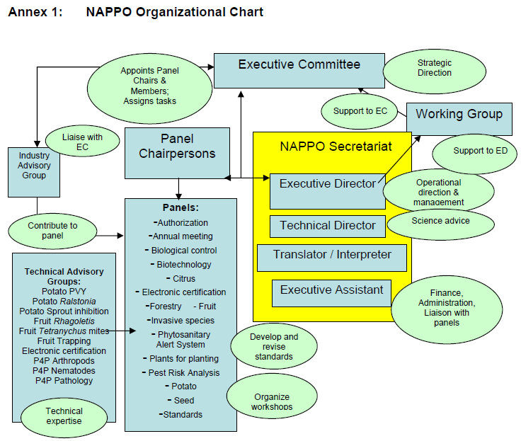

Annex 2: United States

. 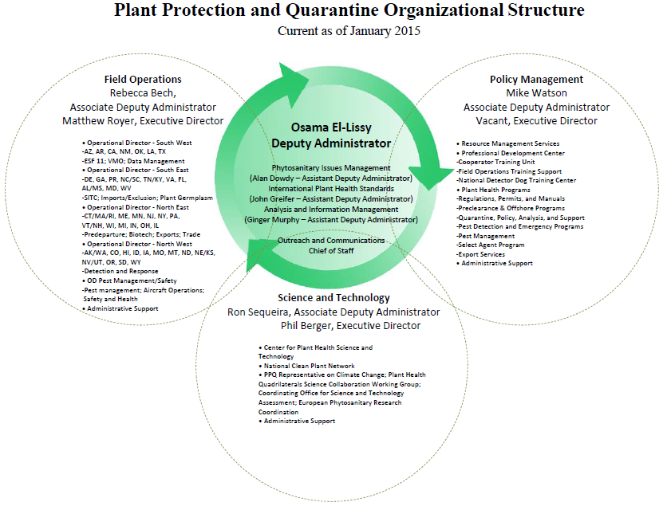

Annex 3: Country Plant Protection Profiles- Australia

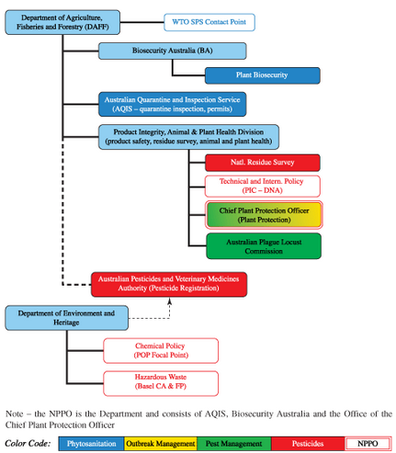

Annex 4: Description of the NPPO of Germany

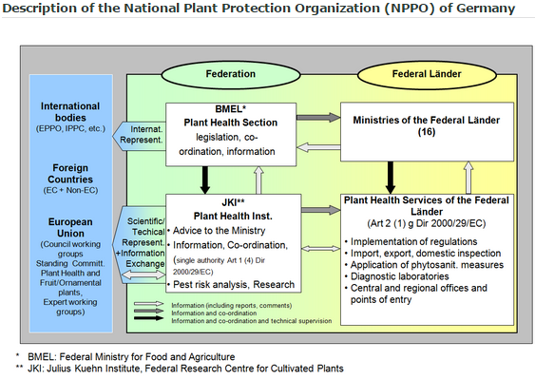

Annex 5: Structure of the Hungarian NPPO

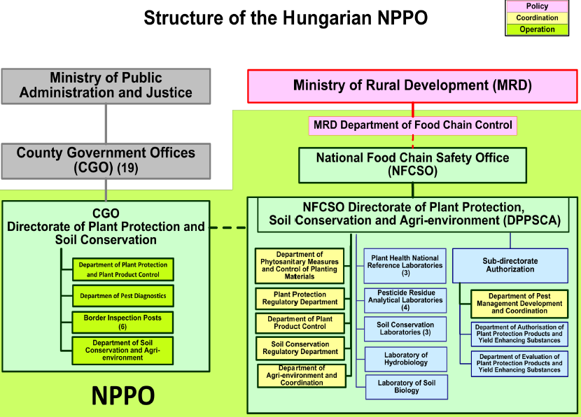

Annex 6: Organizational Chart of Indian Plant Quarantine Structure

Annex 7: Description of the NPPO of Germany

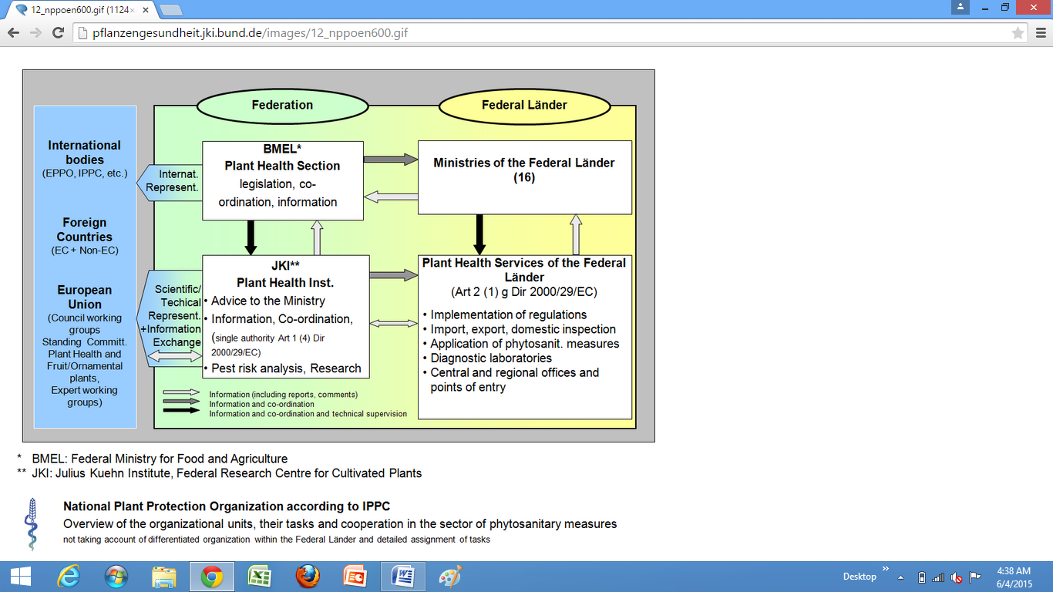

Annex 8: Plant Protection Organization Chart of China

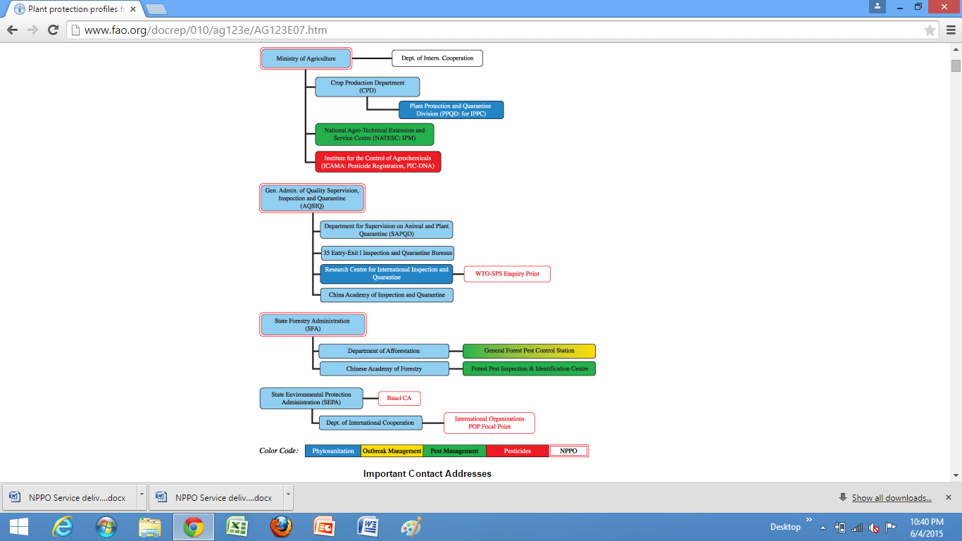

Annex 9: NPPO Action and Contact

Activity | Specific Tasks | Stakeholders | Responsible Agency | Coordination Mechanism
International collaboration and coordination | Exchange of information through PRA request forms while undertaking PRA | NARC, NPQP, PPD, DPR, DOF, AFU | NPPO, PPD and NPQP | PPD (NPPO unit) writes to all the stakeholder organizations for filling up of PRA request form and/or for conducting pest risk analysis, SPQO of NPQP (in technical panel) coordinates to all national stakeholders, to form 'risk analyst's working group". This group synthesizes the report and submits to the NPPO unit of PPD. Revision of the report, if needed, is done by technical panel, upon the request of NPPO Unit. The report is communicated by NPPO secretariat with the help of NPPO unit to related contracting party or stakeholder via email/ formal letter.
 | Risk communication | NARC, NPQP, PPD, DPR, DOF, AFU | NPPO, PPD and NPQP
 | Coordinated management of invasive alien pests | DADO, DFO (at local level), NARC (agronomy division), DPR, DOF and relevant ones. | NPPO, PPD NPQP and  Senior scientific officer of the DPR/ senior scientist of agronomy division NARC | Technical working group(at least one member of technical panel)--report-- NPPO Unit--Technical panel (if needed)-- NPPO unit—NPPO secretariat- International contracting party(foreign NPPO)--NPPO Secretariat--NPPO Unit--Technical panel (if Needed) --specific working group.........
 | Mutual agreement for trade | Commodity organization, commodity directorate, PPD, NPQP, and other relevant etc | Identified national negotiation expert from agri economics division of NARC | Drafting of trade agreement by the working group then submission to the technical panel.
 | Market access negotiations
 | Notification of non-compliance as a part of import regulation
 | Notification of non conformity in export regulation
 | Pest status communication
 | Pest diagnostics and specimen exchange for training purpose
 | Reference laboratories/ and accreditation
 | International notifications
 | Import-export planning
 | Joint monitoring
 | HR exchange schemes
 | Technical/logistic support
 | Collaboration and coordination at the boarder
 | MRA
Accriditation of diagnostic and reference laboratory and pest libraries
representing the Nepal in bilateral, regional and other international phytosanitary forums
 | Phytosanitary capacity evaluation
 | development and agreement on bilateral trade protocols
National collaboration and coordination | sampling and testing
 | Export inspection
 | Certification
 | Implementation Review and Support System (IRSS)
 | Revision of current legal provisions according to need
 | Bearing legal authority and responsibility
 | Drafting and endorsing national phytosanitary standards
 | orientation of standards to the stakeholders (training/workshops)
 | Development of specific survey protocols and endorsement
 | Development of diagnostic Protocols for pests
 | Development of Management protocols
 | Development of phytosanitary training curriculum
 | Development of contingency plans
 | Development of phytosanitary procedures
 | Development of protocols for phytosanitary audit
 | Implementation of protocols and standards
 | facility audit
 | system audit
 | record audit
 | Procedure audit
 | Import regulation
 | Post entry Quarantine study
 | Pest diagnosis
 | Designation and operation of specific growing conditions like PFA, ALPP etc.

16 Lists of Appendixes

Appendix 1: Nepal Gazette designating PPD as the NPPO of Nepal

Appendix 2: Power to designate National Plant Protection Organization

As stated in Article 6 (2) of the Plant Protection Act, 2007, Power to designate National Plant Protection Organization is as follows:

(1) The Government of Nepal may, by a Notification in the Nepal Gazette, designate any central level office related with plant protection as the National Plant Protection Organization.
(2) The functions, duties and powers of the National Plant Protection Organization, in addition to those set forth in this Act, shall be as follows:
(a) To prepare standards on the sanitation of plants or plant products to be imported or exported and submit such standards to the Committee for approval,
(b) To frame and enforce manuals on the examination, test, inspection and treatment of plants, plant products, biological control agents, beneficial organism's another articles,
(c) To identify endangered areas and protect, or cause to be protected, plants and plant products in such areas through quarantine process,
(d) To identify pest free areas and areas of low pest prevalence and make declaration and surveillance ofsuch areas,
(e) To prescribe terms and restrictions relating to the trafficking and use of plants and plant products, biological control agents and beneficial organisms,
(f) To act as a national coordinator for activities relating to plants and plant products, biological control agents and beneficial organisms,
(g)To enforce, or cause to be enforced, approved standards on the sanitation of plants or plant products to be imported or exported,
(h) To make coordination with phyto-sanitary bodies of other countries and make understandings on the recognition of each other's permits and phyto-sanitary certificates,
(i) To perform such other functions as prescribed

