Table 2 - Mexico comments - Draft ISPMs for country consultation, 2007

draft ISPM: Thrips palmi

 | 1. Section | 2. Country | 3. Type of comment | 4. Location | 5. Proposed rewording | 6. Explanation
 | General comments | Mexico |  | 1)All over the text |  | Translation to Spanish should be reviewed throughout the text.  - Throughout the text, translation to Spanish of the term eggs should be revised, in order to translate it as “huevo”.  - Throughout the text, translation to Spanish of the term fine brush should be revised, in order to translate it as “pincel fino”.  - Why different brands are quoted in the text if other ones could be used.  For instance:  - High Pure PCR Template Preparation Kit (Roche)  - Chelex 100 resin (Bio-Rad)  - ABI Prism 7700 or ABI 7900HT Sequence Detection Systems (Applied Biosystems)  - dNTPs (Promega),  - AmpliTaq Gold DNA polymerase (Applied Biosystems)  - Taq DNA polymerase (Roche)  Why not other PCR equipment?
 | 1. Pest Information | Mexico | Transl.  Spanish  Editorial | Para 1 Ora 1;  Thrips palmi Karny is a polyphagous plant pest, especially of species in the Cucurbitaceae and Solanaceae.  Para 1 Ora 3;  It is now present throughout Asia and is widespread throughout the Pacific and the Caribbean.  Para 1 Ora 4;  Otherwise, it occurs locally in North, Central and South America, Africa and Oceania. For more general information about T. palmi, see EPPO/CABI (1997) or Murai (2002).  Para 2 Ora 1;  The species causes economic damage to plant crops both as a direct result of its feeding activity and as a result or of its ability to vector tospoviruses such as Groundnut bud necrosis virus, Melon yellow spot virus and Watermelon silver mottle virus. It is extremely polyphagous, and has been recorded from more than 36 plant families. It is an outdoor pest of Benincasa hispida, Capsicum annuum, Citrullus lanatus, Cucumis melo, Cucumis sativus, Cucurbita spp., Glycine max, Gossypium spp., Helianthus annuus, Nicotiana tabacum, Phaseolus vulgaris, Pisum sativum, Sesamum indicum, Solanum melongena, Solanum tuberosum and Vigna unguiculata. In glasshouses, economically important hosts are Capsicum annuum, Chrysanthemum spp., Cucumis sativus, Cyclamen spp., Ficus spp., Orchidaceae and Solanum melongena. The thrips may be carried on plants for planting, cut flowers and fruits of host species as well as on packing material.  T. palmi is almost completely yellow coloured and its identification is hampered by its small size (1.0–1.3 mm) and great similarity with other yellow species of Thrips. | especialmente de especies de Cucurbitaceas….  distribuida  Ocurre localmente  Sudamérica… | To be consistent with English version.  To be consistent with English version.  The pest occurs locally and is not present in all countries of the regions mention in the text.
 | 3. Detection | Mexico  Mexico  Mexico | Translat. Spanish  Translat. Spanish  Editorial  Translat. Spanish  Technical | T. palmi has six developmental stages, which are usually found in different habitats:  - egg in the leaf, flower and fruit tissue  - larva I on the leaves, flowers and fruits  - larva II on the leaves, flowers and fruits  - pupa I in the soil  - pupa II in the soil  - adult on the leaves, flowers and fruits  On plant material, most of the above-ground parts of the plant may potentially carry T. palmi; the parts of the plant infested can differ according to variables such as host and individual T. palmi population characteristics.  During visual examination of plant material for the presence of T. palmi, attention must be paid to silvery feeding scars on the leaf surfaces of host plants, especially alongside the midrib and the veins. Heavily infested plants are often characterized by a silvered or bronzed appearance of the leaves, stunted leaves and terminals, and scarred and deformed fruits. Detection may be hampered in the following circumstances:  - low-level infestation may produce little or no detectable symptoms  - the presence on the plant of the eggs stage only, within the plant tissue (for example after external treatment which may have removed visible life stages).  Individual specimens are best collected in a fluid called AGA, which is a mixture of 10 parts of 60% ethyl alcohol with 1 part glycerine and 1 part of acetic acid. Several methods can be used to collect thrips specimens (Mantel and Vierbergen, 1996; modified):  - Thrips may be individually removed from the plant (leaves, flowers or fruit) into microtubes containing AGA using a moist, fine brush.  - Thrips may be beaten from plant parts onto a small plastic tray (e.g. a white tray for dark-coloured specimens or onto a black tray for light-coloured specimens). The thrips usually start walking across the tray rather than flying off, allowing time for the thrips to be picked off with a moist, fine brush. The thrips are easily seen on the tray using just a hand lens, but an experienced observer can also see them easily with the naked eye.  - Plant parts may be sealed in a plastic bag for 24 hours, with a piece of filter paper to absorb condensation. Most thrips will leave the plant parts and can then be collected from the inside of the bag.  - A Berlese funnel can be used to process plant material such as flowers, turf, leaf litter, moss and even dead branches of trees. The funnel contains a sieve on which the plant material is deposited. The bottom of the funnel beneath the sieve leads into a receptacle containing 10% ethyl alcohol. The funnel is placed under an electric lamp (60 W), and the heat and light will cause any thrips present in the plants to escape by heading down towards the receptacle. After an appropriate period (8 hours for cut flowers), the content of the receptacle can then be checked under a stereo-microscope.  - Thrips may be monitored (winged adults only) using coloured sticky traps. The attractivity of the colour varies for different thrips species, but blue or white traps are good for T. palmi though yellow traps will also work. For microscopic slide preparation and identification, the thrips will have to be removed from the traps using dichloromethane or a turpentine substitute.  There are no recognised methods for extracting thrips pupae from the soil.  If the specimens are to be stored, they should be transferred to 60% ethyl alcohol and kept in the dark, preferably at temperatures well below 0°C to prevent loss of colour. | Huevo, en los tejidos de la hoja, flor y fruto.  Potencialmente..  Efecto de la alimentación…  A lo largo de …  Pueden producir…  Huevos  Pueden ser individualmente removidos …  Pincel fino..  Pueden ser sacudidos desde las partes de las plantas a una…  Pincel fino…  Los trips…  Simple vista  Césped  Receptáculo  Se escape y dirija hacia abajo, al receptáculo….  O un sustituto de la ….  A range of temperature must be indicated or something on the lines of below zero | To be consistent with English version  To be consistent with English version  To be consistent with English version  To be consistent with English version  To be consistent with English version  To be consistent with English version  Translation to Spanish of the term fine brush in order to translate it as “pincel fino”.  Translation to Spanish of the word “naked eye”, to translate it as “Simple vista”.  To improve translation to Spanish  To improve translation to Spanish  To improve translation to Spanish
 | 4. Identification | Mexico | Translat. Spanish  Translat. Spanish  Technical  Translat. Spanish | Identification of thrips species by morphological examination is restricted to adult specimens because there are no adequate keys for the identification of eggs, larvae or pupae. However, the presence of larvae in samples can give important additional information such as confirming their development on the host plants. If adult material is available, morphological identification is the primary method of identification. Using this protocol with good-quality slide preparations should allow adult T. palmi to be identified with certainty by morphological examination alone.  In cases where adult material is not available, or the adult specimens are atypical or damaged, then molecular assays can be used, as a complementary technique. Such assays can be applied to all life stages. For the identification of eggs, larvae or pupae by this method, it is recommended that at least two different molecular assays be performed. The molecular assays in this protocol have been developed for specific purposes and evaluated against a restricted number of species. | Huevos  El uso de este protocolo junto con preparaciones microscópicas de buena calidad, permitiría identificar los…  If adult material is not available, it is not advisable to make molecular identification of a regulated pest  Damaged or atypical specimens must be first suspect to be T. palmi by morphology.  Huevos | To improve translation to Spanish
 | 4.1 Morphological identification of the adult thrips  4.1.1 Preparation of thrips for microscopic examination | Mexico  Mexico | Translat. Spanish  Editorial  Translat. Spanish  Translat. Spanish  Translat. Spanish  Translat. Spanish  Translat. Spanish | For microscopic examination, adult thrips must be mounted on microscope slides. Material to be kept archived in a reference collection is best macerated, dehydrated and mounted in Canada balsam (Mound and Kibby, 1998). However, the initial slide preparation protocol takes three days to complete. For routine identifications, a water-soluble mountant is rapid and relatively inexpensive. The following steps for mounting thrips are recommended by Mound and Kibby (1998). The specimens are transferred from the collecting fluid into clean 70% ethyl alcohol. If the specimens are reasonably flexible, attempt to open the wings and straighten the antennae using micro-pins. A drop of Hoyers Mountant (50 ml water, 30 g gum arabic, 200 g chloral hydrate, 20 ml glycerine) is placed onto a 13 mm diameter cover slip. A single thrips is placed into this drop, ventral side uppermost, and a slide then gently lowered onto the drop. The slide is inverted as soon as the mountant has spread sufficiently and then immediately placed into an oven at 35–40ºC for at least 6 hours before attempting study. The slide should be left in the oven for approximately 3 weeks at 35–40ºC to dry the mountant, before being ringed with nail varnish and appropriately labelled. | …deben montarse para observación en microscopio…  Sin embargo, el protocolo inicial para la preparación para el montaje toma tres días para completarse.  …liquido de montaje hidrosoluble…  …liquido de montaje de Hoyers…  …es colocada sobre…  …sobre la gota  …liquido de montaje…  El preparado microscópico … a 35 -40…liquido demontaje… | To improve translation to Spanish  To improve translation to Spanish  To improve translation to Spanish  To improve translation to Spanish
 | 4.1.2 Identification of the family Thripidae | Mexico | Translat. Spanish  Translat. Spanish | T. palmi belongs to the family Thripidae, which includes about 1850 species in 260 genera. In most species, the antennae have seven or eight segments (occasionally nine or six); the terminal segments are usually small, and slender sensory trichomes jut from segments III and IV (these are usually forked). The forewings (if present) are usually slender, with two longitudinal veins each bearing a series of setae. The abdomen of the female has a serrated ovipositor, which is turned down at the apex. The males are usually smaller, and may bear one or more glandular areas on their median sternites. | …ocasionalmente…  …curvado hacia abajo… | To improve translation to Spanish  To improve translation to Spanish
 | 4.1.3 Identification of the genus Thrips | Mexico | Editorial  Translat. Spanish  Translat. Spanish  Translat. Spanish  Editorial  Translat. Spanish  Translat. Spanish  Translat. Spanish | The genus Thrips contains almost 280 species from all parts of the world, though the genus is primarily from the Holarctic and the Old World tropics. Members of the genus have the following shared characteristics: only two pairs of ocellar setae (pair I being absent); antennae with seven or eight segments, III and IV with forked sense cones; the pronotum with two pairs (rarely one or none) of major posteroangular setae, and with three to four pairs of posteromarginal setae; female macropterous or micropterous (occasionally apterous); forewings with the setal row on the first vein usually interrupted; metascutum with striate or reticulate sculpturing, campaniform sensillae present or absent, median pair of setae at or behind the anterior margin; tarsi 2-segmented; the abdominal tergites V–VIII with paired ctenidia laterally, with the tergite VIII ctenidia posteromesad to the spiracles; and the sternites and pleurotergites with or without accessory setae.  A simplified summary of the main characteristics is given in Table 1 and is accompanied by illustrative line drawings (Figures 1 and 2).  Identification of the adults can be carried out with keys. Mound and Kibby (1998) give a key to 14 Thrips species of economic importance. In addition, a CD-ROM identification aid for thrips is available which includes an identification system to 100 pest species from around the world based on photomicrographs (Moritz et al., 2004).  More comprehensive keys to the genus are to be found, produced on a regional basis (no such key has been produced for the Afrotropical region):  Asia: Bhatti (1980) and Palmer (1992) provide keys for the identification of species of Thrips occurring in the Asian tropics.  Australasia: Mound and Masumoto (2005) provide a key to the Thrips species of Australasia (but note that on page 42, they erroneously apply a characteristic of T. flavus – ocellar setae III close together behind the first ocellus – to T. palmi).  Europe: zur Strassen (2003) has produced the most recent comprehensive key to the species of Europe (in German).  North, Central and South America: Nakahara (1994) provides a key for Thrips species from the New World. A key to the species of Thrips found in Translat. Spanish  Central America is given by Mound and Marullo (1996) though only one of these species is native to the region. Only species of Thrips that were transported there by the international trade in plants are to be found in South America. | Make more clear what region we are talking about.  Sensillae  …especies plaga…  …microfotografias…  These keys do not already exist, they have to be elaborated.  …Sudamérica…  …provee…  …Sudamérica. | To improve translation to Spanish  To improve translation to Spanish  To improve translation to Spanish  To improve translation to Spanish
 | 4.1.4 Identification of Thrips palmi | Mexico | Translat. Spanish  Translat. Spanish  Translat. Spanish  Translat. Spanish  Translat. Spanish  Translat. Spanish  Translat. Spanish  Translat. Spanish  Translat. Spanish  Translat. Spanish  Technical | Morphological characteristics of Thrips palmi  Bournier (1983), Sakimura et al. (1986) and zur Strassen (1989) all provide detailed descriptions of T. palmi. Sakimura et al. (1986) gave a list of major diagnostic characters to distinguish T. palmi from the other known species of the genus Thrips, and a modified version of this is given here:  1. A clear yellow body without any greyish or brownish blotch, but with slightly thickened blackish body setae.  2. The interocellar setae standing either just outside of the ocellar triangle, or touching the tangent lines connecting the anterior ocellus and each of the posterior ocelli.  3. The metanotum with striate sculpture in the medial area that converges mesad posteriorly.  4. Three distal setae (occasionally two) on the first vein of the forewing.  5. Abdominal tergite II with four lateral setae.  6. Abdominal sternites without accessory setae.  7. Abdominal tergites II to V with setae S2 dark and subequal to S3.  8. Abdominal tergite VIII with comb complete.  9. Male sternites III–VII each with a transverse glandular area.  A simplified summary of the main characteristics is given in Table 1 and is accompanied by illustrative line drawings (Figures 1 and 2).  Comparison with similar species (species that are yellow, or sometimes yellow, without darker body markings)  Two Indian species (T. alatus and T. pallidulus) are very similar to T. palmi, although little is known of their biology:  - Thrips alatus Bhatti – antennal segment V is uniform brown (often pale basally in T. palmi); abdominal tergites III and IV with setae S2 paler and much weaker than S3 in both sexes; the striate metanotal sculpture usually not converging posteriorly; India, Nepal.  - Thrips pallidulus Bagnall – metanotal sculpture is medially reticulate, not striate; India.  Three common Palearctic species (but also with wider distributions) that may be confused with T. palmi are T. flavus, T. nigropilosus and T. tabaci:  - Thrips flavus Schrank – ocellar setae pair III are inside the ocellar triangle (located outside the ocellar triangle in T. palmi); the length of antennal segment VI is 54–60 μm (42–48 μm in T. palmi); the metanotal sculpture does not converge posteriorly; common flower thrips throughout Asia, Europe.  - Thrips nigropilosus Uzel – three lateral setae on abdominal tergite II; no campaniform sensillae (metanotal pores) on the metanotum (present in T. palmi); often with dark abdominal markings (T. palmi is pale bodied); abdominal tergites IV–V with the pair of median setae (S1) more than 0.5 times as long as median length of these tergites (less than 0.3 times in T. palmi); common leaf feeding species, sometimes a pest under glass, Asia, Australasia, East Africa, Europe, North America.  - Thrips tabaci Lindeman – three lateral setae on abdominal tergite II; no campaniform sensillae (metanotal pores) on the metanotum (present in T. palmi); usually four (occasionally two to six) setae on the distal half of the first vein of the forewing; highly variable in coloration; polyphagous pest with a worldwide distribution.  Two further European species (T. alni and T. urticae) are less commonly encountered but may be confused with T. palmi. Females of T. alni are particularly similar in morphology to those of T. palmi.  - Thrips alni Uzel – abdominal tergites II–V with setae S2 pale (dark in T. palmi); seta S2 much weaker than seta S3 on tergite V (these setae are subequal in T. palmi); seta S1 subequal to seta S2 on tergite VIII (S1 is much weaker than S2 in T. palmi); antennal segment V is uniform brown; the male with narrow oval glandular areas on abdominal sternites III-VI (broad transverse glandular areas present on sternites III–VII in T. palmi); restricted to the leaves of Alnus, Europe, Siberia, Mongolia.  - Thrips urticae Fabricius – a pair of setae on the anterior margin of the pronotum almost twice as long (usually more than 30 μm) as any of the discal setae (not so in T. palmi, always less than 25μm); abdominal tergites usually with a grey area medially; no anterior pores present on abdominal tergite IX (usually present in T. palmi); restricted to Urtica dioica, Europe.  Thrips morphology is subject to variation even within a single species. The characters for T. palmi given in this protocol will allow the user to identify this species. Nevertheless, some characters are sometimes subject to slight variation. Thus, in T. palmi antennal coloration can vary from the most commonly observed state (as illustrated in Figure 2.1), as can the number of distal setae on the forewing, etc. | …parduzcas…  …ocasionalmente…  …dibujos lineales ilustrativos…  …pardo uniforme…  …sensillae…  (menos de 0.3 veces en T. palmi)  …sensillae…  …altamente variable en coloración…  …pardo uniforme…  …como lo puede hacer…  Any other confusing characteristics must be enumerated. This phrase must be more precise. | To improve translation to Spanish  To improve translation to Spanish
 | 4.2 Molecular assays for identifying Thrips palmi | Mexico | Spanish  Technical |  | Ensayos moleculares para la identificación de todos los estados de vida de Trips palmi. | To improve translation to Spanish
 | 4.2 Molecular assays for identifying Thrips palmi | Mexico  Mexico | Spanish  Technical  1.Technical  2.Technical  3.Technical  4.Technical  Translat. Spanish  Translat. Spanish  Translat. Spanish | Four molecular assays have been published that can be used in the discrimination of T. palmi and these are described below. A CD-ROM identification system is also available and includes molecular data for a number of thrips species (Moritz et al., 2004). The specificity of each assay is described below. This indicates the thrips species against which each assay was evaluated and the original use for which the assay was designed.  Requirements for controls  With all molecular methods the use of appropriate controls is essential; a validated T. palmi positive extract should shall be included as an additional sample to ensure that amplification has been successful. PCR amplification, either for Real time PCR TaqMan or PCR-RFLP, should shall also be performed on a sample with no template where the DNA extract is replaced with water. This negative control guards against possible reagent contamination and false positives.  DNA extraction  DNA may be extracted from single eggs, adults, puparia or larvae. DNA is extracted using DNA extraction methods suitable for insects. For example:  - The thrips may be ground in a lysis buffer in a microtube using a miocropestle and the High Pure PCR Template Preparation Kit (Roche) then used according to the instructions in the mammalian tissue protocol. The DNA is eluted with 50 μl of 10 mM Tris, pH 8.5.  - Alternatively, a thrips may be ground in 50 μl nuclease-free water before the addition of 50 μl of a 1:1 (volume to volume) slurry of Chelex 100 resin (Bio-Rad) and nuclease-free water, and then being heated to 95ºC for 5 min and centrifuged at 11,000 g for 5 min. The supernatant is transferred to a new microtube and stored at −20ºC. | …discriminación…  Huevos  Micropistilo  See that miocropestle is not right in English.  Put references in English between quotations. | To improve translation to Spanish and for a better comprehension  1.It is technically incorrect to perform a test without appropriate positive end negative controls and it is mandatory to include them  2.The right nomination for the technique is Real time PCR.  3.It is technically incorrect to perform a test without appropriate positive end negative controls and it is mandatory to include them.  4. The issue of the template is not clear.  To improve translation to Spanish and for a better comprehension  To improve translation to Spanish and for a better comprehension also in English
 | 4.2.1 SCAR marker-generated sequence-based real-time PCR assay for Thrips palmi | Mexico | Editorial  Transl Spanish  Translat. Spanish | This assay of Walsh et al. (2005) was designed as a species-specific assay against T. palmi for use by the phytosanitary authorities in England and Wales. It was evaluated by screening the assay against 21 other species of Thysanoptera thrips, including ten in the genus Thrips. These were predominantly, but not exclusively, European species.  Methodology  The T. palmi-specific PCR primers and TaqMan probe used in this assay are as follows:  PCR primer: P4E8-362F (5’-CCGACAAAATCGGTCTCATGA-3’)  PCR primer: P4E8-439R (5’-GAAAAGTCTCAGGTACAACCCAGTTC-3’)  TaqMan probe: P4E8-385T (FAM 5’-AGACGGATTGACTTAGACGGGAACGGTT-3’ TAMRA).  Real-time PCR reactions are set up using the TaqMan PCR core reagent kit (Applied Biosystems) with 1μl (10–20 ng) of DNA extract, 7.5 pmol of each primer and 2.5 pmol probe in a total volume of 25μl. Plates are cycled at generic system conditions (10 min at 95°C and 40 cycles of 1 min at 60°C, 15 s at 95°C) on either ABI Prism 7700 or ABI 7900HT Sequence Detection Systems (Applied Biosystems), using real-time data collection. Ct values lower than 40 indicate the presence of T. palmi DNA. | Los primers específicos para T. palmi y la sonda…  Las placas son termocicladas en condiciones genericas del sistema… | For a better comprehension  Use “primer (s)” in Spanish all over the text.  To improve translation to Spanish and for a better comprehension
 | 4.2.2 COI sequence-based real-time PCR assay for Thrips palmi | Mexico | Editorial  Translat. Spanish  Translat. Spanish | This assay of Kox et al. (2005) was designed as a species-specific assay against T. palmi for use by the phytosanitary authorities in the Netherlands. It was evaluated by screening the assay against 23 other species of Thysanoptera thrips, including 11 in the genus Thrips. These were predominantly, but not exclusively, European species.  Methodology  The Thrips palmi-specific PCR primers and TaqMan probe used in this assay are as follows:  PCR primer: Tpalmi 139F* (5’-TCA TGC TGG AAT TTC AGT AGA TTT AAC-3’)  PCR primer: Tpalmi 286R* (5’-TCA CAC RAA TAA TCT TAG TTT TTC TCT TG-3’)  TaqMan probe: TpP (6-FAM 5’-TAG CTG GGG TAT CCT CAA-3’ MGB)  * Primers adjusted for greater sensitivity. (NB: “R” indicates “either A or G”.)  The 25 μl reaction mixture contains: 12.5 μl of 2x Taqman Universal master mix (Applied Biosystems), 0.9 μM each primer, 0.1 μM Taqman probe, 1.0 μl DNA. The real-time PCR is performed in a suitable instrument for detection of reporter fluorescence, such as ABI Prism 7700 or 7900 Sequence Detection Systems (Applied Biosystems) using the following conditions: 10 min at 94°C; then 40 cycles of 15 s at 94°C and 60 s at 60°C. Ct values lower than 40 indicate the presence of T. palmi DNA. | Los primers específicos para T. palmi y la sonda…  Los 25 μl de mezcla de reacción contienen:…. | To improve translation to Spanish and for a better comprehension  Use “primer (s)” in Spanish all over the text.  This kind of expression about reaction mixtures must be changed all over the text.
 | 4.2.3 ITS2 sequence-based PCR-RFLP assay for nine species of thrips including Thrips palmi | Mexico | Editorial | Methodology  The PCR primers (located in the 5.8 S and 28 S regions flanking the ITS2 region of ribosomal DNA) used in this assay are as follows:  5’-TGTGAACTGCAGGACACATGA-3’  5’-GGTAATCTCACCTGAACTGAGGTC-3’.  T. palmi generates a 588-bp PCR-product (longer or shorter fragments are produced from the other species). The 20 μl-reaction mixture is composed as follows: 1 μM each primer, 250 μM dNTPs (Promega), 1 Unit AmpliTaq Gold DNA polymerase (Applied Biosystems), 2 μl 10 x reaction buffer [with 25 mM MgCl₂], 0.5 µl DNA. The PCR was performed in a 96-well Peltier-type thermocycler (e.g. PTC200, MJ-Research) with the following parameters: 9 min at 94ºC, 35 cycles of 30 s at 94ºC, 30 s at 50ºC, and 1 min at 72ºC, followed by a final extension for 10 min at 72ºC and quickly cooled to room temperature. The PCR products are analysed by agarose gel electrophoresis. | …is performed… | To be consistent with the text and for a better comprehension
 | 4.2.4 COI sequence-based PCR-RFLP assay for ten species of thrips including Thrips palmi | Mexico | Technical | These primers amplify a 433-bp fragment in all the species separated by this assay. The 50 μl-reaction mixture was composed as follows: 0.76 μM each primer, 200 μM dNTPs (Promega), 1 Unit Taq DNA polymerase (Roche), 5 μl 10 x reaction buffer [with 15 mM MgCl2], 1 µl DNA. The PCR was performed in a 96-well Peltier-type thermocycler (e.g. PTC200, MJ-Research) with the following parameters: 1 min 94ºC, 40 cycles of 15 s at 94ºC, 30 s at 55ºC, and 45 s at 72ºC, followed by a final extension for 10 min at 72ºC and quickly cooled to room temperature. To gauge the fragment size produced after amplification, 5 µl of the PCR products can be analysed by agarose gel electrophoresis. | To gauge the fragment size produced after amplification, 5 µl of the PCR products analysed by agarose gel electrophoresis | There is not alternative way to gauge the fragment.
 | 5. Records | Mexico | Technical  Translat. Spanish  Technical  Technical  Technical | The records and evidences detailed in ISPM No. 27 (Diagnostic protocols for regulated pests) should be kept, as appropriate.  In cases where other contracting parties may be adversely affected by the diagnosis, the records and evidence (in particular, a report of the specific techniques used for the diagnosis, preserved specimens, slide-mounted specimens, photographs of distinctive taxonomic structures, or DNA extracts kept in a freezer, photographs of gels, as appropriate) should be kept for at least one year. | Evidences must also be kept.  …deberían conservarse…  The protocol must include a detailed list of the evidences and records on which T palmi diagnosis is based.  To fulfil the requirements of ISPM No. 27. | To improve translation to Spanish and for a better comprehension  Not all records and evidences listed in ISPM No. 27 area the right ones for this case.

Table 1: Diagnostic features of the genus Thrips and of T. palmi

Specimens can be recognized as Thrips by the following combination of characters (see Figure 1 for the location of the various features):

Antenna | comprising seven or eight distinct segments: segments III and IV with forked trichomes or sense cones | (Figs 2.1  & 2.2) | Why trichomes????
Head | with two pairs of ocellar setae (II and III); pair I missing | (Fig. 2.3)
Pronotum | with two pairs of posteroangular setae | (Fig. 2.4)
Forewing | 1st vein – row of setae with gaps (most species) | (Fig. 2.5)
Abdominal tergites V to VIII | with paired ctenidia (combs – each comprising a series of ridges) | (Fig. 1) | Ridges: rugosidades.
Abdominal tergite VIII | with ctenidia posterior and medial to the spiracles | (Fig. 2.6)

Specimens can be identified as Thrips palmi Karny by the presence of the following characters:

Body colour | clear yellow body with no dark areas on the head, thorax or abdomen: antennal segments I and II are pale | (Fig. 2.1)
Antennal segment V | usually yellowish at basal ⅓ to ½ | (Fig. 2.1)
Antennal segment VI | length = 42–48μm | (Fig. 2.1)
Head: ocellar setae pair III | with their bases outside or tangential to the ocellar triangle | (Fig. 2.3)
Forewing: 1st vein | with two or three setae in the distal half | (Fig. 2.5)
Metanotum | with a pair of metanotal pores (campaniform sensillae); with striate sculpturing, usually converging posteriorly | (Fig. 2.7) | sensillae
Abdominal pleurotergites | ridges without microtrichia; accessory setae absent | (Fig. 2.8)
Abdominal tergite II | with four lateral setae | (Fig. 2.9)
Abdominal tergites III and IV | S2 almost equal to S3 | (Fig. 2.10)
Abdominal tergite VIII | with complete posteromarginal comb of microtrichia | (Fig. 2.6)
Abdominal tergite IX | usually with two pairs of pores (anterior and medial) | (Fig. 2.11)
Male: sternites | transverse glandular areas on sternites III to VII | (Fig. 2.12)

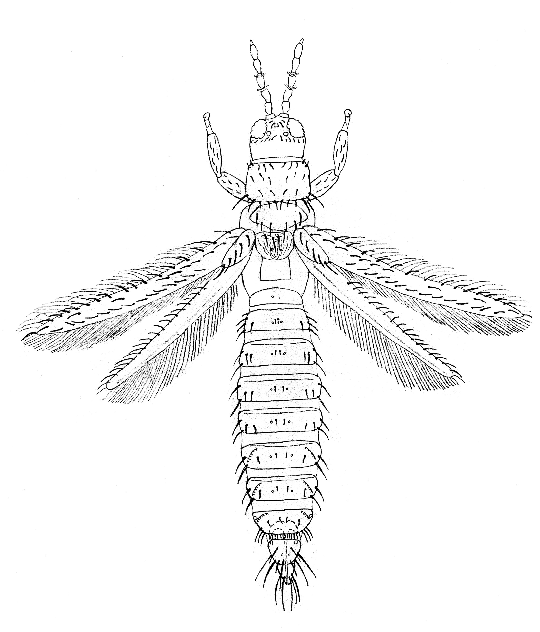
antennal segment V
Figure 1. Location of general characters of Thrips (♀ – dorsal view)
ocellar setae
ocelli
pronotum
posteroangular seta
forewing
1st vein
ctenidia
spiracle
abdominal tergite VIII
mesonotum
metanotum
ovipositor (ventral)
abdominal tergite II
antennal segment IV (with forked trichomes or sense cones)
antennae
2nd vein
posteromarginal comb
postocular setae
tergites (dorsal view); pleurotergites lateral, sternites ventral

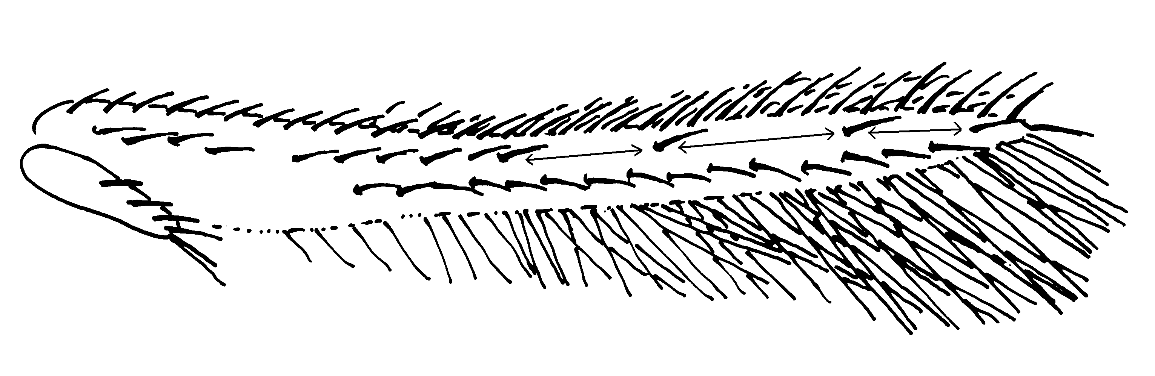
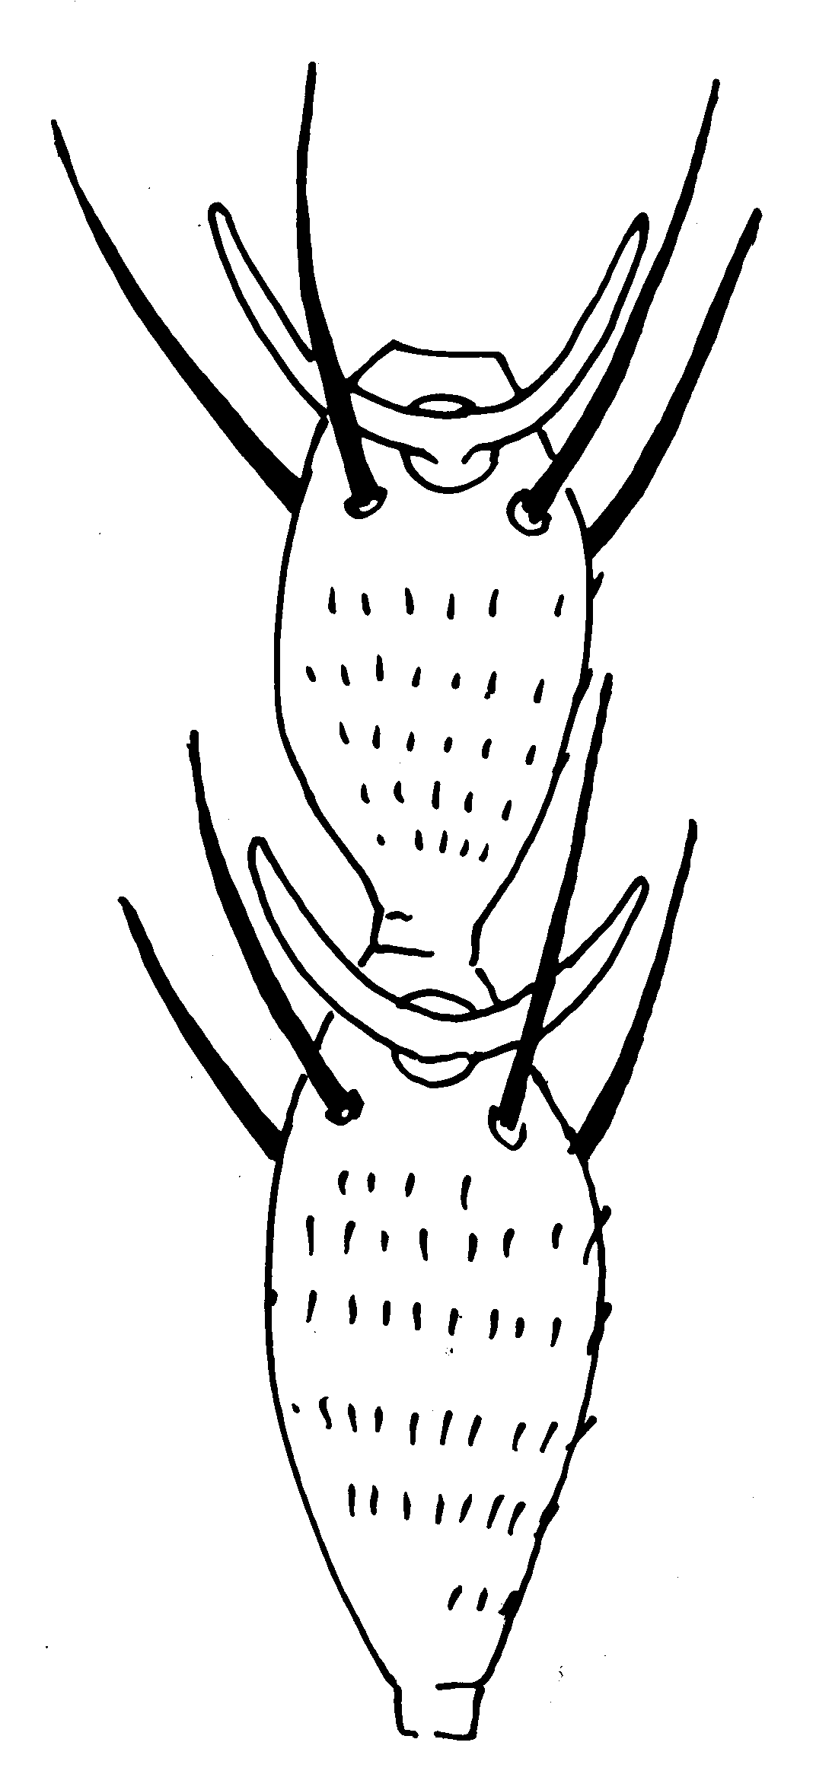
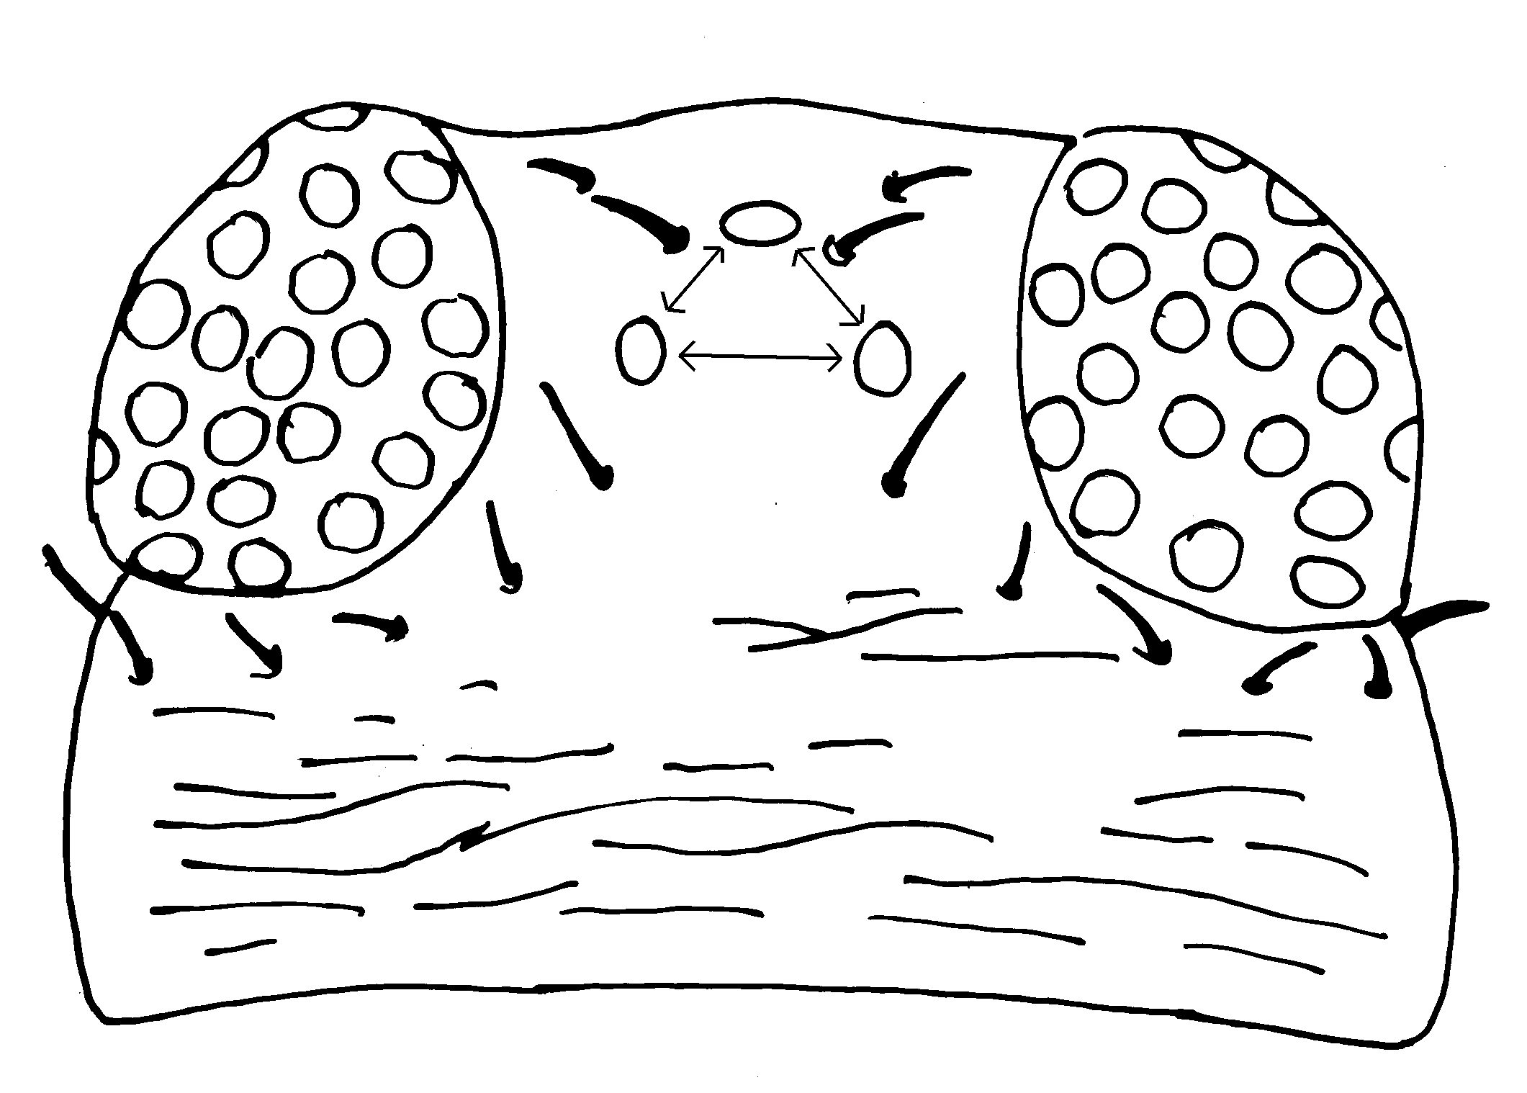
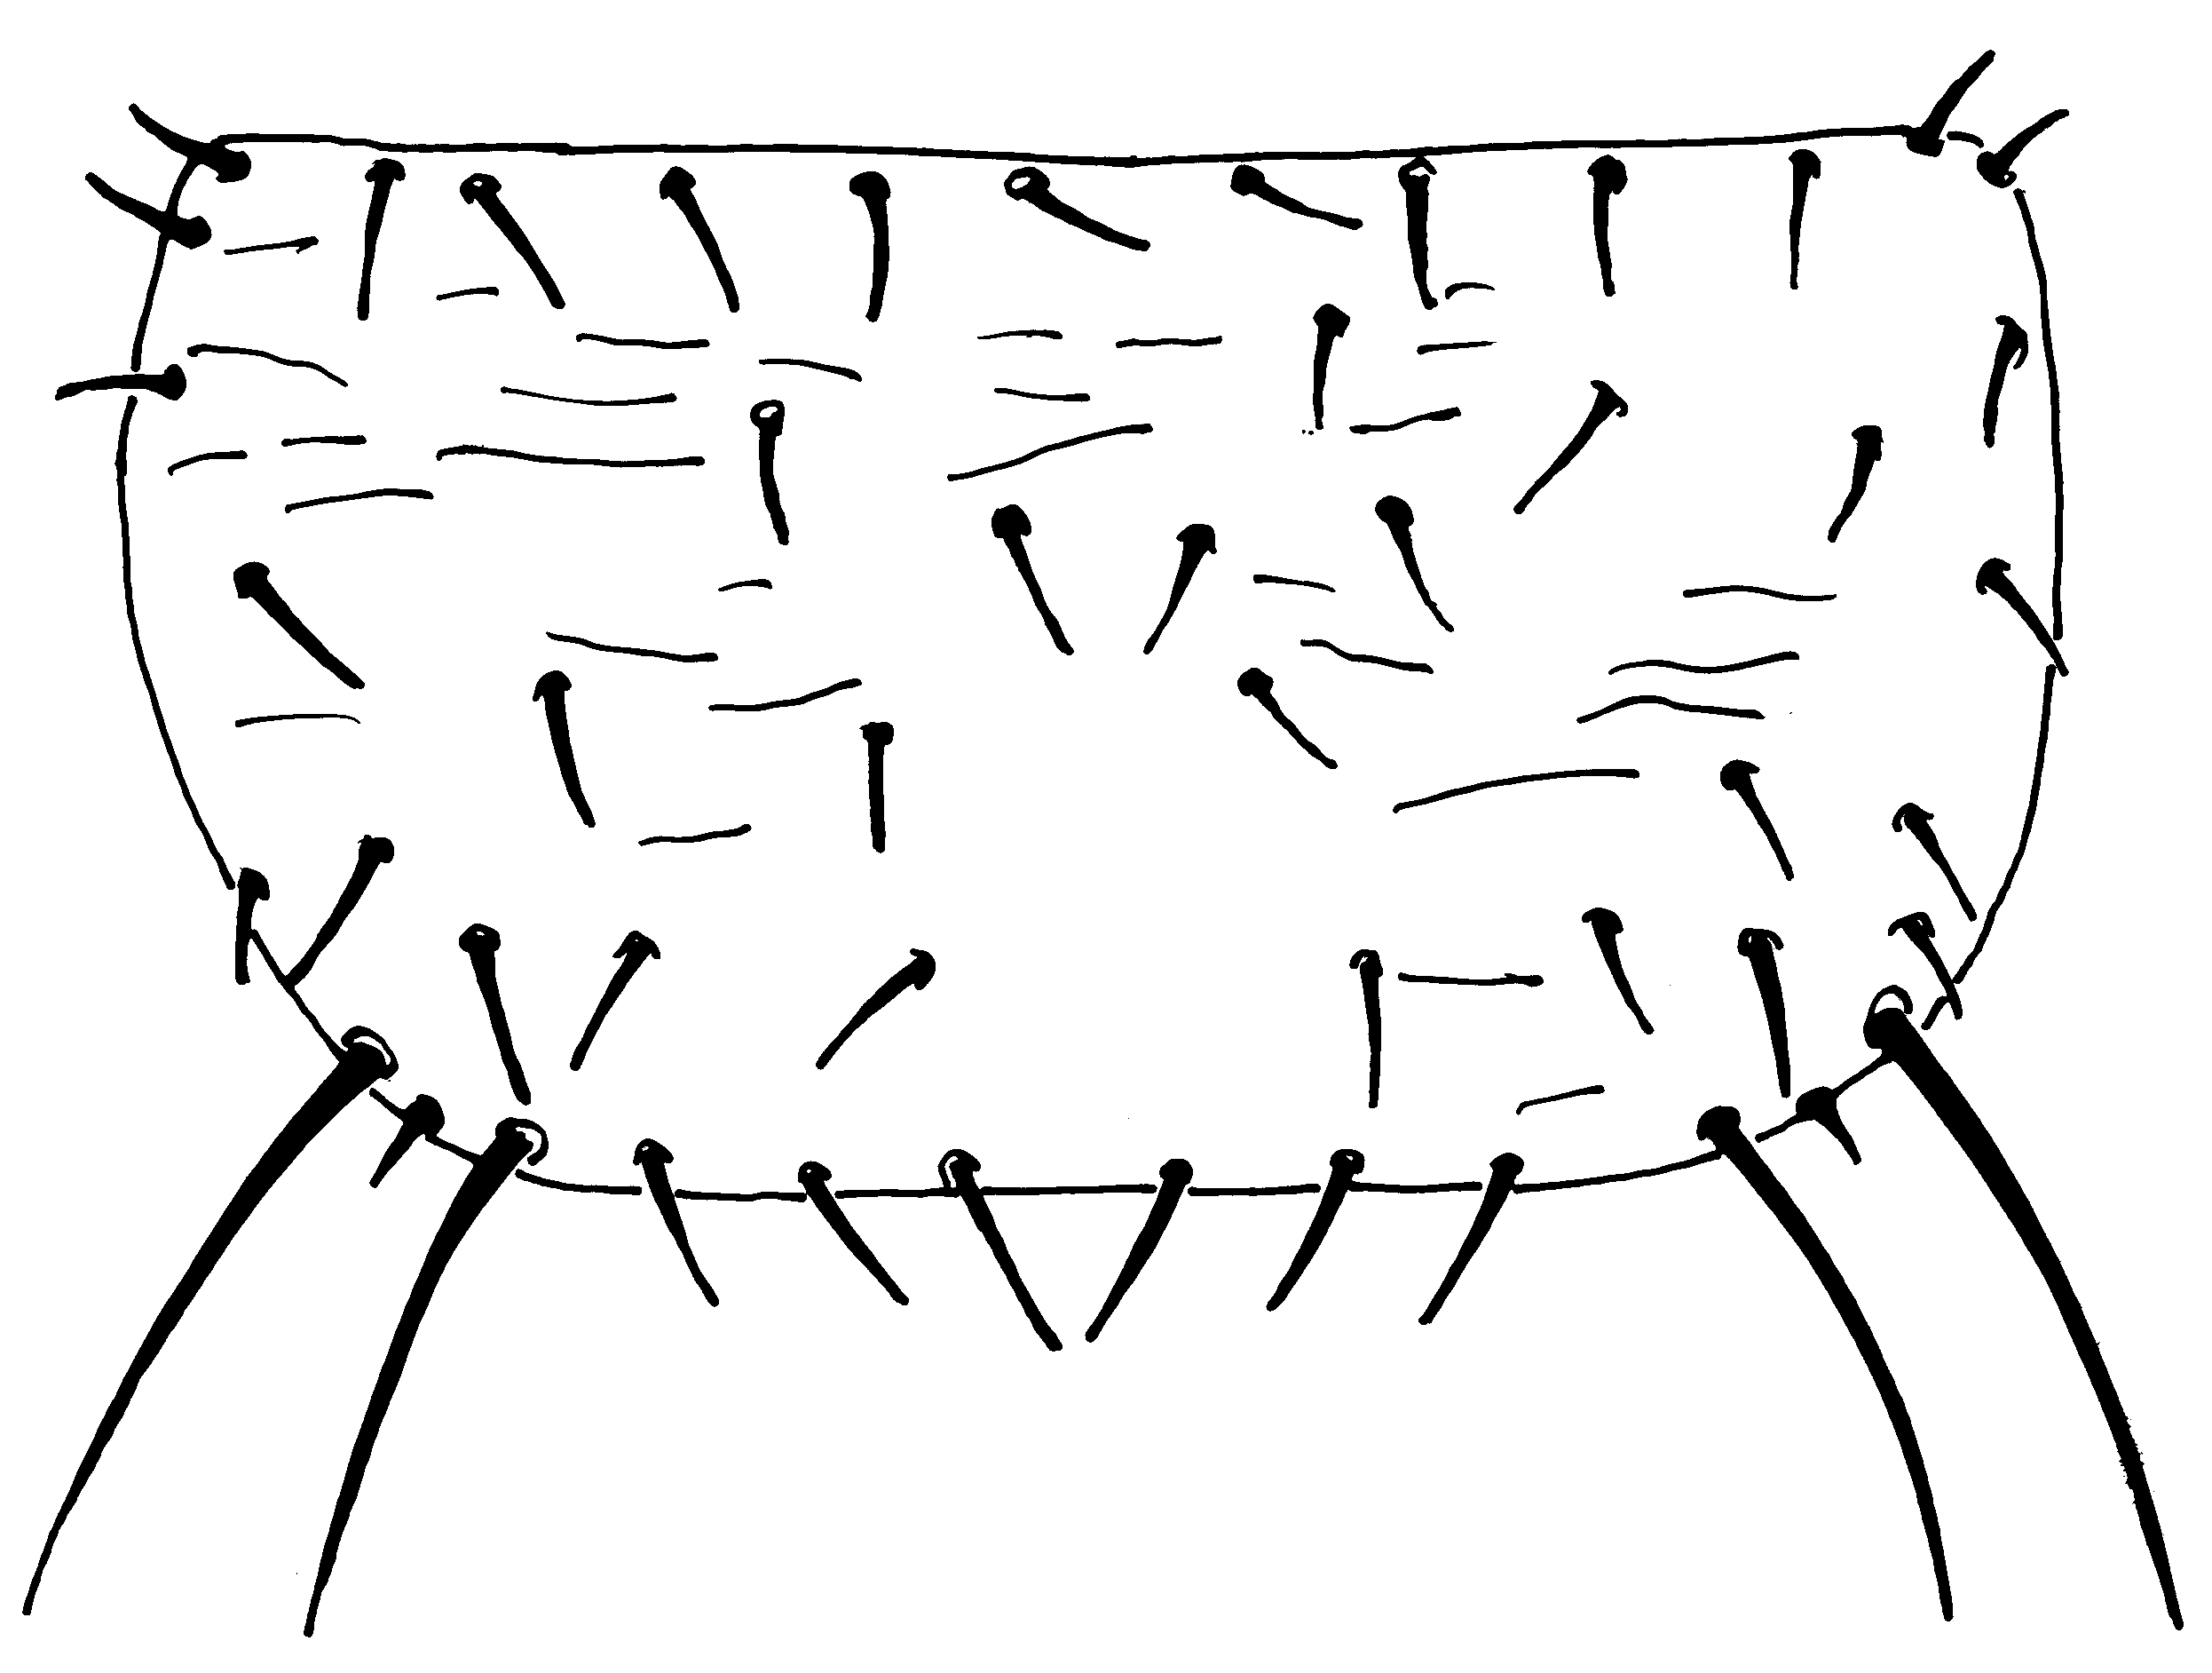
Figure 2. Characters of Thrips palmi (drawn by S. Kobro, Norwegian Crop Protection Institute, Norway)
forked sense cones
III
IV
(2) Antenna: segments III and IV with forked sense cones
(3) Head: with two pairs of ocellar setae (pair I missing)
ocellar setae pair II
ocellar setae pair III
(4) Pronotum: two pairs of posteroangular setae
three distal setae
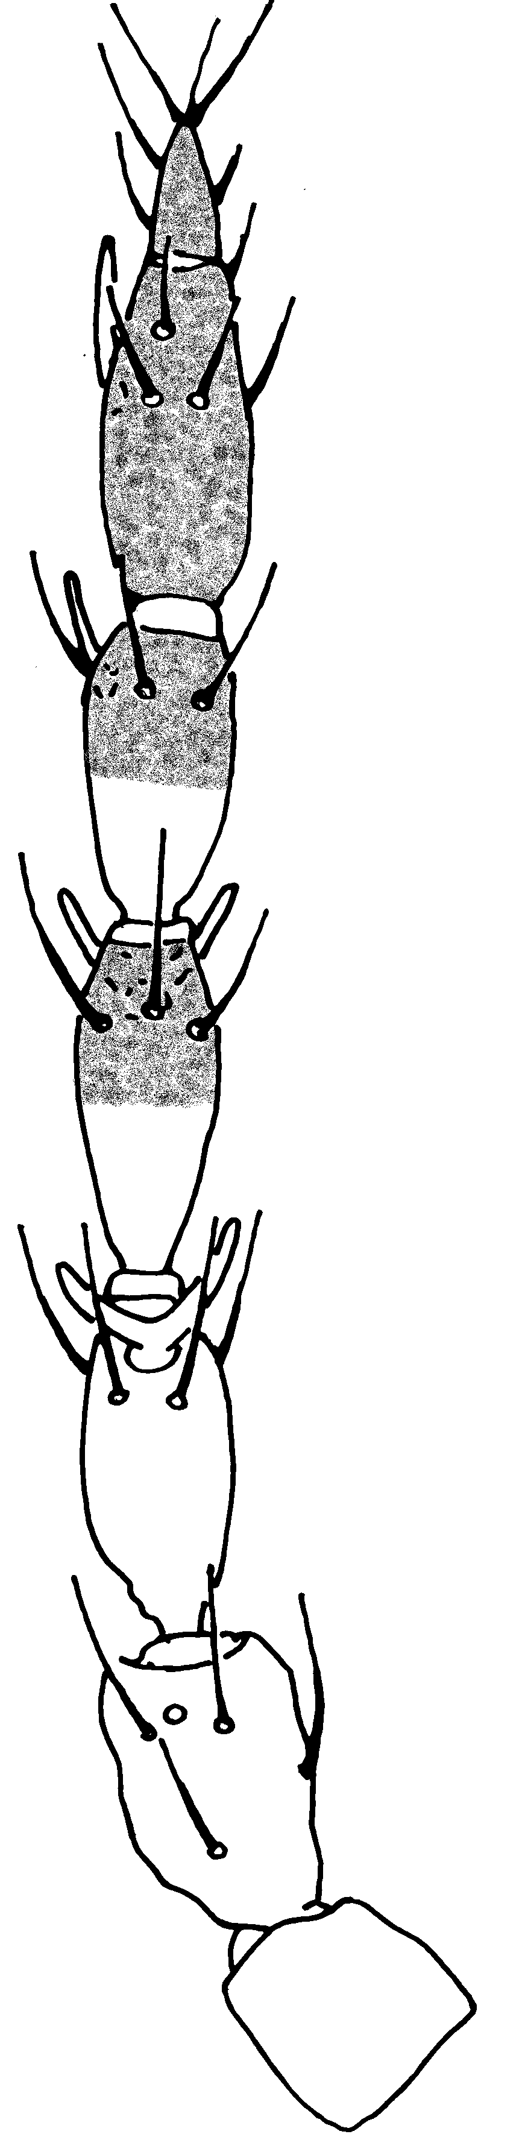
(5) Forewing: first vein – row of setae with gaps in distal half (most species)
(1) Antenna: seven segments; length of segment VI:
42–48 μm.
Fig. 2 continued.
ctenidium
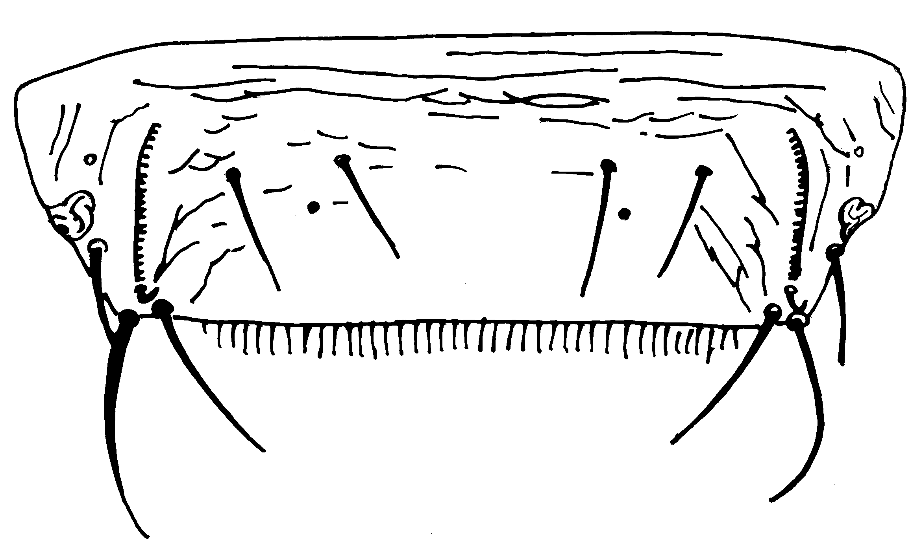
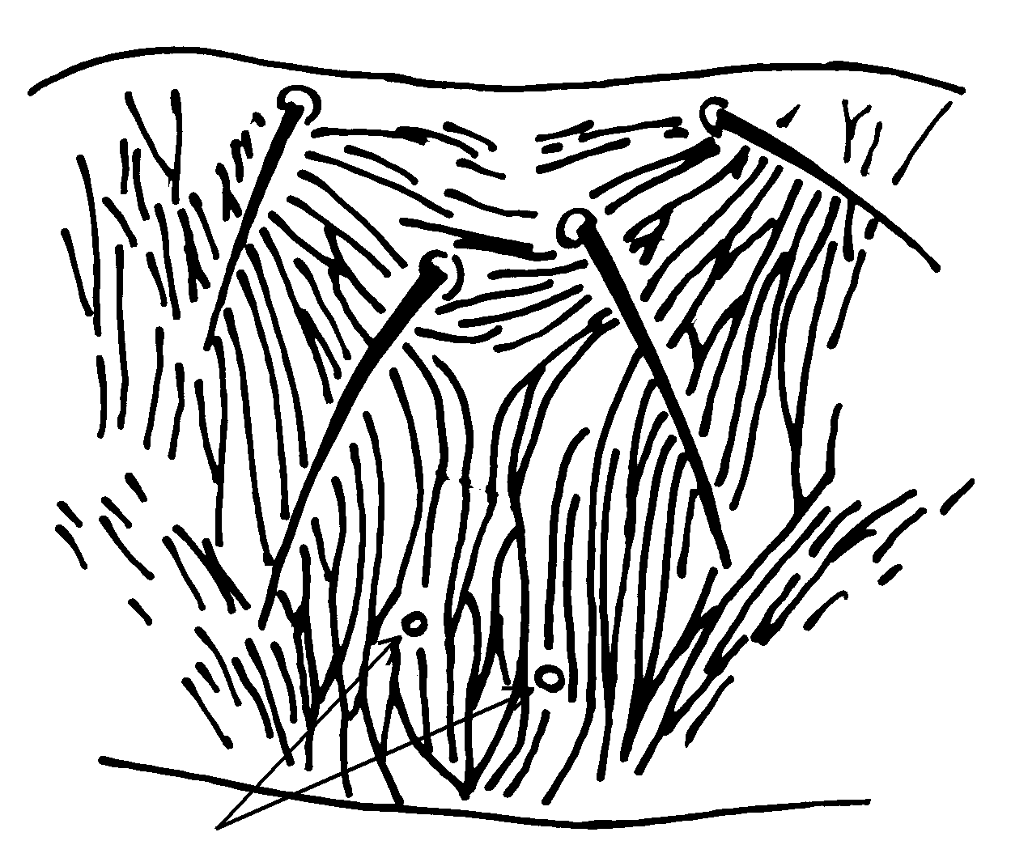

spiracle

comb complete
Metanotal pores

converging sculpture

(7) Metanotum

(6) Abdominal tergite VIII: spiracle lying anterior and lateral to ctenidium

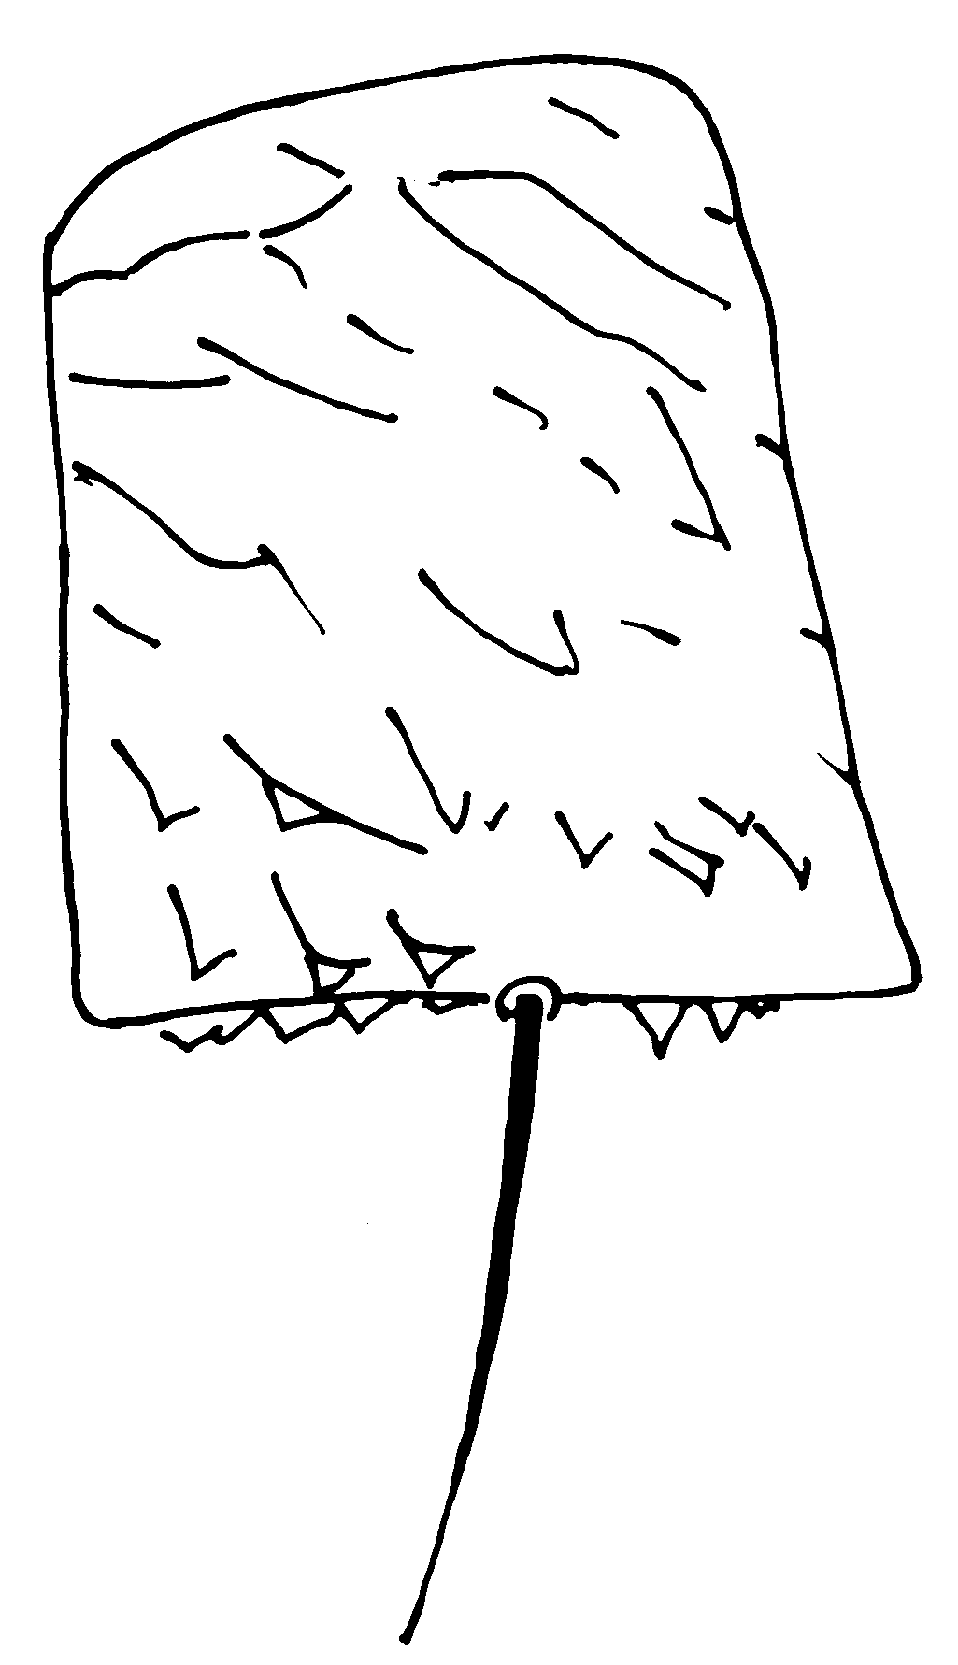
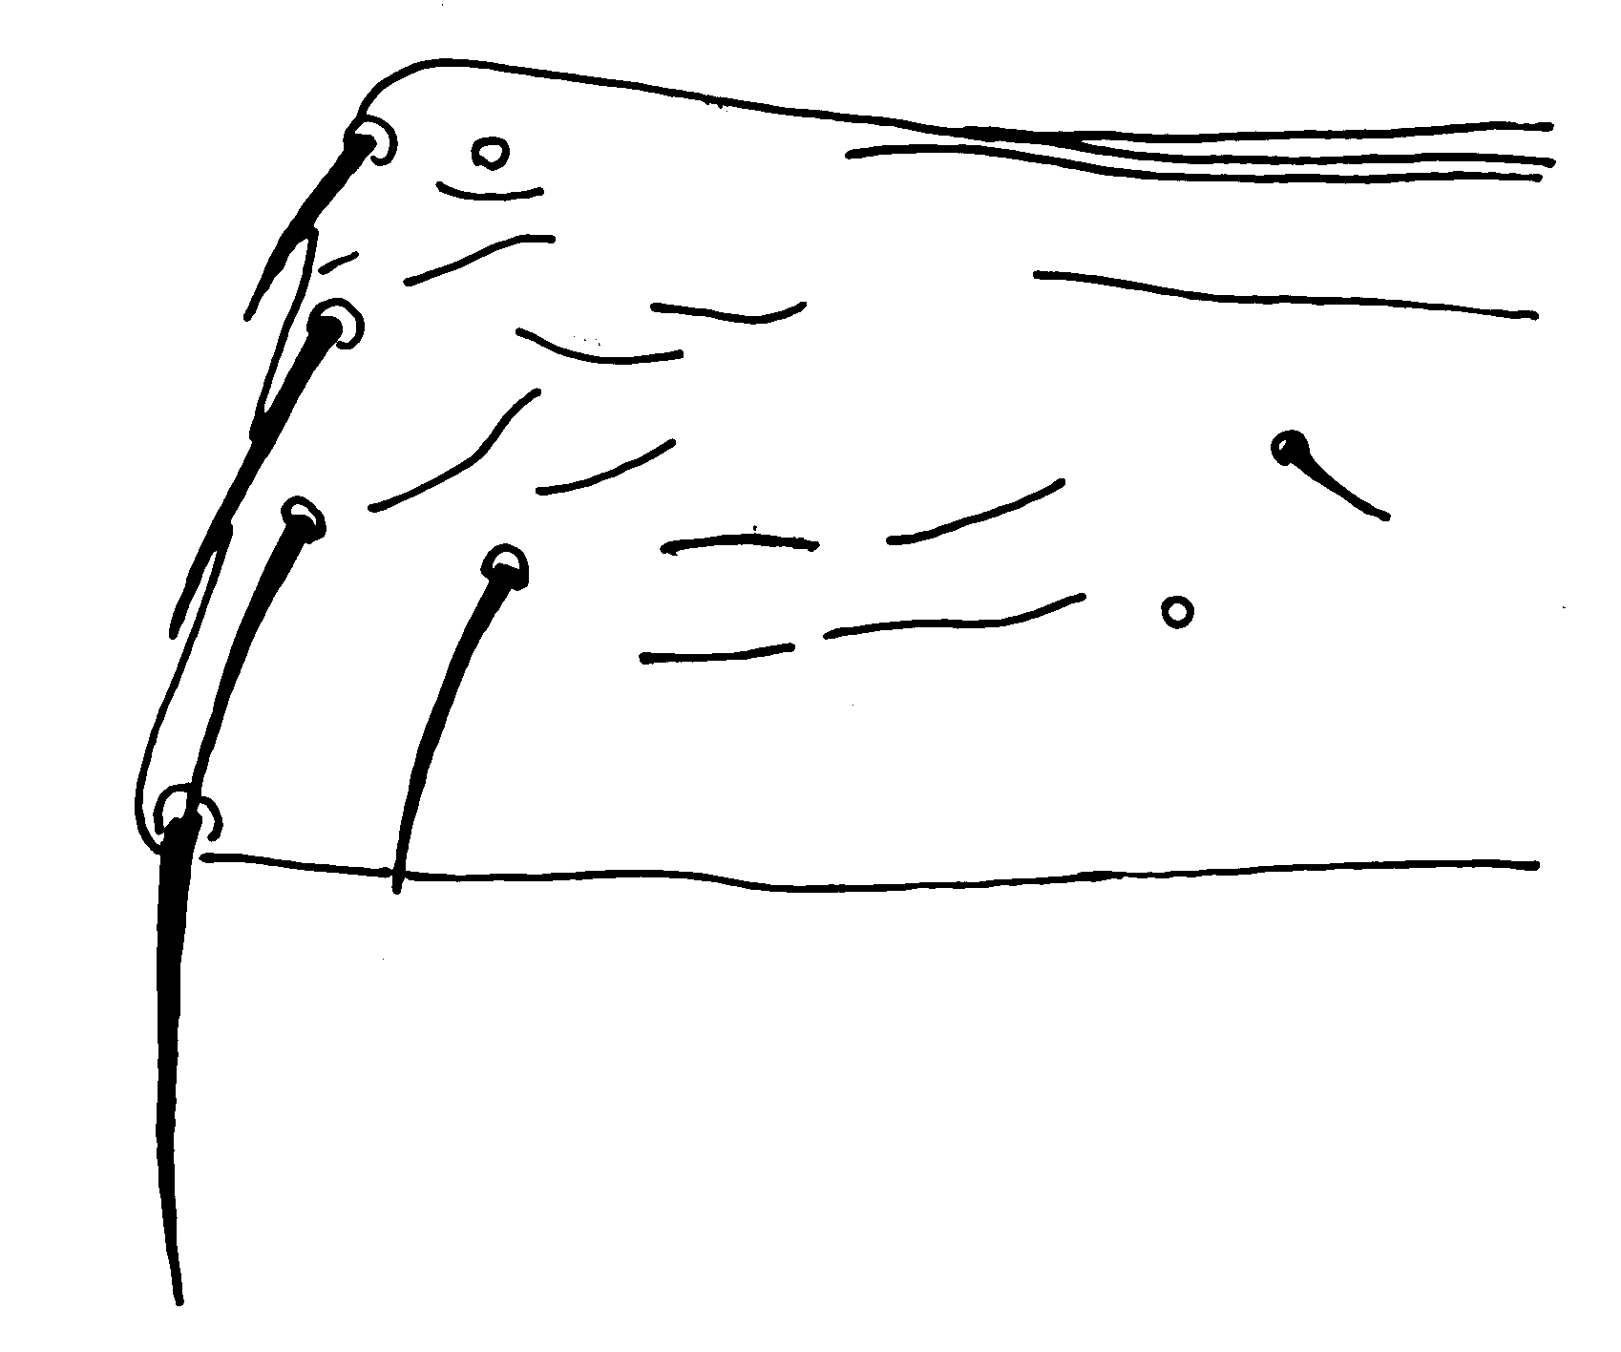

four setae in a row

(9) Abdominal tergite II: four lateral setae
(8) Abdominal pleurotergite

Two pairs of pores

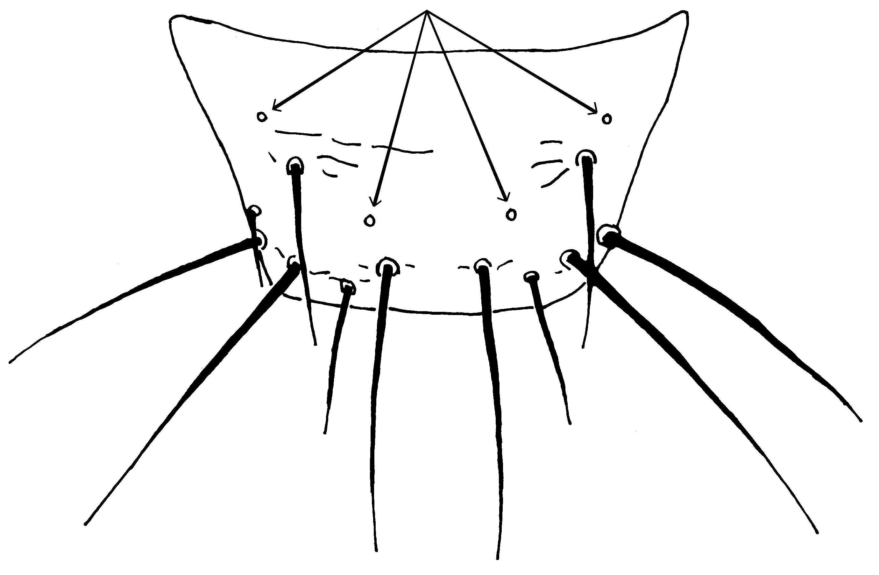
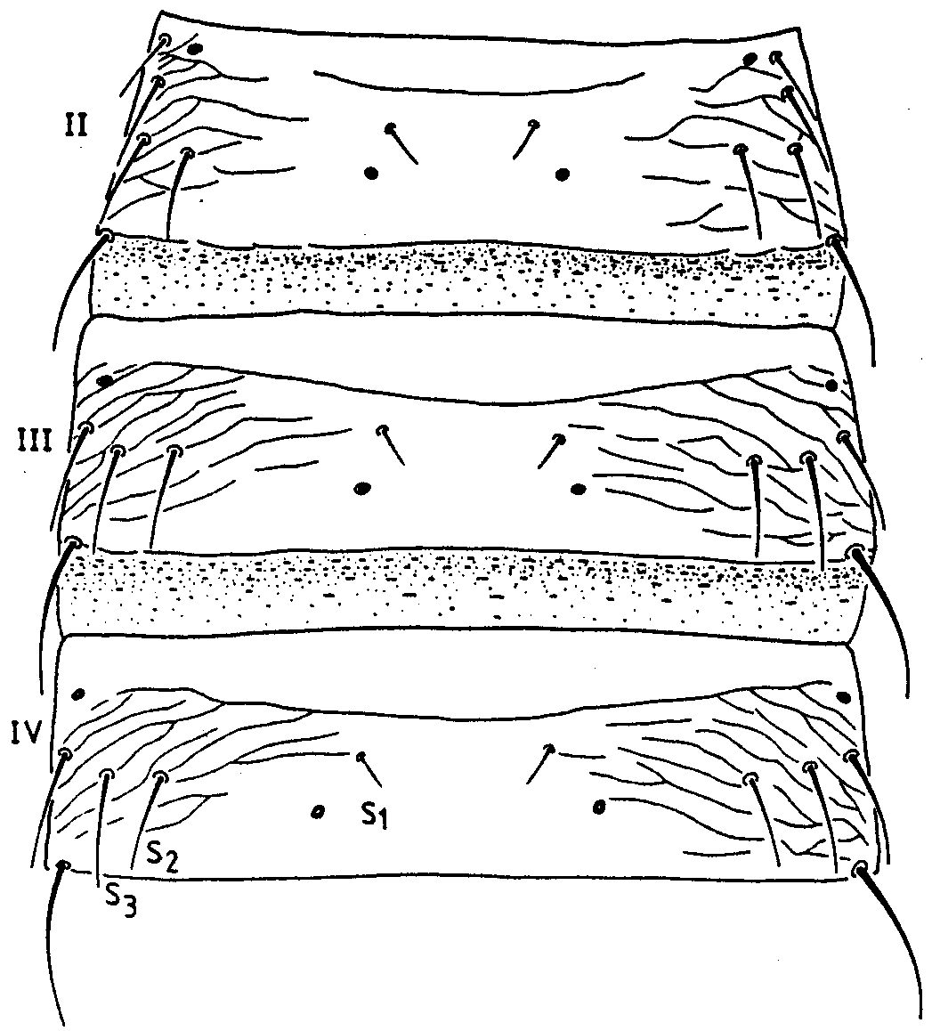

(11) Abdominal tergite IX

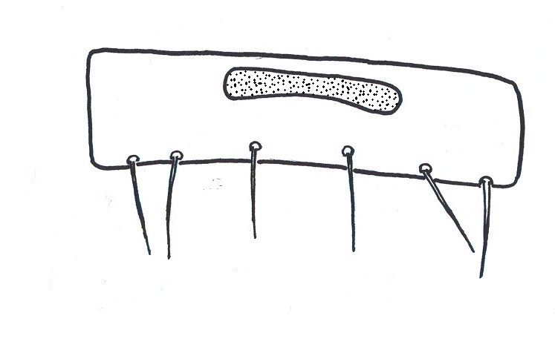

(10) Tergite II–IV, female: S2 about same size as S3 (from zur Strassen, 1989).

(12) Sternite V of male

